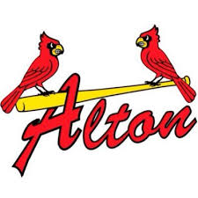
ALTON HIGH

JUNE 16, 17 & 18
9am-12noon
BASEBALL CAMP
2026 REGISTRATION

Grades 3-8

CAMPER INFORMATION

Name: Birthdate:

Address: Grade (entering ’26-’27):

Shirt (circle) Youth: S M L
Adult: S M L
School:

Emergency Contact

Name:

Phone:

Relationship:

Email:

CAMP FEES
Multiple campers from the same family qualify for discounts

- BOYS BASEBALL: $50 individual -- $40 each additional camper [family only]

** PLEASE SUBMIT FEES WITH REGISTRATION FORM**
Redbirds Baseball Camp, 4200 Humbert Rd., Alton, IL 62002
MAKE CHECKS PAYABLE TO: ALTON SCHOOL DISTRICT

LIABILITY WAIVER
I,the undersigned, intending to be legally bound for myself, my heirs, executors and adminitstrators, waive and release all claims for damages, actions and causes of actions against Alton High School and their affiliates, subsidiaries, officials, representatives, employees, successors and assigns, for any injuries my child suffers while or as a result of attending camp. In addition, I attest my child possesses medical insurance. Finally, I grant full permission for the legitimate use of my child’s name, photographs, recordings (audio and video) and other records of this event.

PARENT SIGNATURE

