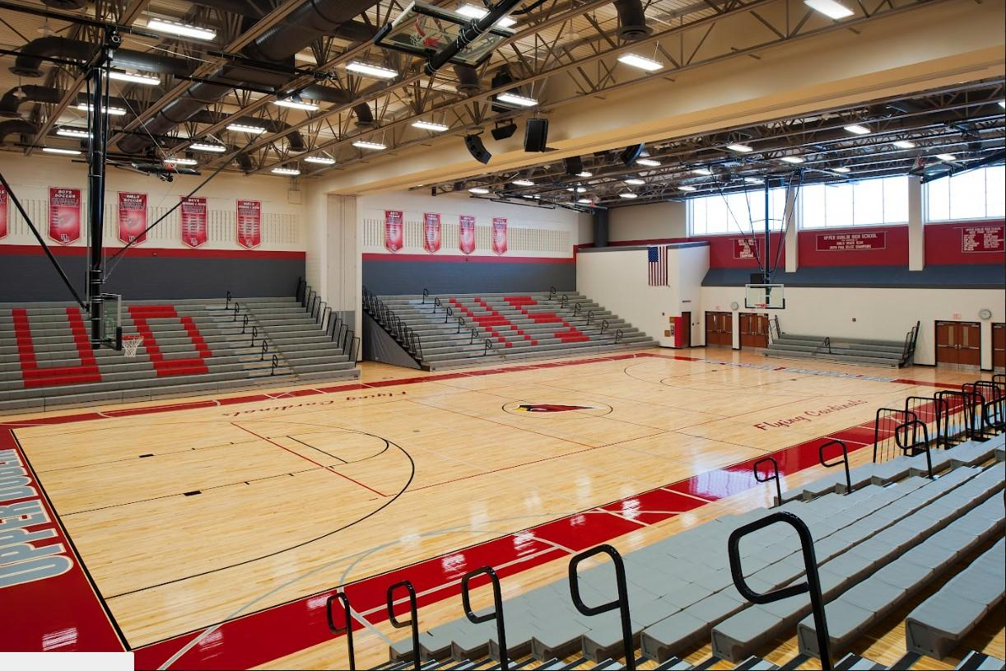
UD Team Bench
Visitors Team Bench
Visitors Student Section
Visitors Fan Section
Home Student Section
Upper Dublin Cheerleaders

Home Fan Section

UD Media
Fan Overflow

