
Varsity Volleyball
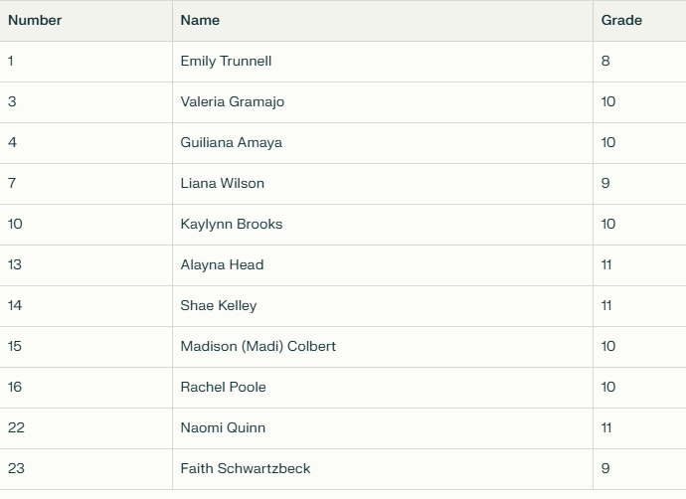

Head Coach: Kayla Dock
Assistant Coach: Aleta Krop

