Dear High School Athletic Director, Coach, or Administrator,

An emergency action plan (EAP) is a set of protocols for most emergency situations. The EAP contains useful information such as emergency phone numbers and directions to specific sport venues. There are several roles that must be filled in an emergency situation, with the most important role being providing immediate care. This is followed by bringing all appropriate emergency equipment to the scene, activating emergency medical services, and efficiently directing them to the sports venue/injured athlete.

This EAP contains several components, including:

1. Emergency Personnel
2. Emergency Communication
3. Emergency Equipment
4. Roles of the First Responder(s)
5. Venue Directions with a Map

Take notice that:

1. This document is a template that is structured in a fill-in-the-blank format. Please take the time to read through the entire document, discuss with the necessary personnel in your school/community, and make the adjustments you see fit. Each indoor and outdoor venue that you will utilize for practices and/or games should be included in your EAP with a separate page being completed for each venue.

2. While working on this document words that are in [brackets], italicized, and highlighted yellow are areas where you will need to make changes to fit your specific school. Once the document is completed none of these “fill-in-the-blank” areas should be left.

When you have completed your work on the EAP, it should be a document that represents all personnel that would be available to help in an emergency situation, at all venues your teams may compete at. Additionally, this document should be coordinated with local emergency services (EMS) and hospitals. After completing the EAP all highlighted areas should be filled.

If you have any questions, please feel free to reach out to Valerie Moody, Director of The Montana Youth Sports Safety Institute (MYSSI), at valerie.moody@mso.umt.edu. A member of the MYSSI team will be able to provide answers to any questions you may have to ensure your EAP can be established and implemented effectively.

Thank you,

Montana High School Association’s Sports Medicine Advisory Committee




Emergency Action Plan

[Insert Name of School]

Updated/Reviewed [Month Year]

In case of an emergency, personnel responsibilities, locations of emergency equipment, and other emergency information such as 911 call instructions, addresses/directions to the venue, and a chain of command with important phone numbers have been listed here.

Emergency Phone Numbers

Off Campus Contacts | Phone Numbers
Emergency | 9-1-1
Police Department
Fire and Ambulance
[Nearest] Hospital
[Second] Nearest Hospital
Hazardous Materials
Poison Control Center

On Campus Offices | Phone Numbers
Athletic Training Room
School Nurse
Athletic Director
Main Office
Administrator Office
School Counselor Office

Title | Name | Office Phone Number | Cell Phone Number
Athletic Trainer
Athletic Director
Principal
Assistant Principal
Assistant Principal
School Nurse
Team Physician
School Resource Officer

Emergency Plan For [Name of Venue]

[Street Address of Venue]
[City Name, State and Zip Code]

Emergency Medical Services Meeting Point/Venue Access:
[Where will a member of the school meet the ambulance; be very specific]

Available Emergency Equipment:
AED Location: [State the exact location of the nearest AED at this venue]
[AEDs should be reachable within 1-3 minutes of sport venues]
[List all emergency medical equipment available at the venue such as CPR masks, bloodborne pathogen supplies, crutches, splint kits, etc.]

Indoor Location in the Event of Lightning [delete section for indoor venues]
[Indoor location should be fully covered and have plumbing and electricity going to the facility. Cars or buses are also acceptable areas for coverage]

Staff Roles:
1. Activate EAP: [Who will decide that EMS needs to be called]
2. Call EMS/Ambulance:[Who will call EMS and provide directions to the venue]
3. Meet EMS at access point and direct to injured individual:[Who will meet EMS at the access point/ensure that access points are unlocked and open]
4. Immediate care of the injured athlete
a. Who will retrieve emergency equipment
i. AED Code Person: [Who will be designated to retrieve the AED]
b. Who will evaluate, assess, and stabilize the athletes until EMS arrives (this includes starting immediate CPR on a suddenly collapsed athlete)
5. Staff available for EMS transport: [Who will accompany the athlete to the hospital if parent/guardian isn’t present]
6. Crowd Control: [who will ensure emergency personnel can provide care without distraction]
7. Lightning Monitor: [who will monitor lightning and activate safety precautions - for outdoor venues only]

When calling EMS (911) use the following prompt:
“This is (name of person making call) at [Insert Name of High School]. We have (provide description of the incident/injury) requiring EMS personnel. I am calling from (state phone number). We are located at (use address at top of page). We will meet you at (state meeting point) to direct you to the scene.”
MAKE SURE TO STAY ON THE LINE UNTIL TOLD TO HANG UP
[Insert map showing route to venue and access point]
[Each venue that you use for athletics should be a separate page
This sheet can be printed and posted in each venue to use in case of emergency]

Considerations for Successful Implementation of Your Emergency Action Plan:

1. Prior to the beginning of each season, every coach should receive a copy of the Emergency Action Plan (EAP).
- An administrator or activities director should answer any questions the coaches may have in an effort to ensure the EAP can be activated effectively.
- These questions can also be answered by any medical personnel in your community that will be providing coverage to your school’s athletic events (i.e. Licensed Athletic Trainer, Physician, EMS, etc.).
- Based on your school district’s policies and procedures, it may be beneficial to have coaches sign off confirming they have read and understand the EAP annually.
2. A copy of the relevant EAP should be in a location where all emergency personnel have easy access to it at all practices/games.
- Consider posting a copy at entrances to gyms and fields.
3. The EAP should be re-evaluated each summer or prior to each sports season to make updates to personnel, emergency equipment, or access points.
4. Each time the EAP is activated, personnel should meet to discuss what went well and what needs to be improved. Think of your EAP as a policy that can always be improved upon.

Class B/C Completed Example
Emergency Plan for Sawyer High School Football Stadium
499 Jaques Road
Sawyer, MT 59745

Emergency Medical Services Meeting Point/Venue Access:
Ambulance will enter on the NORTH EAST Corner of the Football Field

Available Emergency Equipment:
-AED located inside the “New Gym” by the south side entrance doors
-Crutches

Indoor Location in the Event of Lightning
-Home and away student athletes will seek shelter in the “Old Gym” via south side entrances
-Spectators will be asked to seek shelter in their vehicles

Staff Roles:
1. Activate EAP: Ron Johnson (Head Football Coach)
2. Call EMS/Ambulance: Jimmy Smith (Athletic Director)
3. Meet EMS at access point and direct to injured individual: Sandra Matthew (Principal)
4. Immediate care of the injured athlete
a. Who will retrieve emergency equipment: Arnold Higgins (Assistant Football Coach)
b. Who will evaluate, assess, and stabilize the athletes until EMS arrives: Kay Smith, RN
5. Staff available for EMS transport: Jeremy Strong (JV Football Coach)
6. Crowd Control: Jimmy Smith (Athletic Director)
7. Lightning Monitor: Jimmy Smith (Athletic Director)

When calling EMS (911) use the following prompt:
“This is (name of person making call) at Sawyer High School. We have (provide description of the incident/injury) requiring EMS personnel. I am calling from (state phone number). We are located at 499 Jaques Rd in Sawyer, MT We will meet you at the North east corner of the stadium to direct you to the scene.”
MAKE SURE TO STAY ON THE LINE UNTIL TOLD TO HANG UP
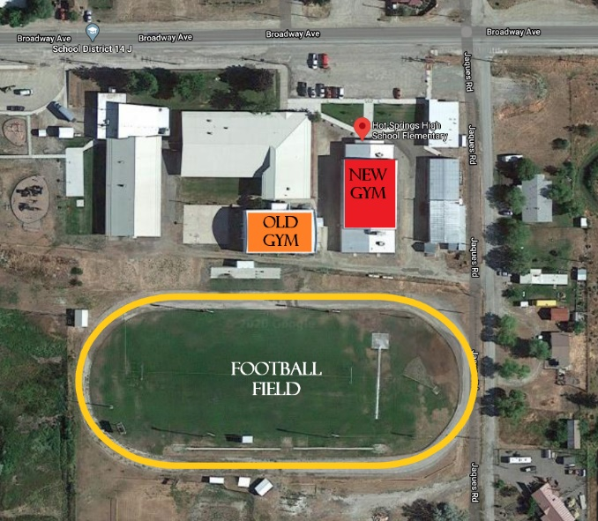
Class AA/A Completed EAP Example
Emergency Plan for Ross J Richardson Memorial Gym (New Gym)
38 East Gold Street
Butte, MT 59701

Emergency Medical Services Meeting Point/Venue Access
- Meet EMS at double doors #15 facing Gold Street
- Access gym using elevator to the right of the entrance to the 2nd floor
Available Emergency Equipment
- AED is located in the athletic training room on the 1st floor during practices and on the sideline with the AT during games. AED is located at the base of the main gym stairs by the elevator and at the top of the training room stairs near the football coaches’ office
- Scoop stretcher, vacuum and SAM splints, crutches, blood pressure cuff, pulse oximeter, stethoscope, CPR mask, BVM, BBP supplies
Staff Roles:
- Activate EAP: Riley Ungaretti, LAT or Bryan Arntson if AT is not present
- Calling EMS: Bryan Arntson
- Meet EMS at access point and direct to injured individual: Chuck Merrifield or Jackie Pauffhausen if AD is not present
- Immediate care of the injured athlete: Riley Ungaretti, LAT or Eddy Stewart if AT is not present will evaluate, assess and stabilize athlete until EMS arrives
  - Retrieving emergency equipment: Courtney Schad
- Staff available for EMS transport: Eddy Stewart
- Crowd control: Chuck Merrifield or Bryan Arntson
When calling EMS (911) use the following prompt:
“This is (name of person making the call) from Butte High School. We have a (provide description of the incident/injury) requiring an ambulance. I am calling from (phone number) and we are located at 38 East Gold Street in the BHS main gym. We will meet you at the double doors #15 facing Gold Street to direct you to the scene. Access this entrance using the bus driveway located at Platinum and Wyoming to the front of the building.”
MAKE SURE YOU STAY ON THE LINE UNTIL YOU ARE TOLD TO HANG UP. BE PREPARED TO DESCRIBE THE CONDITION OF THE ATHLETE (BLEEDING? BREATHING? CONSCIOUS?)
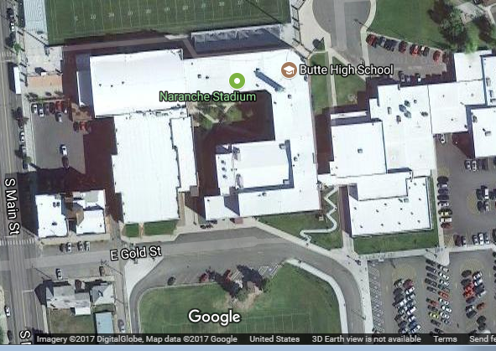
EMS Meeting Point

