How to create a family account and register for sports

At www.sabercatspots.com, click on registration

Please read through the information on the page if this is your first time visiting. At the bottom of the page, click on the paw.
Click Here for

Athletic Registration

If you are a parent of a freshman or new to Castle View High School, please read through the information on the page.

Create your family account by clicking on the button:

First Time Users - Create an Account & Register
Note: If you previously created an account and want to add a sibling or new student, login to your family account. DO NOT create a separate account.

- Fill out the registration form.
- Create a username and password for your family account on the checkout page.

Here is where you will create your family account, please remember your log in information for future reference.
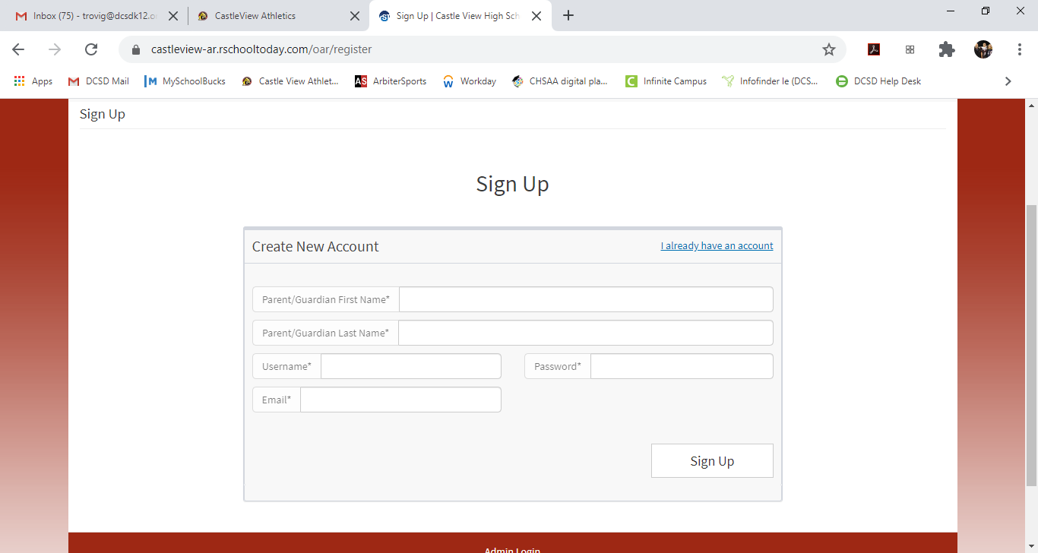

Now you will be able to add all of your student athletes to this account.

Register a Student from the Family Account
Register a Student from the Family Account
When inside a Family Account and you want to register a student from the account,
1. Click Register.
2. Select whether you will register an existing Student or a new Student.
Note that for an existing Student the stored Student information will be pre-filled.
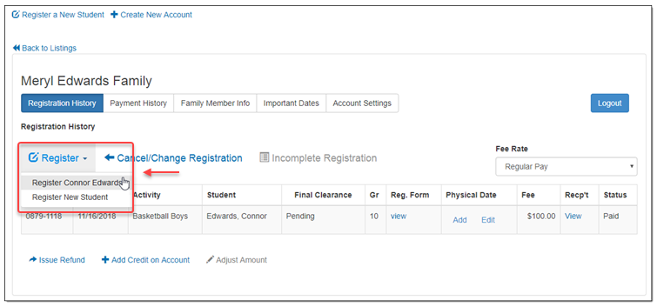
On the pop-up, select the Registration Form to register the student. Here is where you will select the Castle View Sports Registration 2020-21 for fall/winter/spring athletics.
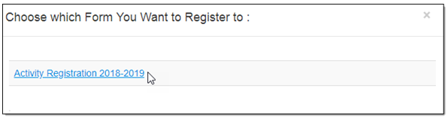
You will be directed to Step 1 of the Registration Form. Start filling out the Form step-by-step starting with Step 1 Student Information, Step 2 Select Activity, Step 3 Parent/Guardian Info, Step 4 Physical Forms, Step 5 Medical Information.
The rest of the steps will be similar to the tutorial from Registering a New Student. Locate the tutorial on the Left Navigation, under Family Account and right below the tutorial or Family Accounts Listing.

During registration, you will able to upload a current physical.
At the end of registration, please go to www.sabercatsports.org, click on school store, select categories from the drop down list and athletics. Find the appropriate sport you are paying for and pay the registration fee. If your student has been approved by DCSD for the 2020-21 school year Free & Reduced Lunch program, PLEASE PROCEED to My School Bucks and check out. This needs to be done in order to clear your student.
Please look for an email with your clearance for participation.

