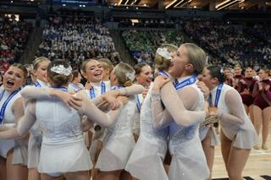

Benilde-St. Margaret’s
KNIGHTETTES
TRYOUT INFORMATION

WHEN: Mon – Wed (May 6 – May 8)

WHERE: Great Hall @ Benilde-St. Margaret’s School

TIME: 4:30 – 6:30 PM

WHAT TO WEAR:
- ANY BLACK LEOTARD AND BLACK LEGGINGS/ RUNNING SHORTS
- ANY BSM TANK TOPS OR T-SHIRTS ARE ACCEPTABLE
- BLACK TANKS ARE ALSO ACCEPTABLE
- NO JEWELRY
- JAZZ SHOES AND TENNIS SHOES

WHAT TO BRING:
- WATER
- YOUR BEST DANCE SKILLS AND A BIG SMILE! HAVE FUN!!

** Dance Experience is typical as ALL dancers
will need some proficiency in a variety of dance skills **

Questions/Contact Information:
Head Coach: Sam Cameranesi samantha.cameranesi@gmail.com

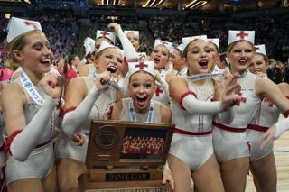
2024-2025 Dance Season
Summer Training Sessions – begins on June 10
Performance/Fall Season - begins August 12
(perform @ HOME regular season FB games)
Competition/Winter Season – begins Oct. 21

