Upper Field Track/Football/Soccer Zone 2
Parking for Disabilities Directions

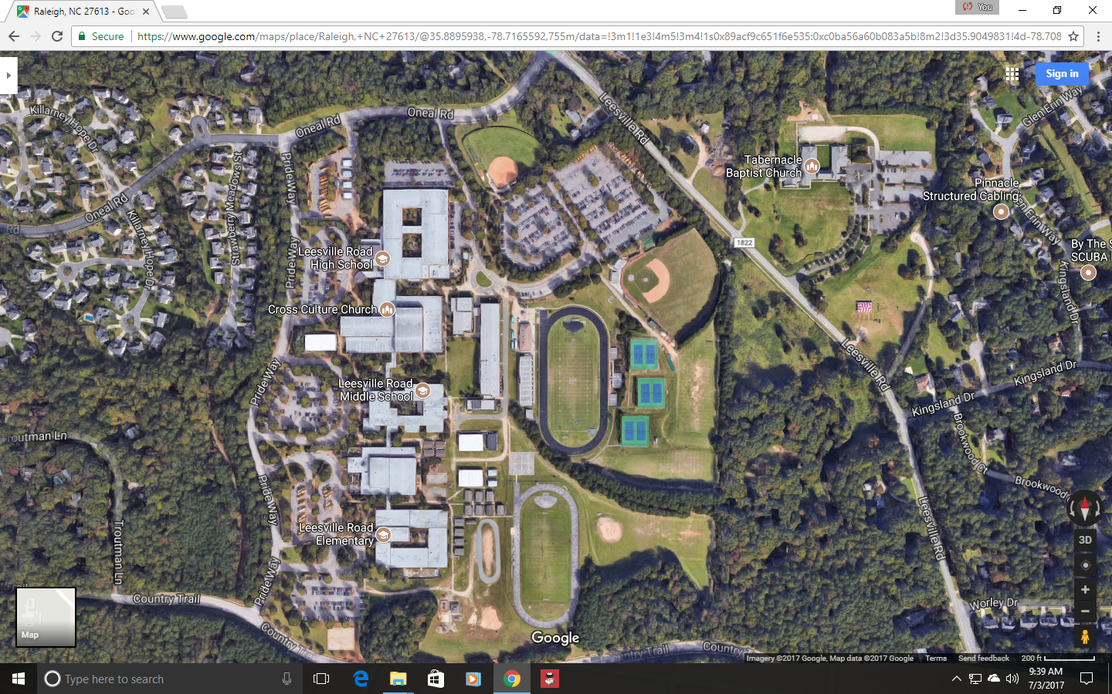
Directions: From the Leesville road red light, turn on to O’Neal Rd. Turn at the first left hand turn by the softball field above. This road will go over several speed bumps until you arrive at a tall mesh fence surrounding the High School Stadium Field. Just before this fence is a road with a gate that runs between the building and the fence. Drive down this road to the Middle School fields. The Middle School Football/Soccer field is across from the basketball court. Park near the fence by the basketball court.
Football / Soccer /Track Zone 2
Football Parking

