Athletic Trainer IS on site | Contact Information
- Notify the Athletic Trainer on duty.  - The Athletic Trainer will determine if EMS is appropriate.  - If EMS is appropriate, the Athletic Trainer will care for athlete, until the arrival of EMS. The Athletic Trainer or Coach will then contact the parents/guardian to inform them of the actions taken.  - After the EMS departs, the Athletic Trainer will contact the Athletic Director and make record of the incident. | Medical Staff:  - Lauren Hatch: 303-717-5468  - AT Office Phone: 303-387-2190  - Email: lhatch1@dcsdk12.org  Administration:  - Josh Stephenson: 720-241-6244
Athletic Trainer IS NOT on site | Venue Information
When an injury occurs, the Coach must determine the seriousness of the injury and activate EMS (call 911). If you have any doubt of the seriousness of the injury, activate EMS.  If EMS IS Activated  - If EMS is appropriate the Coach must contact the parents/guardian immediately to inform them of the actions taken.  - After EMS departs the Coach must contact Lauren by phone.  - The Athletic Trainer will contact the Athletic Director if not already done so.  - The Athletic Trainer & Coach will make record of the incident.  If EMS IS NOT Activated  - All injuries must be reported to the Athletic Trainer within 24 hours.  - After the injury is reported. The Athletic Trainer will follow up with athlete and parents.  - The Athletic Trainer will contact the Coach to discuss return to play protocol.  - The Athletic Trainer will make record of the incident.  Hospital Access  - Nearest medical facilities to this venue are located at UCHealth Highlands Ranch Hospital, 1500 Park Central Drive, 80129 | - Landline: Athletic Training Room (A-115)  - AED: Mobile AED with Athletic Trainer (four located inside school, two downstairs across from main gym and lower security, two upstairs across from security desk and by woodshop)  - Key & Gate Access: District lock on gate access. ATC or admin has key.  Information for EMS  - Location: East of Turf Field, use path down to field  - Address: 1991 W Wildcat Reserve Parkway, 80129  - Athlete name and age  - What happened  - Status of athlete (breathing, conscious, bleeding, etc.)  - Stay on the line w/ dispatcher and answer any questions  Roles  - Head Coach – Call 911, contact parents; direct EMS as needed  - Administrator – contact parents and call 911 if head coach is unable, open appropriate games/doors if needed  - Assistant Coach – get Administrator if present, meet EMS, open appropriate gates/doors if needed, get athlete’s stuff together, check on other players  - Parent – give info to EMS/Athletic Trainer as needed  Weather  - Lightning: ThunderRidge High School  - Tornado: Locker Rooms
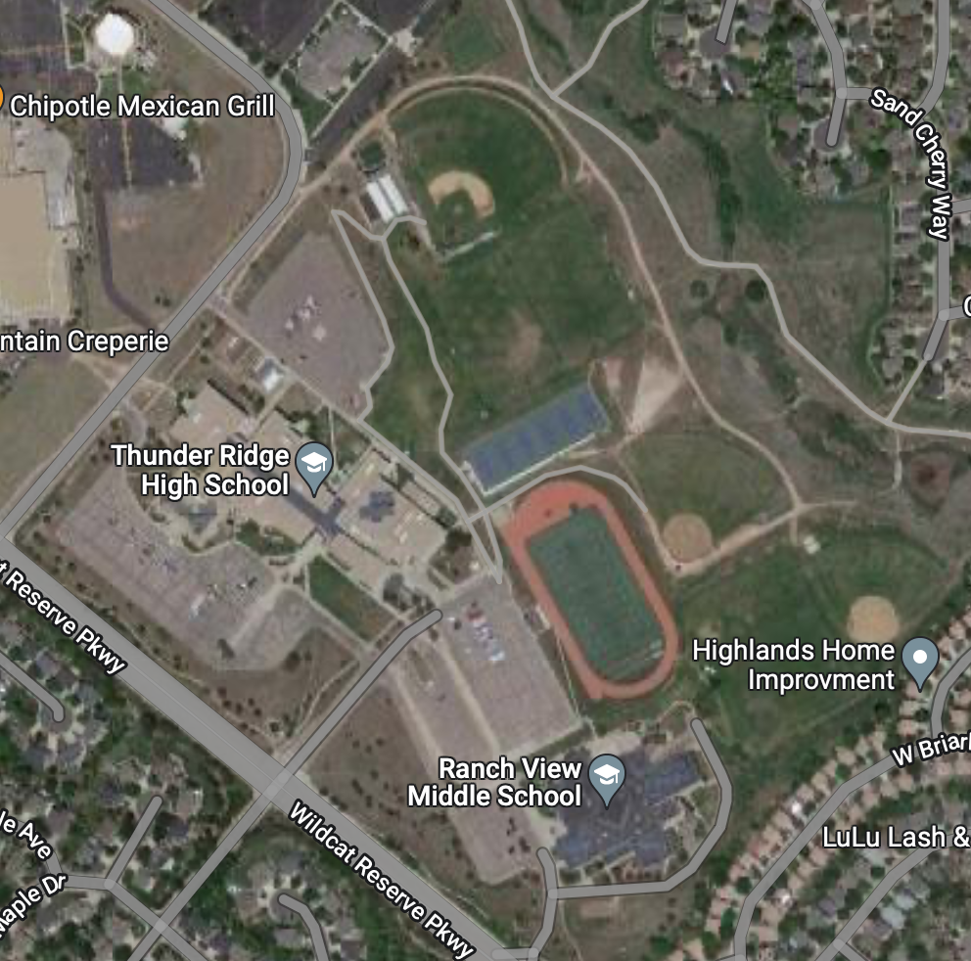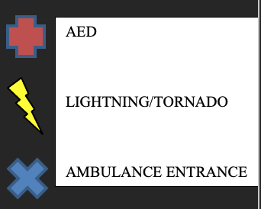
Softball Field
JV Field

