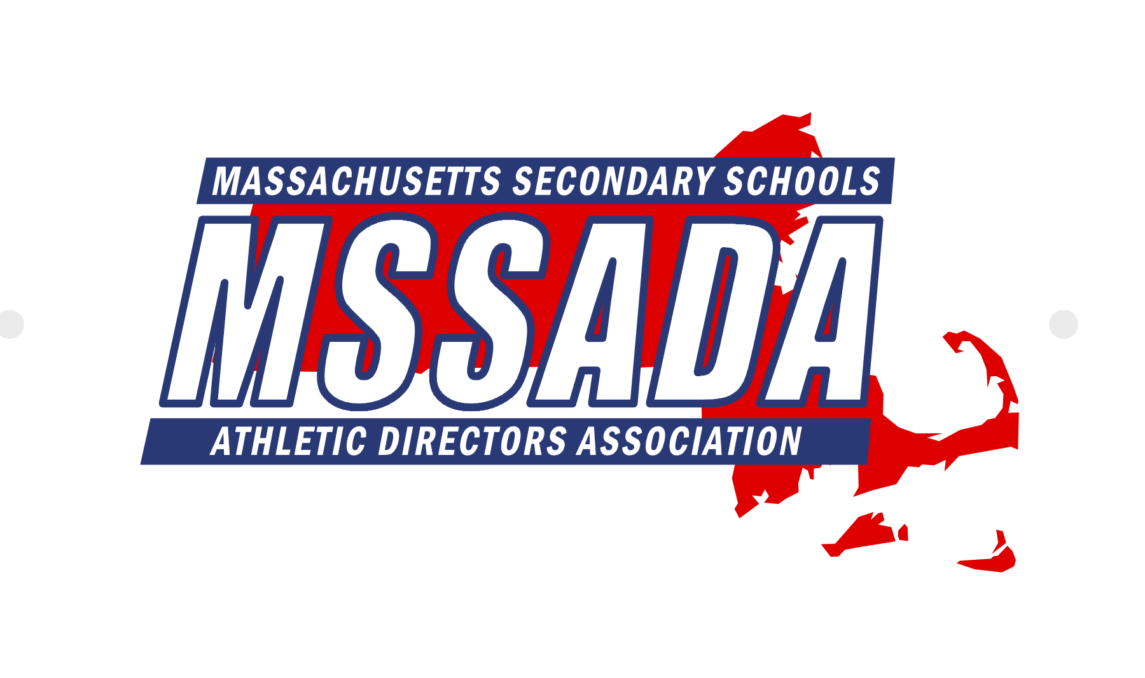

Fran Whitten, Executive Director Keith Mangan, President Matt Trahan, 1st Vice President Tom Tarpey, 2nd Vice President

Jim Quatromoni, 3rd Vice President Tania Rich, Secretary John Lynch, Treasurer Andy Crisafulli, Public Relations

Jay Costa, Past President Mike Denise, Conference Coordinator Terry Riley, Awards Chair Karrah Ellis, LTC Coordinator

**Executive Board Meeting Agenda**

**January 10, 2022 @ 10:00AM via Zoom**

**Attendance:** Keith Mangan, Fran Whitten, Jim Quatromoni, Matt Trahan, Tom Tarpey, Jay Costa, Tania Rich, Andrew Crisafulli, Ann Palumbo, Dave Lezenski, John Lynch, Kelly Wolff, Thom Holdgate, Terry Riley, Eric Scott, Peter Serino, Pete Jones, Johanna DiCarlo, Jared Shannon, Michael Denise, Bob Baldwin, Sahill Quaisar, Karrah Ellis

**Regrets:** Jack Owens, Kevin Karo

Call to order at 10:03AM by President Keith Mangan.

1. **Secretary Report – Tania Rich** 
   1. Review minutes from December 2021. Motion to approve November meeting minutes by Jim Quatromoni. Second by Andy Crisafulli. Approved unanimously (16-0-0).
2. **Treasurer’s Report – John Lynch**
   1. John distributed the January 2022 financial report. In the bank, MSSADA currently has $91,063.16 ($60,691.98 in TD Bank checking and $30,371.18 in TD Bank Money Market). Motion to approve the treasurer’s report by Andrew Crisafulli. Second by Jim Quatromoni. Approved unanimously (16-0-0).
   2. Membership Update – Currently 325 members
3. **MIAA Executive Director Report – Dr. Robert Baldwin**
   1. Met with NE Executive Directors on 1/10/2022
   2. In MA, our goal is to continue to have kids compete!
   3. Seeking input from AD’s across the state regarding the winter season
      1. Frustration regarding schools following protocols at hockey rinks
      2. Appreciate the MIAA allowing local decisions
   4. BOD Working Group – BOD reps to provide a sounding board regarding season and tournament
4. **MIAA Board of Directors Liaison Report – Jim Quatromoni**
   1. Met on 12/8/21
   2. Creating an Educational Athletics Scholarship
   3. Feedback on statewide tournament
   4. Update on DEI program
   5. BOD Working Group meeting on 1/12/22. Jim Q is a co-chair.
5. **Executive Director Report – Fran Whitten**
   1. Thanks to Dr. Baldwin for hosting the brunch!
   2. Future Conference sites - Nashville, Orlando, Austin, Tampa
   3. New initiative – Make a Wish Foundation
   4. Red Sox Partnership – Still waiting to hear back
   5. Student Scholar Essay Contest – Please share with your schools!
   6. Communication between MSSADA/MIAA – Encourage District Reps to share information
6. **Section 1 Report – Fran Whitten**
   1. Section 1 Scholarship for a first time attendee
   2. Vacancy on DEI Committee from Section 1
   3. Section 1 (Burlington VT) Meeting March 27-29 – Fran will represent MA.
7. **MIAC Liaison Report – Andy Crisafulli**
   1. Met in November 2021 and next meeting in Spring 2022
8. **Public Relations Report – Andy Crisafulli**
   1. Next newsletter scheduled for January 31, 2022
9. **Web Administrator Update – Matt Trahan**
   1. Website is updated as of 1/10
10. **Conference Updates – Mike Denise**
    1. Conference Update – Mike Denise
       1. Discussion about in-person vs. virtual conference
       2. Currently 22 vendors committed to the conference
       3. Conference Gift – UA Backpack
       4. Social at BBC – Due to COVID, they close at 8PM. Mike has requested if they would stay open for our social.
       5. Triple Threat Leadership (Dr. Scott Grant) – Keynote Speaker - Asking for assistance with a portion of expenses – flights, car rental ($600).
       6. Sponsors – Waiting to hear back from Nally and Scoreboard Enterprises
       7. Check on projectors – Did we purchase them in the past?
    2. Conference Schedule Update – Matt Trahan
       1. Working document
    3. Awards Chair Report – Terry Riley
11. **LTC Coordinator Report – Karrah Ellis**
    1. LTC 501 will be offered virtually on 1/24/22
    2. Conference Course Offerings – 503, 504, 506, 508, 510, 726, 600?
    3. CAA Exam will be offered on Friday
12. **District Reports**
    1. District 1 – Jared Shannon
       1. Masks: We are having many of the same challenges. I view this also as a local school problem. Some schools are doing a poor job of enforcing masking. Traveling fans and teams are the biggest issue. Most home fans respect the rules of the home schools. Many schools are still playing….a few have taken brief pauses. We are running a WMass tourney as we have in the fall. We received mostly positive feedback for the state tourney. Some examples of long travel, however, not much worse for most in the west than in years past. The competitive equity in the tourney was a bright spot.
    2. District 2 – Pete Jones
       1. Limited Spectator Policy (Household members only)
    3. District 3 – Ann Palumbo
       1. Limited Spectator Policy (Household members only).
       2. Planning league and CMass tournaments
    4. District 4 – Jack Owens
    5. District 5 – Kelly Wolff
       1. Frustrations with inconsistencies with masks
    6. District 6 – Sahill Quaisar
       1. GBL still on pause throughout the city
    7. District 7 – Eric Scott
       1. Limited Spectator Policy (Household members only).
    8. District 8 – Kevin Karo
    9. District 9 – Peter Serino
       1. Held a district wide zoom last week to discuss best practices and challenges (masks, when to shut down, etc.).
13. **Retired AD’s Update – Jeff Long**
    1. Fran reported for Jeff. Jeff is going to draft a letter to share with district reps.
    2. Planning to bring back a retired AD’s luncheon at the Cape conference and ask retired AD’s to help with registration and check-in.
    3. Share Google sheet - <https://docs.google.com/spreadsheets/d/1-9TsnEpLFnTEK1N_nep2nm-uNIin05I3_PDPu51FtPw/edit?usp=sharing>
14. **Old Business**
    1. Membership Update – Dave Lezenski
       1. Fran reported for Dave. He is calling schools that opted out.
    2. Title IX Initiative – Johanna DiCarlo
       1. Brainstorming ideas… but holding off due to COVID.
       2. Recognize women in districts and have current student-athletes interview them
       3. Highlight female athletic directors
    3. Strategic Plan Update – Jay Costa
       1. Overall, MSSADA is doing very well – technology, mentoring, etc.
       2. Need to continue working with DESE. Fran will reach out to executive directors to see where there states are in this certification process.
15. **New Business**
    1. Mentoring Program – Thom Holdgate
       1. Tabled to the February meeting
    2. Appoint MSSADA Rep to MIAC
       1. 4 applicants – Committee of officers met to discuss applicants
       2. Keith appointed Tania Rich as the MSSADA Rep to MIAC.

Meeting adjourned at 11:23AM.

Next meeting 2/7 at MIAA Office.