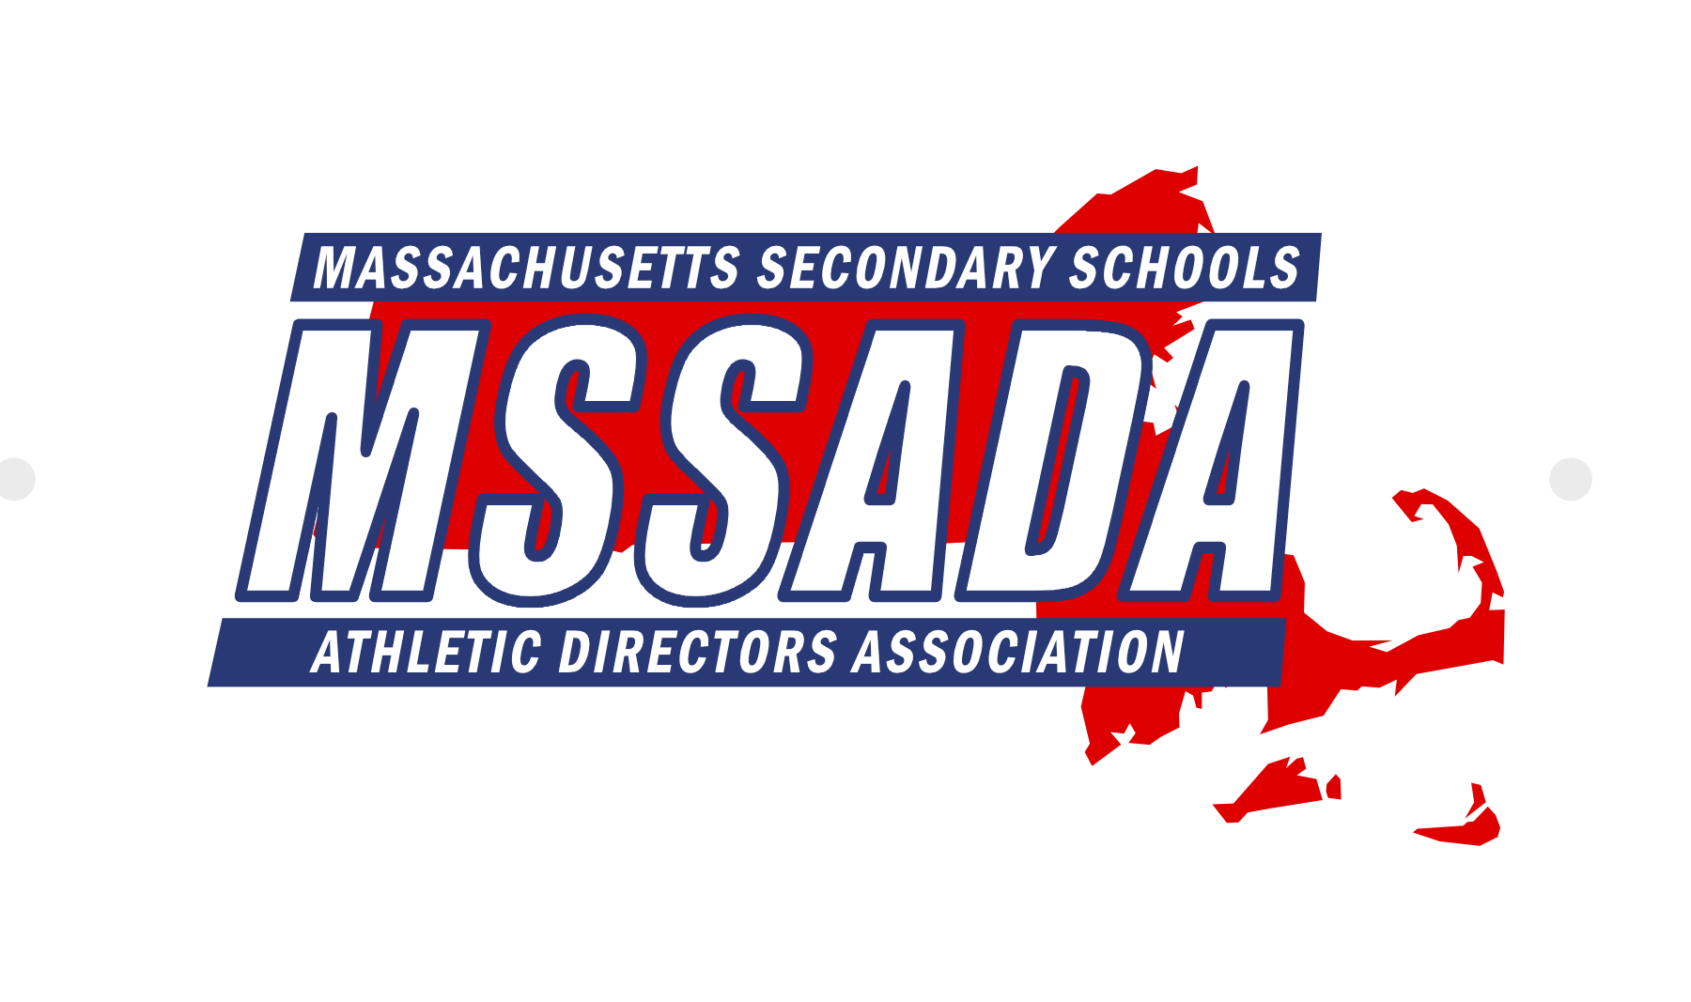

Fran Whitten, Executive Director Keith Mangan, President Matt Trahan, 1st Vice President Tom Tarpey, 2nd Vice President

Jim Quatromoni, 3rd Vice President Tania Rich, Secretary John Lynch, Treasurer Andy Crisafulli, Public Relations

Jay Costa, Past President Mike Denise, Conference Coordinator Terry Riley, Awards Chair Karrah Ellis, LTC Coordinator

**Executive Board Meeting Minutes**

**February 7, 2022 @ 10:00AM at MIAA Office**

**Attendance:** Keith Mangan, Fran Whitten, Matt Trahan, John Lynch, Tom Tarpey, Kevin Karo, Jim Quatromoni, Eric Scott, Peter Serino, Thom Holdgate, Andy Crisafulli, Jeff Long, Dave Lezenski, Johanna DiCarlo, Kelly Wolff, Terry Riley, Mike Denise, Karrah Ellis, Jay Costa, Tania Rich, Bob Baldwin

**Regrets:** Jared Shannon, Ann Palumbo, Pete Jones, Sahill Quaisar

Call to order at 10:01AM by President Keith Mangan.

1. **Secretary Report – Tania Rich** 
   1. Review minutes from January 10, 2022. Motion to approve January meeting minutes by Jim Quatromoni. Second by Eric Scott. Approved unanimously (15-0-0).
2. **Treasurer’s Report – John Lynch**
   1. John distributed the February 2022 financial report. In the bank, MSSADA currently has $86,870.95 ($56,498.48 in TD Bank checking and $30,372.47 in TD Bank Money Market). Motion to approve the treasurer’s report by Matt Trahan. Second by Tom Tarpey. Approved unanimously (15-0-0).
3. **MIAA Executive Director Report – Dr. Robert Baldwin**
4. Thank you for your patience and professionalism! Understands things are frustrating.
5. BOD Meeting on 2/9. Will review organizational analysis.
6. Met with Section 1 – Discussed lacrosse equipment supply chain/backorder issues. Executive Directors reaching out to NFHS regarding this issue.
7. NFHS is looking into putting together “NFHS Experience” which would include all technology (i.e. Arbiter, ticketing, etc.)
8. New MIAA Website in transition
9. Votes coming up – Possible ski deadline could be moved and rugby start date change
10. Working Group – Jim Q. (chair) – Group to discuss issues and topics (i.e. masking inconsistencies)
11. **MIAA Board of Directors Liaison Report – Jim Quatromoni**
    1. Next meeting is scheduled for 2/9
    2. Working Group is scheduled to meet on 2/8. Good discussions within the group.
12. **Executive Director Report – Fran Whitten**
    1. NEDC Update – Award deadlines
    2. NIAAA Scholar Essay Reminder – Extending the deadline to 2/18
    3. National Conference Sites – Nashville, Orlando, Austin, Tampa
    4. National Initiative – Make a Wish Foundation
    5. Red Sox Partnership is in slow motion!
    6. Sponsors – Working with Conference Coordinator on sponsorship tiers
    7. Membership Drive – Asking District reps to follow up with schools who opted out
13. **Section 1 Report – Fran Whitten**
    1. Membership Commendation
    2. Vacancy on the DEI Committee
    3. Section 1 Meeting – Burlington VT – Fran will attend.
14. **MIAC Liaison Report – Andy Crisafulli**
    1. Tania Rich appointed to MIAC
15. **Public Relations Report – Andy Crisafulli**
    1. MSSADA Messenger Newsletter review
16. **Web Administrator Update – Matt Trahan**
    1. The website is update to date. Thank you for board members for sharing information.
17. **Conference Updates – Mike Denise**
    1. Conference Update – Mike Denise
       1. Vendors – 55 as of 2/7
       2. Sponsorships are in a good spot for the conference
       3. Hotel – No mask mandates as of right now
       4. Projectors – Need 5 (Kelly-1) – Let Mike/Matt know if your school has one that you can bring
       5. Banners – Looking to update banners with new logo
       6. District Raffle Gifts ($100 value)
    2. Conference Schedule Update – Matt Trahan
       1. Draft schedule
    3. Awards Chair Report – Terry Riley
       1. Program – Working with Matt and Mike. Will share draft with the board.
    4. Discussion around using QR codes for daily schedule, workshop sign-in, etc.
    5. Tickets – Can we look into digital ticketing?
18. **LTC Coordinator Report – Karrah Ellis**
    1. Offering 7 courses at the conference
    2. Gary Stevens and Mark Rerrick will each be teaching 2 courses
    3. CAA Exam will be offered on Friday 4/1. Study session on Thursday.
19. **District Reports**
    1. District 1 – Jared Shannon
    2. District 2 – Pete Jones
    3. District 3 – Ann Palumbo
    4. District 4 – Jack Owens
       1. Workshop scheduled for 2/18
    5. District 5 – Kelly Wolff
       1. Have not met, but continued email discussions regarding COVID
    6. District 6 – Sahill Quaisar
       1. Keith reported. Transportation issues.
    7. District 7 – Eric Scott
       1. Planning a District 7 meeting soon
    8. District 8 – Kevin Karo
       1. Will meet at the conference as a district
    9. District 9 – Peter Serino
       1. Held a district workshop – discussed the many issues everyone is experiencing
20. **Retired AD’s Update – Jeff Long**
    1. Seeking retired AD’s to help at the conference
21. **Old Business**
22. **New Business**
    1. Mentoring Program Update – Thom Holdgate
    2. Conference Fee – Motion by Matt Trahan to accept a fee of $100 to allow an individual (Assistant AD, intern, grad student, etc.) to attend the MSSADA Conference as a first time attendee. Second by Jay Costa. Approved 15-0-0.
    3. Winter Tournaments – Get the scores into Arbiter! If you postpone a game, go into that game when rescheduling and change the game back to “normal.”

Meeting adjourned at 11:42AM.