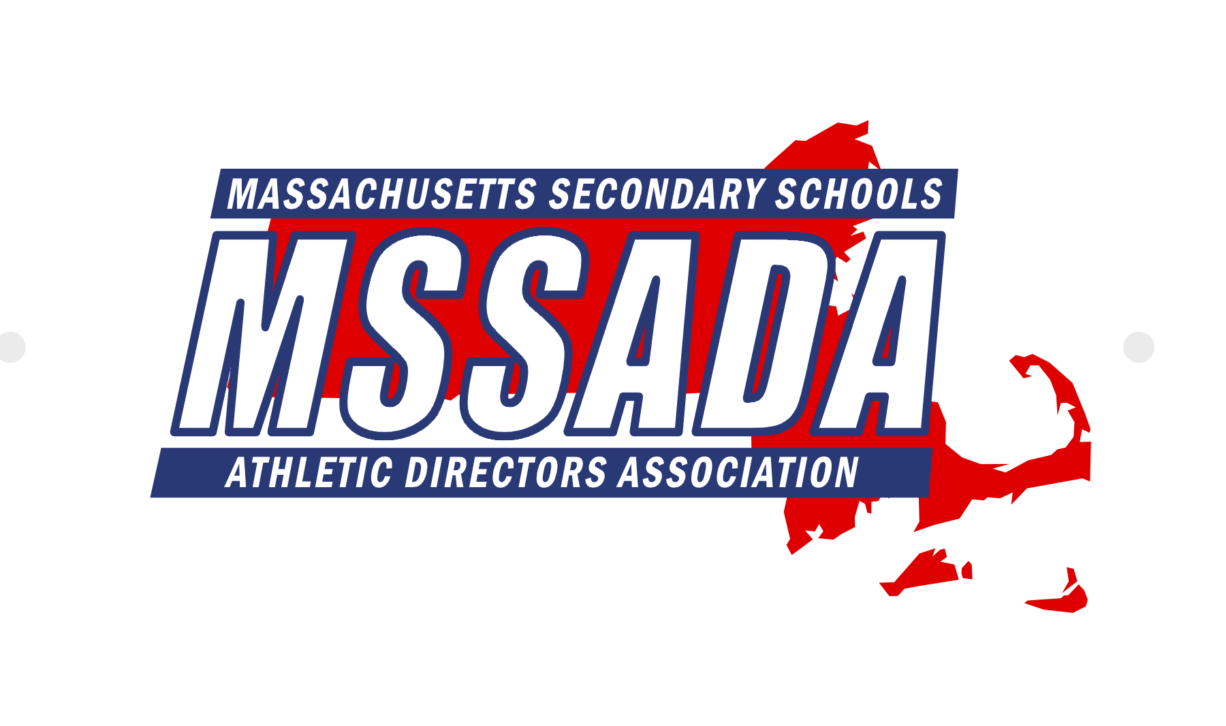

Fran Whitten, Executive Director Keith Mangan, President Matt Trahan, 1st Vice President Tom Tarpey, 2nd Vice President

Jim Quatromoni, 3rd Vice President Tania Rich, Secretary John Lynch, Treasurer Andy Crisafulli, Public Relations

Jay Costa, Past President Mike Denise, Conference Coordinator Terry Riley, Awards Chair Karrah Ellis, LTC Coordinator

**Executive Board Meeting Minutes**

**May 2, 2022 @ 10:00AM at MIAA Office**

**Attendance:** Keith Mangan, Matt Trahan, Fran Whitten, Tom Tarpey, Kevin Karo, Thom Holdgate, Andy Crisafulli, Terry Riley, Bob Baldwin, Pete Serino, Jeff Long, Pete Jones, Ann Palumbo, Johanna DiCarlo, Karrah Ellis, Mike Denise, Jay Costa, Tania Rich

**Regrets:** Sahill Quaisar, Jack Owens, Jim Quatromoni, Kelly Wolff, Eric Scott, John Lynch

Call to order at 10:04AM by President Keith Mangan.

Keith turned the meeting over to President Elect Matt Trahan. Matt thanked Keith for all his hard work.

1. **Secretary Report – Tania Rich** 
   1. Review minutes from March 7, 2022. Motion to approve March meeting minutes by Thom Holdgate. Second by Karrah Ellis. Approved unanimously (12-0-0).
2. **Treasurer’s Report – John Lynch**
   1. John emailed the May 2022 financial report. In the bank, MSSADA currently has $46,033.62 in TD Bank checking and $30,376.17 in TD Bank Money Market. Discussion and vote on financial report tabled.
3. **MIAA Executive Director Report – Dr. Robert Baldwin**
   1. Commend the board on a great conference! Very well organized, great general session speaker, great sessions, etc.
   2. Section 1 Executive Directors meet on Mondays – Discussed the Crown Act and crowd control and behaviors
   3. NFHS Legal Meeting Update – Discussed the importance of knowing the rules!
   4. Discussion regarding Arbiter
4. **MIAA Board of Directors Liaison Report – Jim Quatromoni**
   1. Tabled until June.
5. **Executive Director Report – Fran Whitten**
   1. Thank you to the board with the exceptional job on the conference! Thanked Bob and his staff for attending sessions and involved in the conference.
   2. DEI Committee has become a standing committee.
   3. NIAAA – Role of the Athletic Administrators
   4. National Conference – Registration fee will be $295.00
   5. NIAAA Theme – “Value Others”
6. **Section 1 Report – Fran Whitten**
   1. Section 1 Meeting – March 28th in Vermont. Next meeting is May 8, 2023 in Warwick RI. MSSADA will need to consider our attendance at the meeting.
   2. Summer Institute (June 2022) – This is the last year it will be held at Ocean’s Edge in Brewster.
7. **MIAC Liaison Report – Andy Crisafulli**
   1. Next meeting – May 25, 2022
8. **Public Relations Report – Andy Crisafulli**
   1. Working on next newsletter
9. **Web Administrator Update – Matt Trahan**
   1. Website is updated
   2. rSchool is working on updating the site
10. **Conference Updates – Mike Denise**
    1. Conference Update/Review – Mike Denise
       1. Thank you to everyone!
       2. Working on finalizing the financial report
    2. Awards Chair Report – Terry Riley
       1. Award nominations by June
       2. Tickets via GoFan – Need to discuss the process
       3. Conference Programs – Do we continue with the programs? Yes.
       4. Award Social – Do we allow only family members/guests or league members?
    3. Possibility of Relocating?
       1. There were issues with the hotel that were brought to our attention.
       2. Officers and Conference Coordinator met with Gillette on 4/30 to discuss the possibility of holding the conference at that location. There are pros/cons for this location.
11. **LTC Coordinator Report – Karrah Ellis**
    1. 77 participants / 7 courses offered at the conference
12. **District Reports**
    1. District 1 – Ryan Dunphey
    2. District 2 – Pete Jones
       1. Will begin our CMADA tournament in 3 weeks
    3. District 3 – Ann Palumbo
       1. Will begin our CMADA tournament in 3 weeks
       2. League hosted a Student Ambassador workshop on 4/28
    4. District 4 – Jack Owens
    5. District 5 – Kelly Wolff
    6. District 6 – Sahill Quaisar
    7. District 7 – Eric Scott
    8. District 8 – Kevin Karo
       1. Planning to meet in mid-June
    9. District 9 – Peter Serino
       1. Positive feedback about the conference
13. **Retired AD’s Update – Jeff Long**
    1. Luncheon at the conference was a success!
14. **Old Business**
    1. Squad Locker – Polos – Email will be sent out.
    2. Title IX Update – Johanna – Focus on MSSADA Past President & AD of the Year and then list all 53 female AD’s
15. **New Business**
    1. BOD - District 7 Rep – Motion by Keith Mangen to approve Eric Scott as the District 7 representative on the BOD. Second by Thom Holdgate. Approved unanimously 12-0-0.
    2. Executive Director Interviews 5/11 – Subcommittee will be conducting interviews (3 applicants)
    3. Next Meeting – June 6, 2022 – Officers, Conference Coordinator, LTC Coordinator, Awards Chair, Director of Communication
    4. Jay Costa (Past President) – Thank you as it is his last meeting on the board!
    5. Gipper Contract – Negotiating proposals
    6. President Rings (Championship Awards Guys) – Discussion

Motion by Keith Mangen to adjourn at 11:46AM. Second by Jay Costa. Approved unanimously.