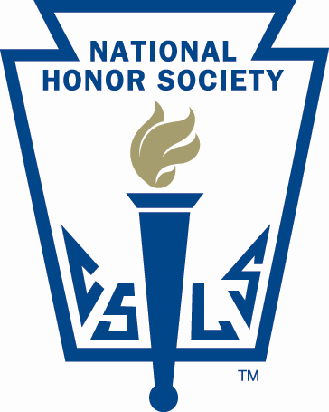

Red Rock Central High School
National Honor Society Selection Guidelines

The National Honor Society chapter of Red Rock Central High School is a duly chartered and affiliated chapter of the National Honor Society.

Membership is open to those students who meet the required standards in four areas of evaluation: scholarship, leadership, service, and character. Students are selected for membership by majority vote of a 5-member Faculty Council, appointed annually by the principal, which bestows this honor upon qualified students on behalf of the faculty of our school each year. The chapter adviser, Rachel Karnitz, is also appointed by the principal and facilitates all selection procedures and chapter activities during the year.

Students in grades 10-12 are eligible for membership. For the scholarship criterion, a student must have a cumulative GPA of 3.3 or better on a 4.0. Those students who meet this criterion are invited to complete an application form that provides the Faculty Council with information regarding the candidate’s leadership and service. A history of leadership experiences and participation in school or community service is also required.

To evaluate a candidate’s character, the Faculty Council obtains additional professional input. First, official school disciplinary records are reviewed. Second, members of the faculty are requested to provide their professional reflections on a candidate’s service activities, character, citizenship, and leadership. These forms and the Candidate Forms are carefully reviewed by the Faculty Council to determine whether each candidate meets the criteria for membership. A majority vote of the Council is necessary for selection. Following a review of the results of the Faculty Council voting by the principal, candidates are notified regarding selection or non-selection according to a predetermined schedule.

Once the notification process is completed, a formal induction ceremony is held at the school to recognize all the newly selected members. Once inducted, new members are required to maintain the same level of performance (or better) in all criteria that led to their selection. This obligation includes regular attendance at chapter meetings held monthly during the school year, fulfillment of 15 hours of community/volunteer service, and participation in the chapter service projects(s). A full list of member obligations is provided to all candidates and is available from the chapter adviser upon request.] Students or parents who have questions regarding the selection process or membership obligations can contact the chapter adviser, Rachel Karnitz, by phone at 507-752-7361 or email at rachelkarnitz@rrcfalcons.org

