Address: 110 Blake Rd S, Hopkins, MN, 55343

*Masks are optional in the building

Those arriving on BUS: Have them drop off and pick up at Aamoth lot!

Please see following pages for photos and directions of the school.

Parking: You can park either in the main lot, or the aamoth athletic lot. I would recommend parking in the aamoth lot if you can find a space— it is closer to the pool.

Main lot: You will head South on Blake road from Excelsior Blvd, and enter in between the two brick pillars. Continue on up the hill to the main lot, then enter in as described, below.

Aamoth: The Aamoth lot is on the south side of the street, on Excelsior Blvd, west of Blake Road. You will see an illuminated sign at the entrance. It is across the street from goodwill. As you enter the lot, you will see our football stadium and ice rink. 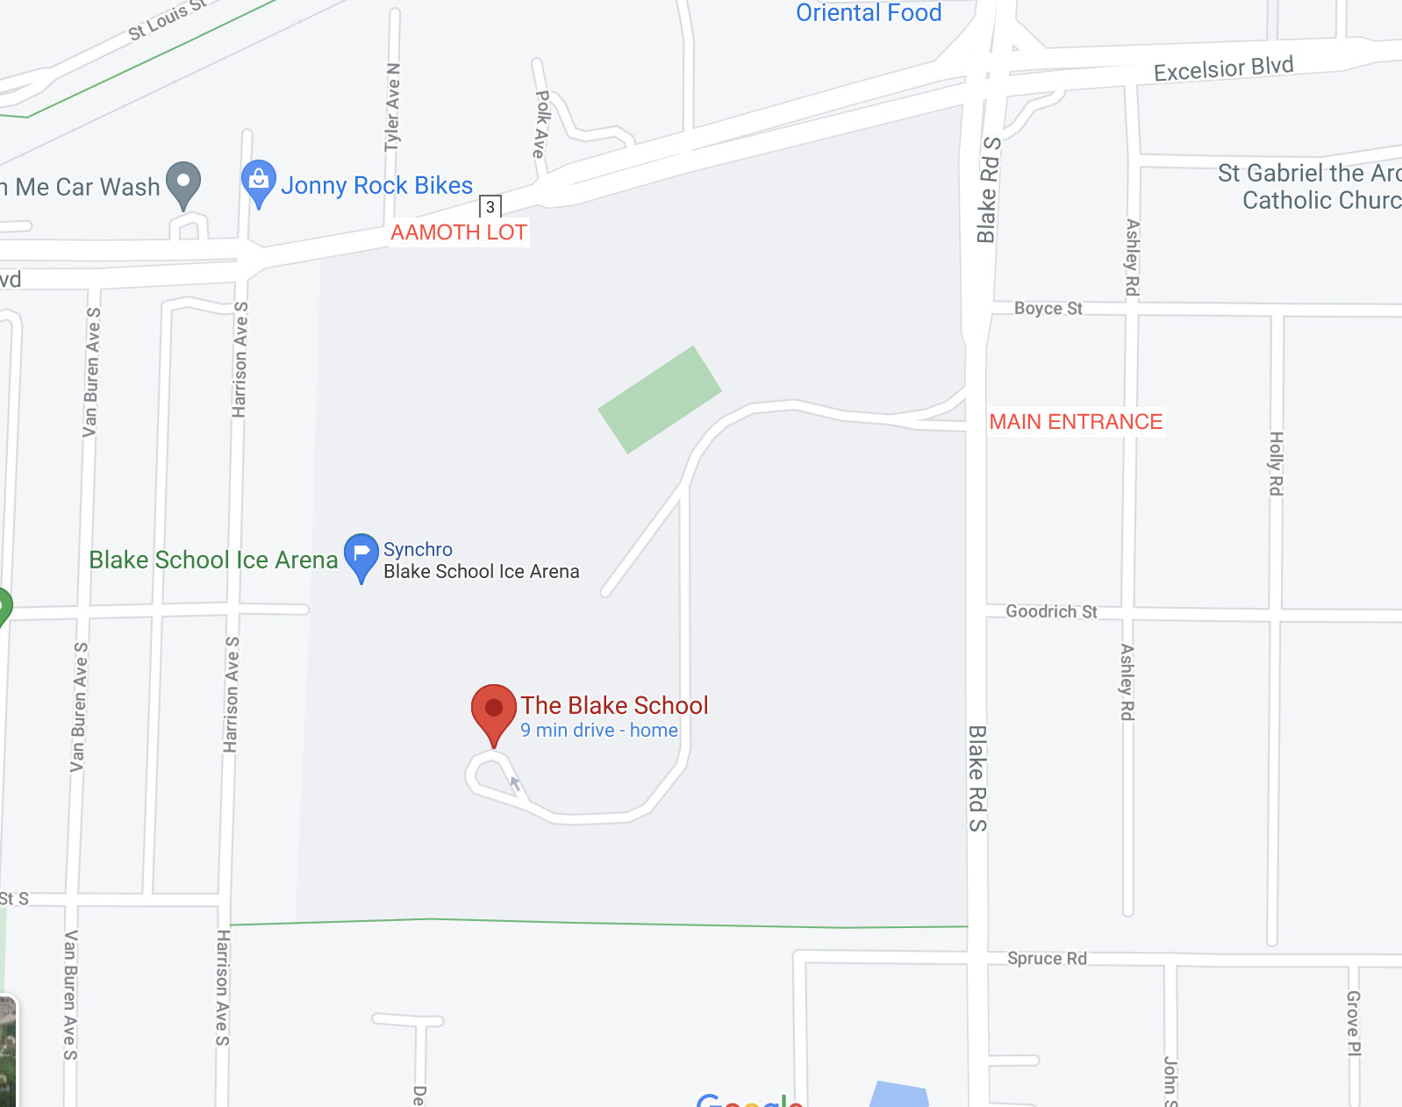

From the aamoth lot:

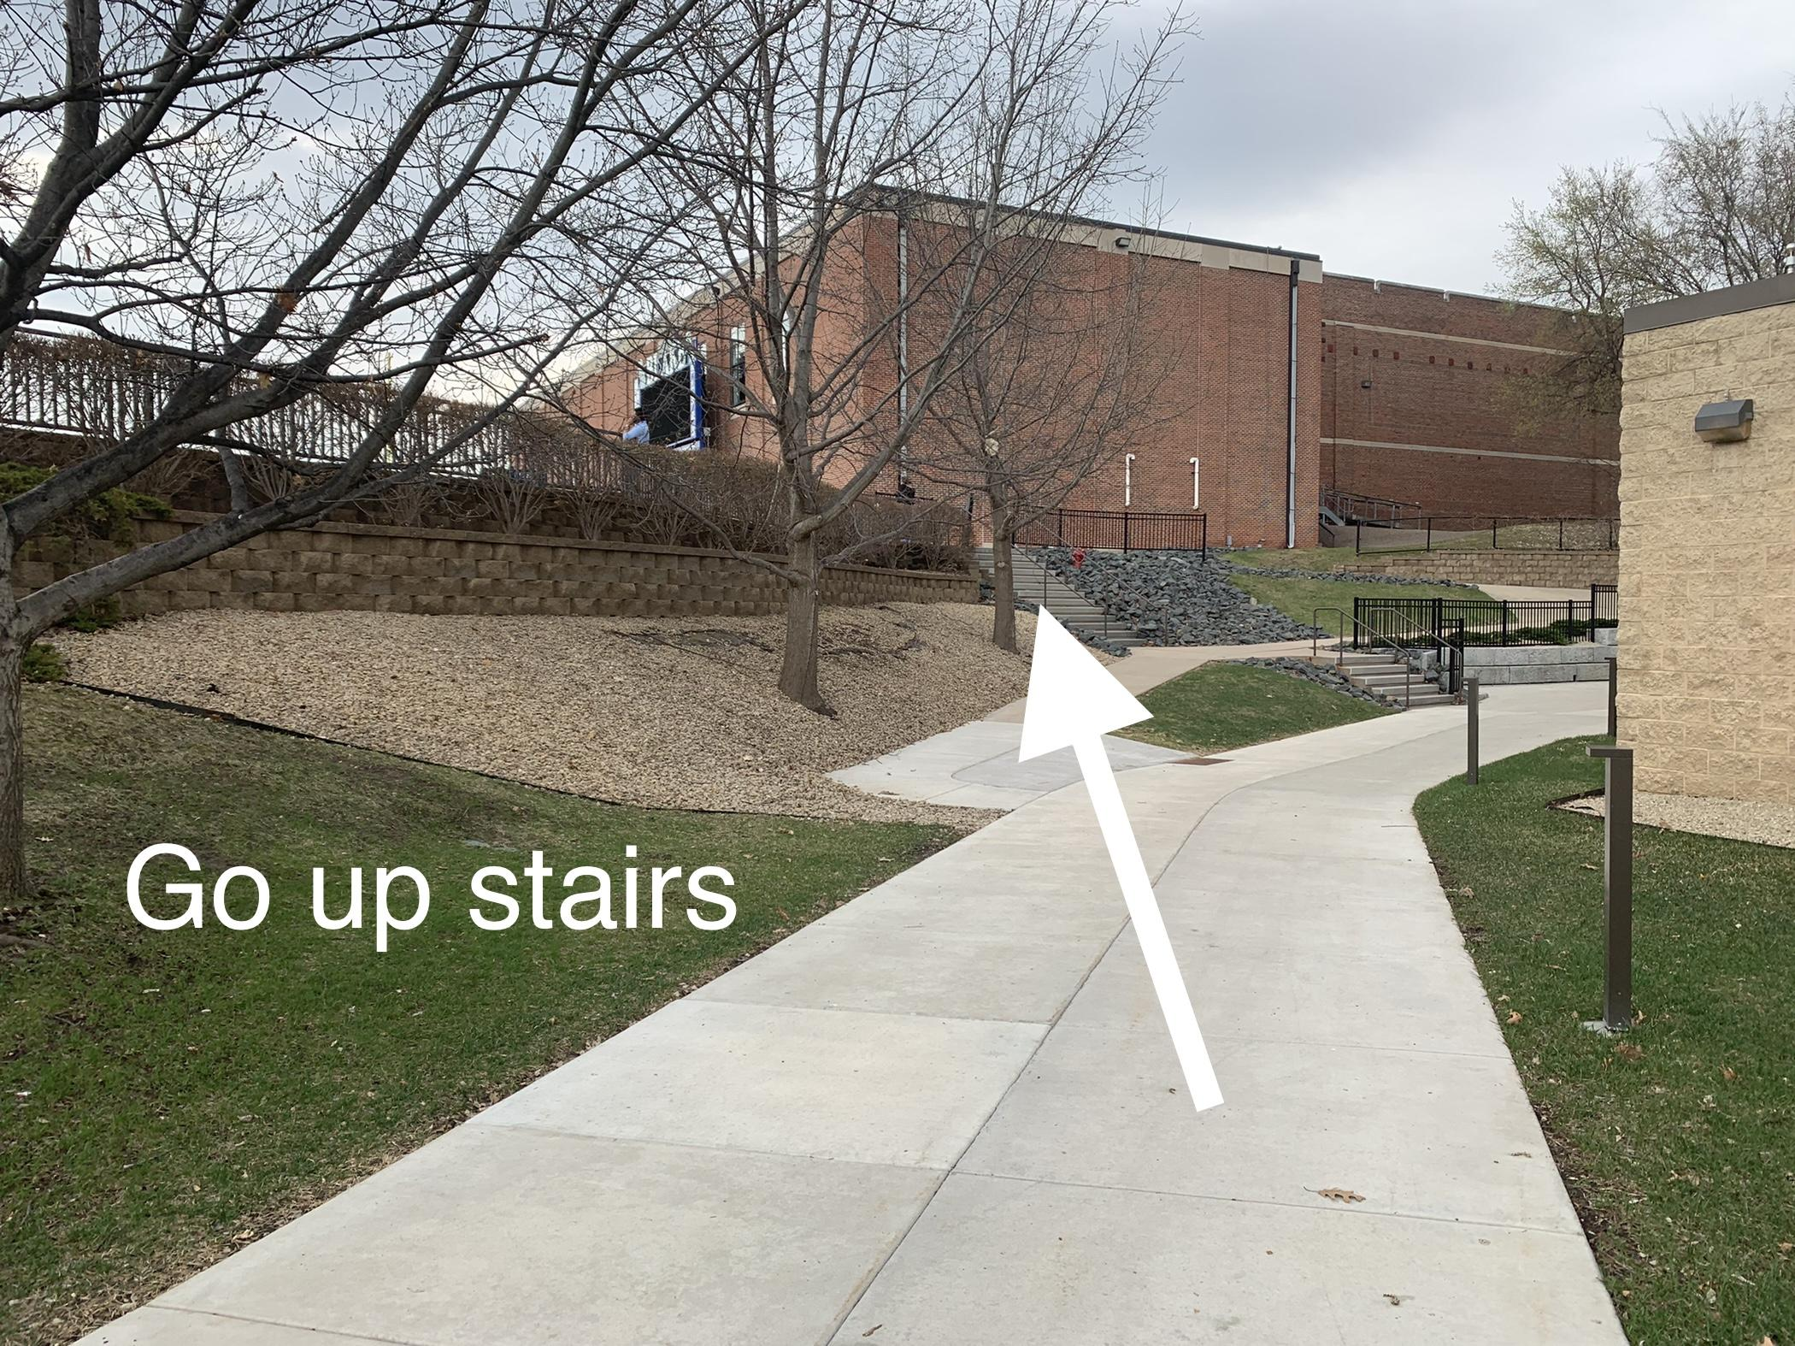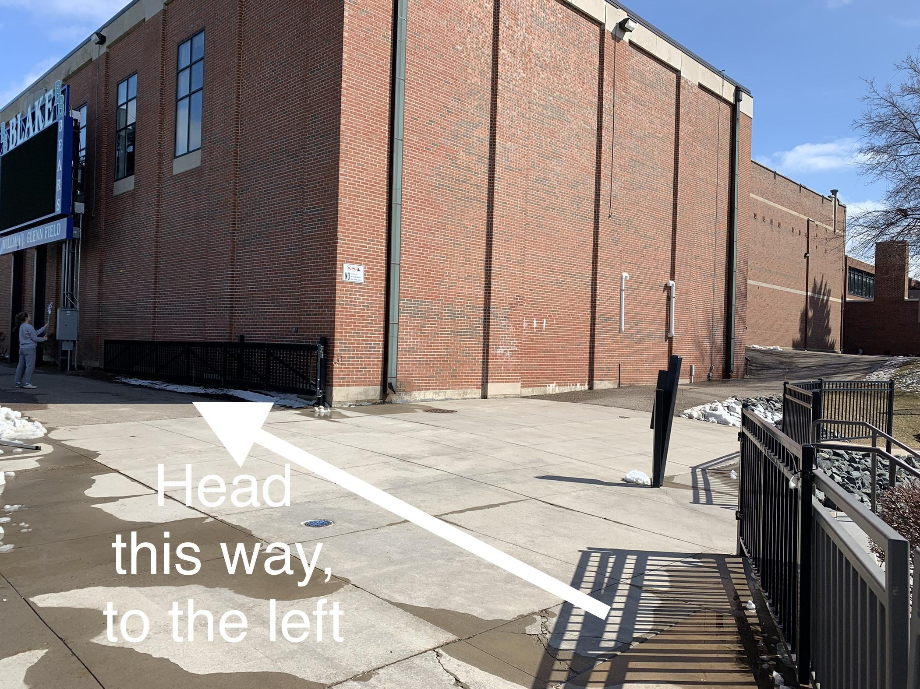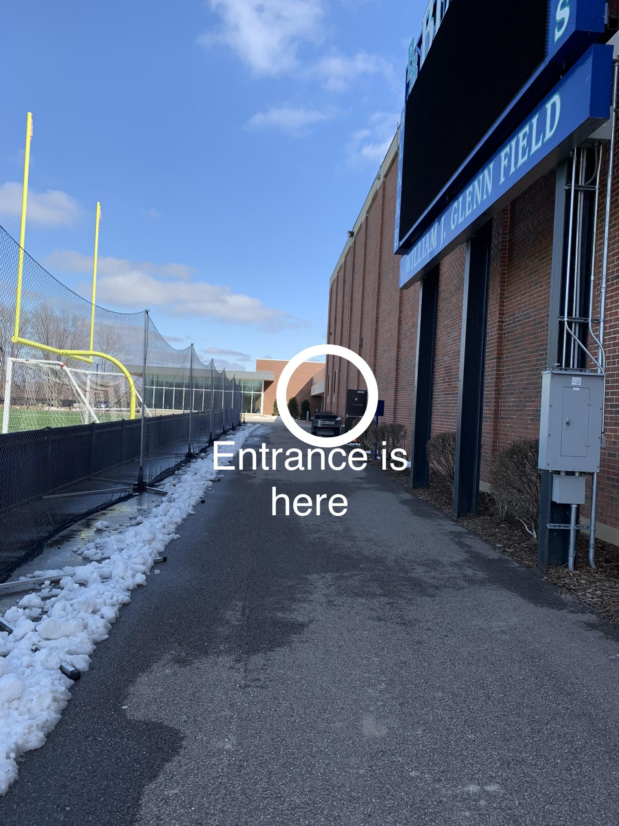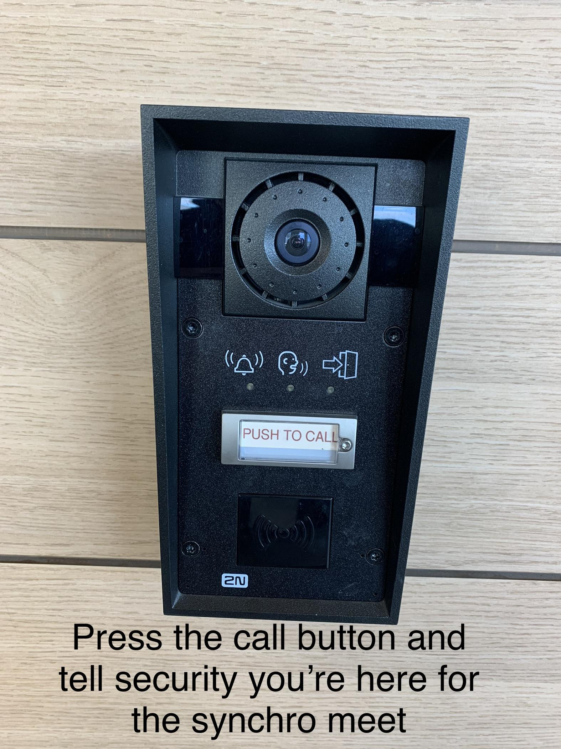
If you can’t get an answer, call me and i can send someone to open the door for you: 952-270-7178

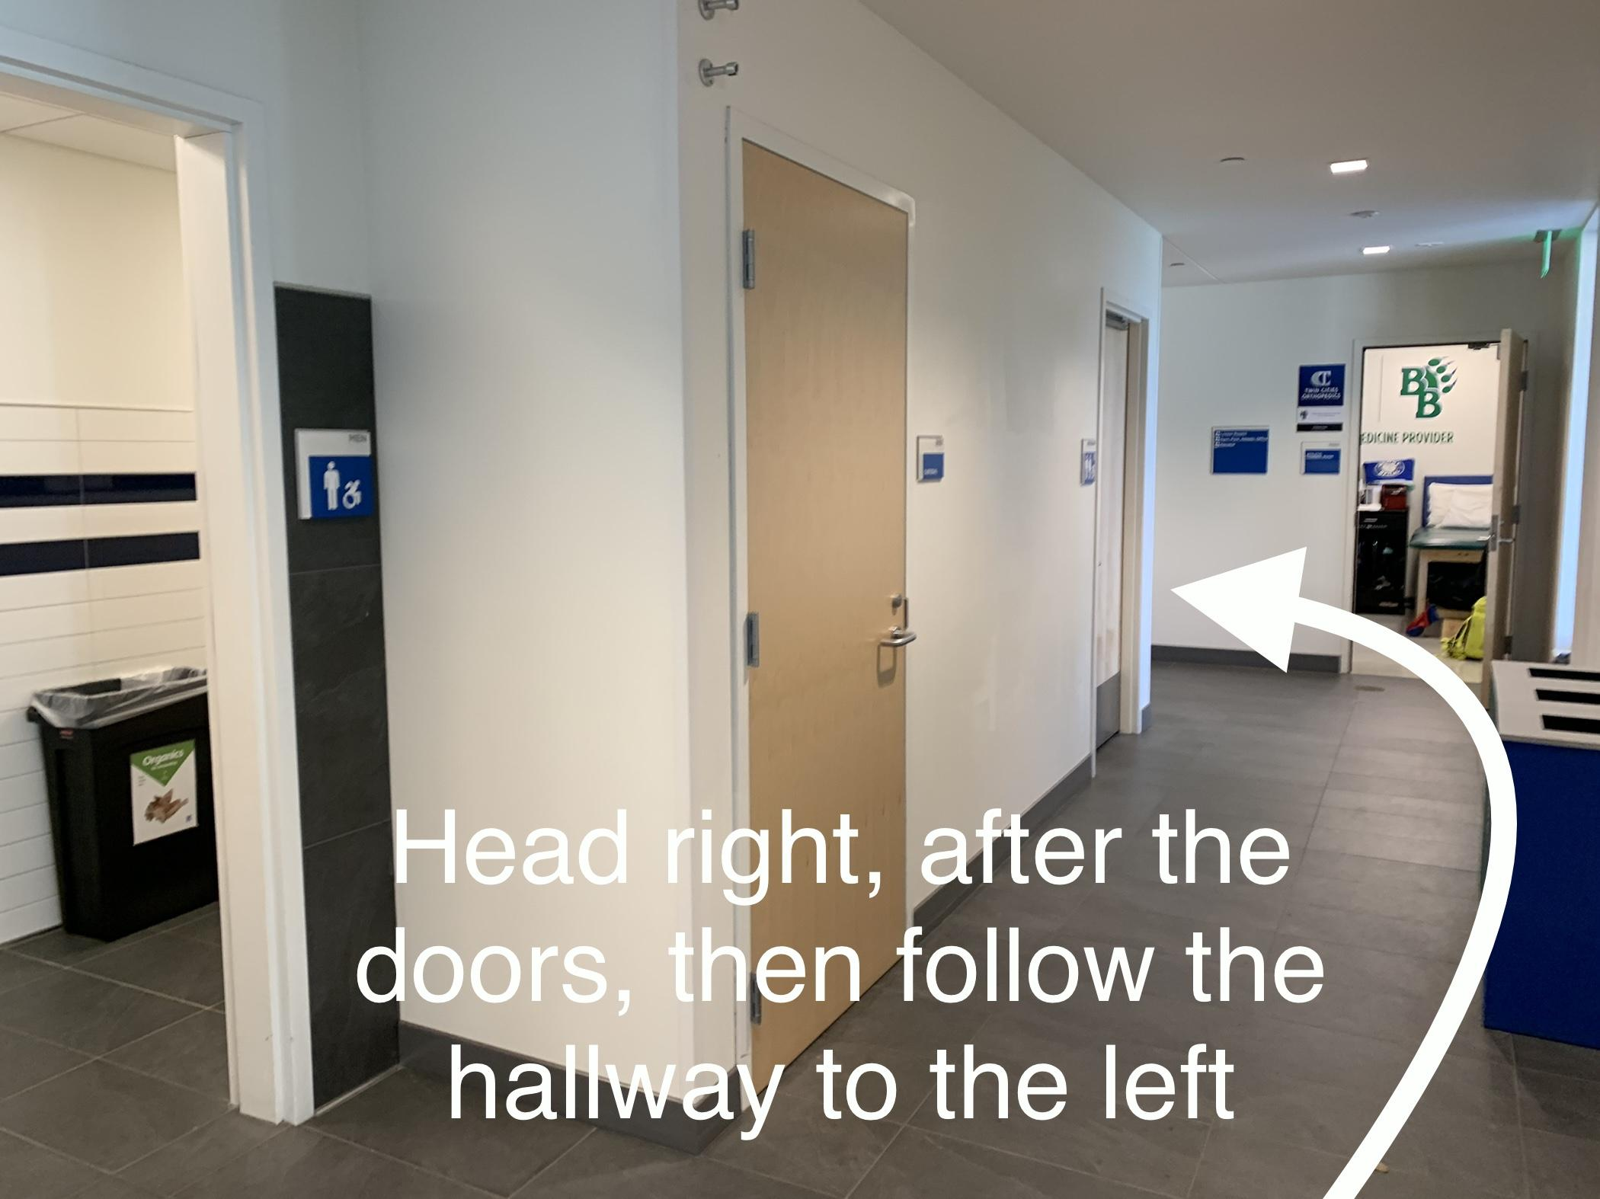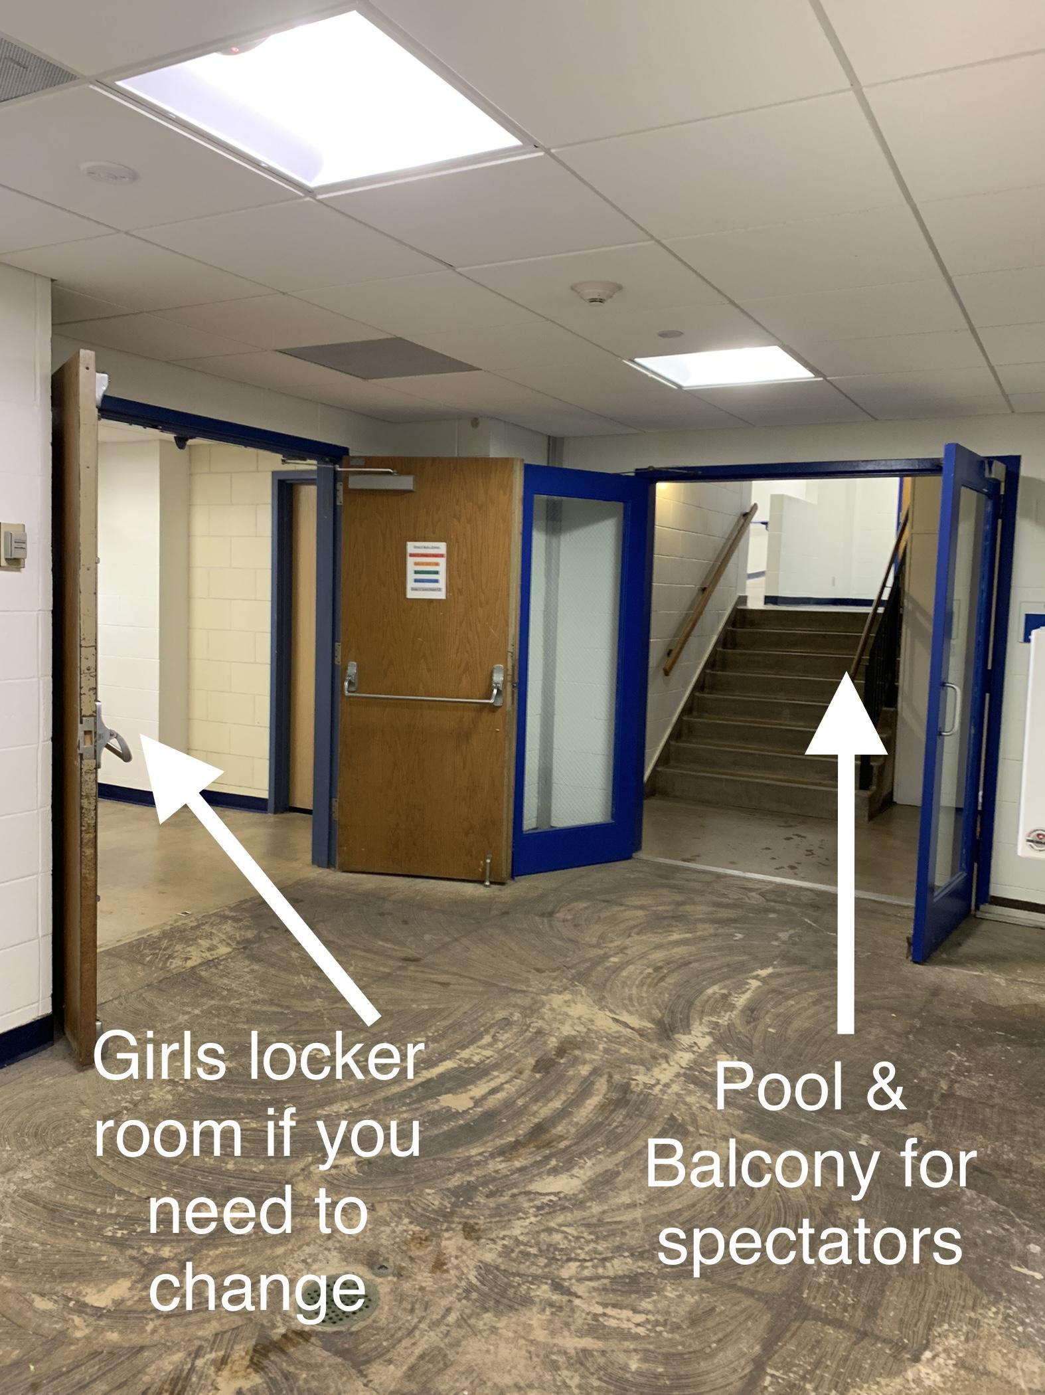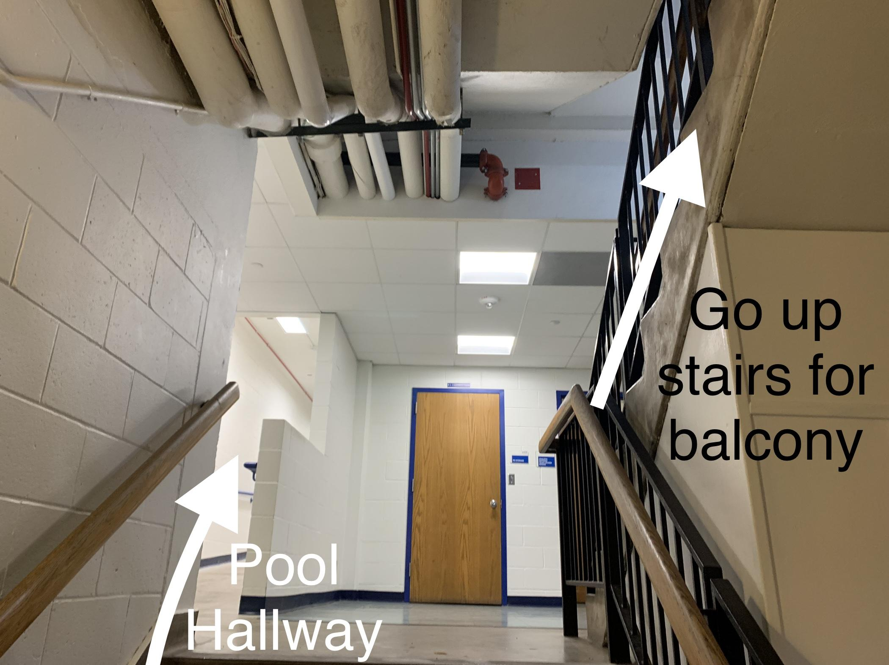
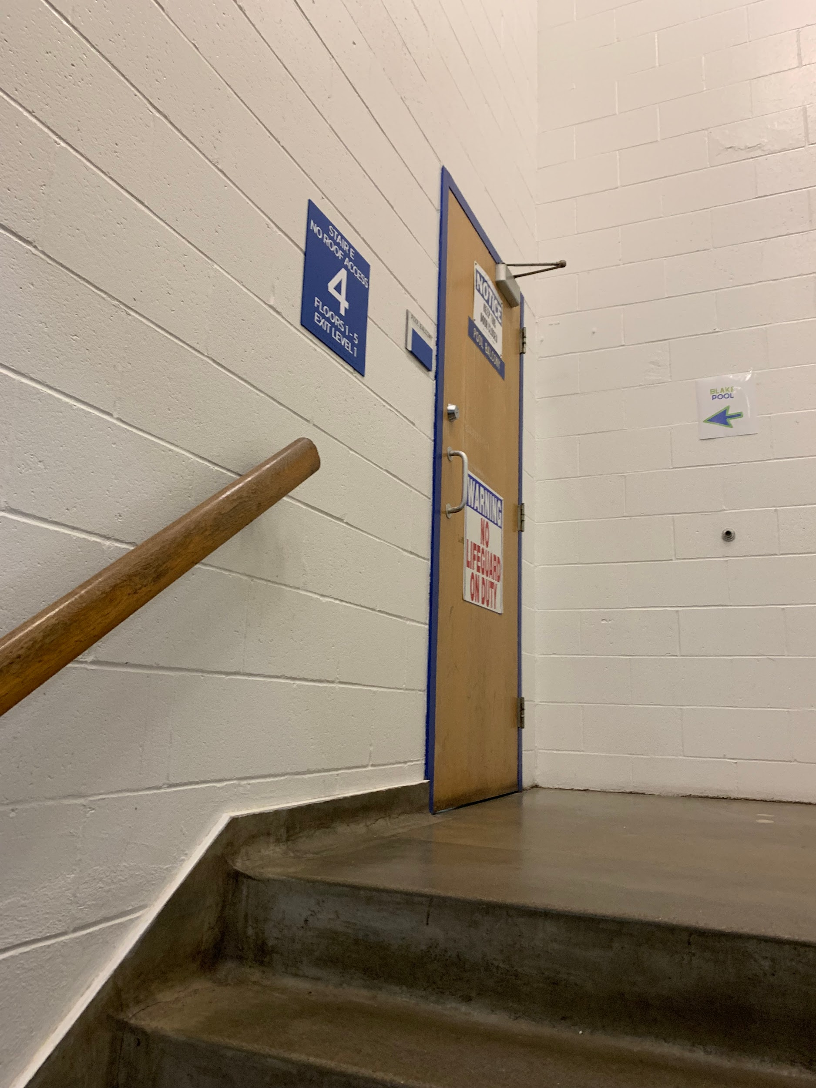

From the main entrance:
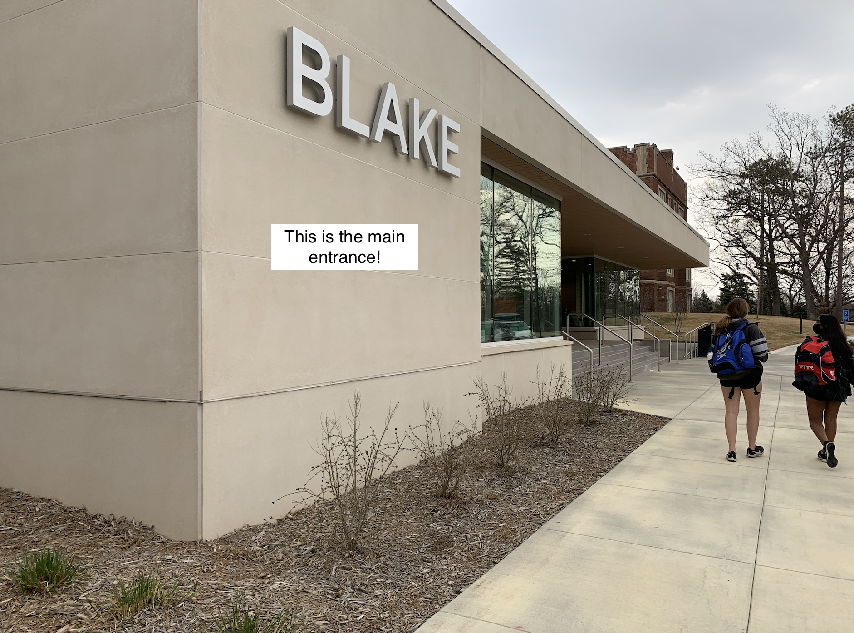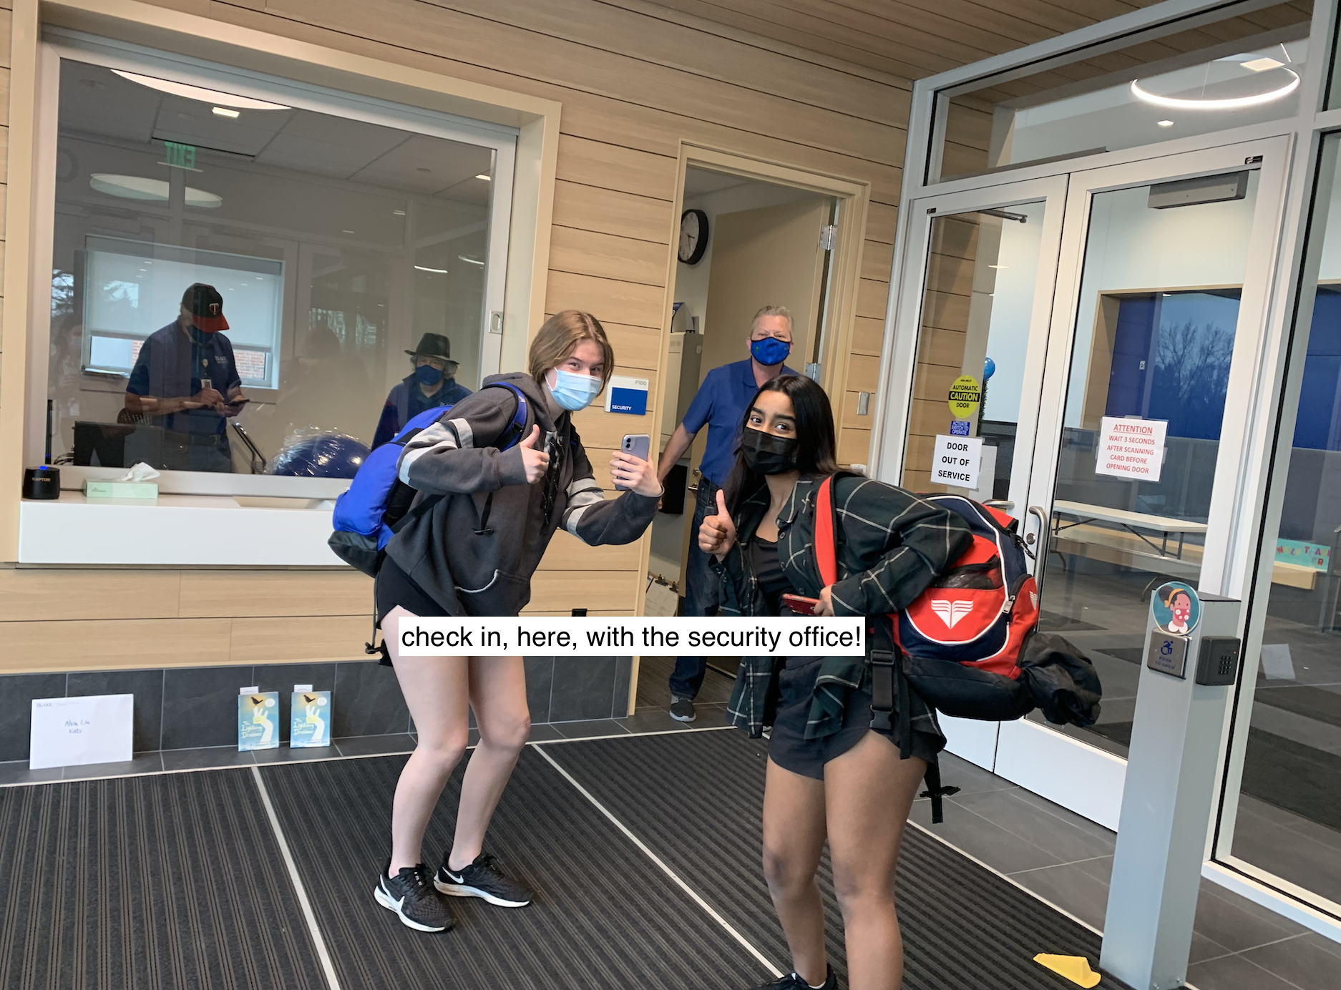
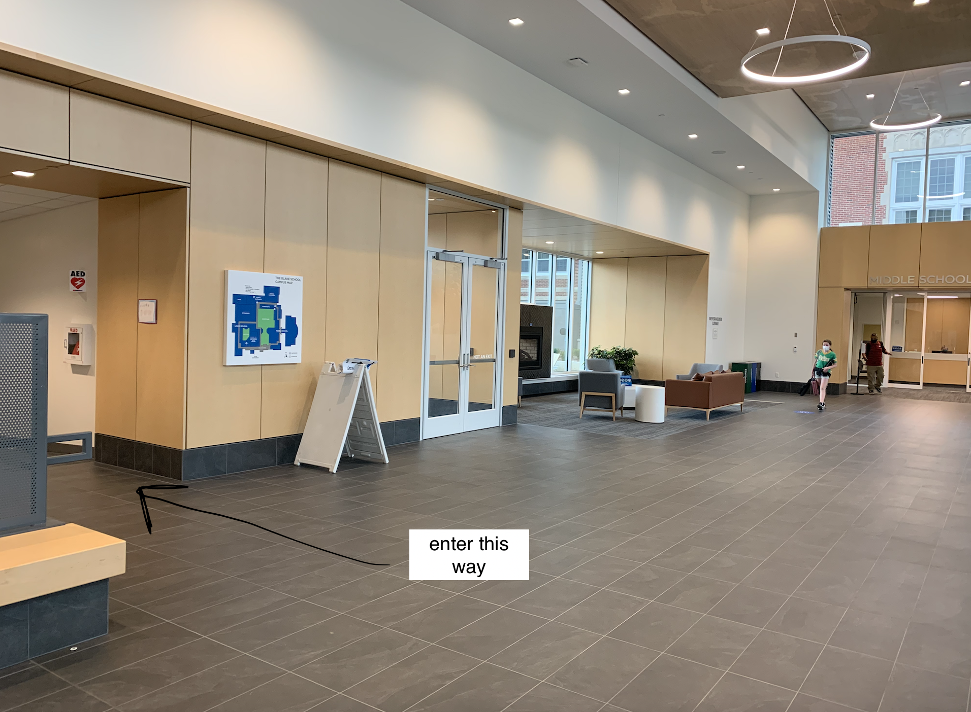

The hallway between these two points will turn a couple times… just follow it until you reach the elevator.

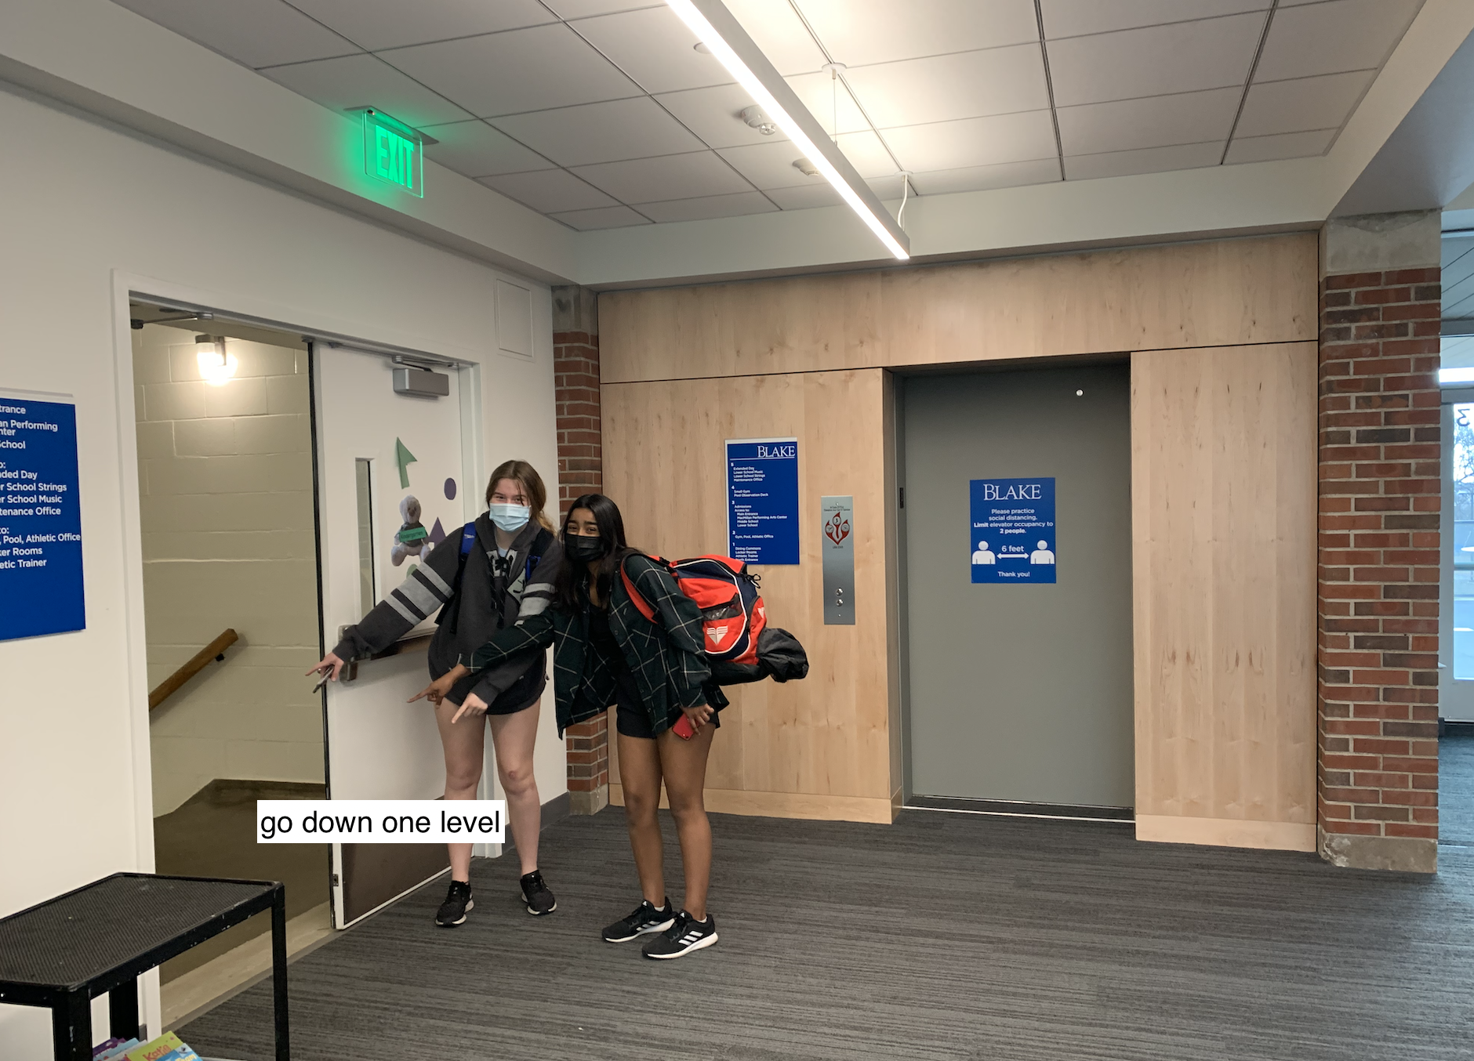
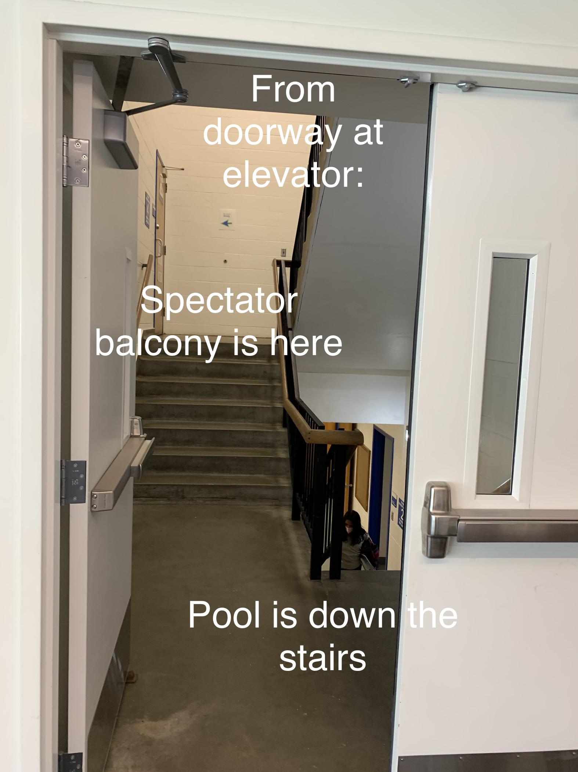
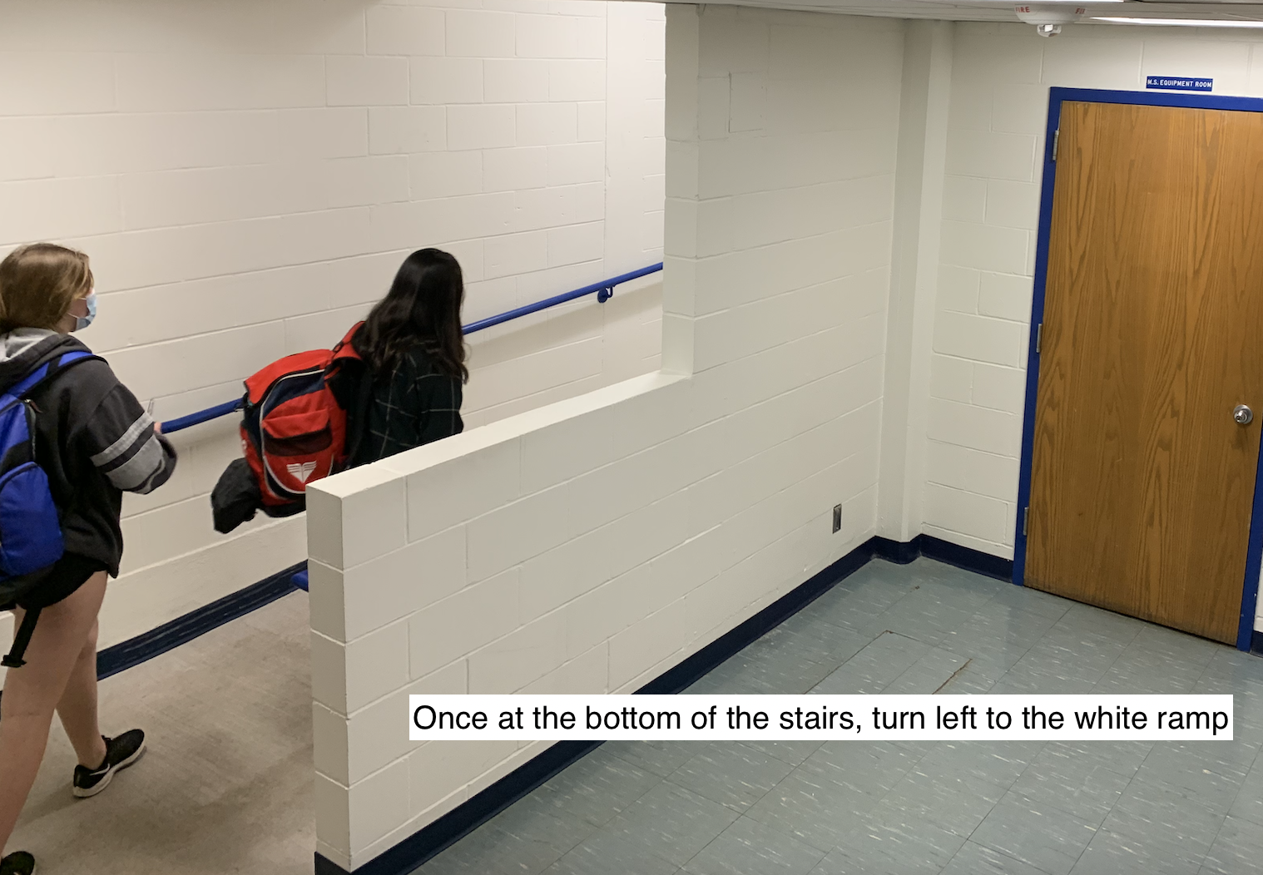
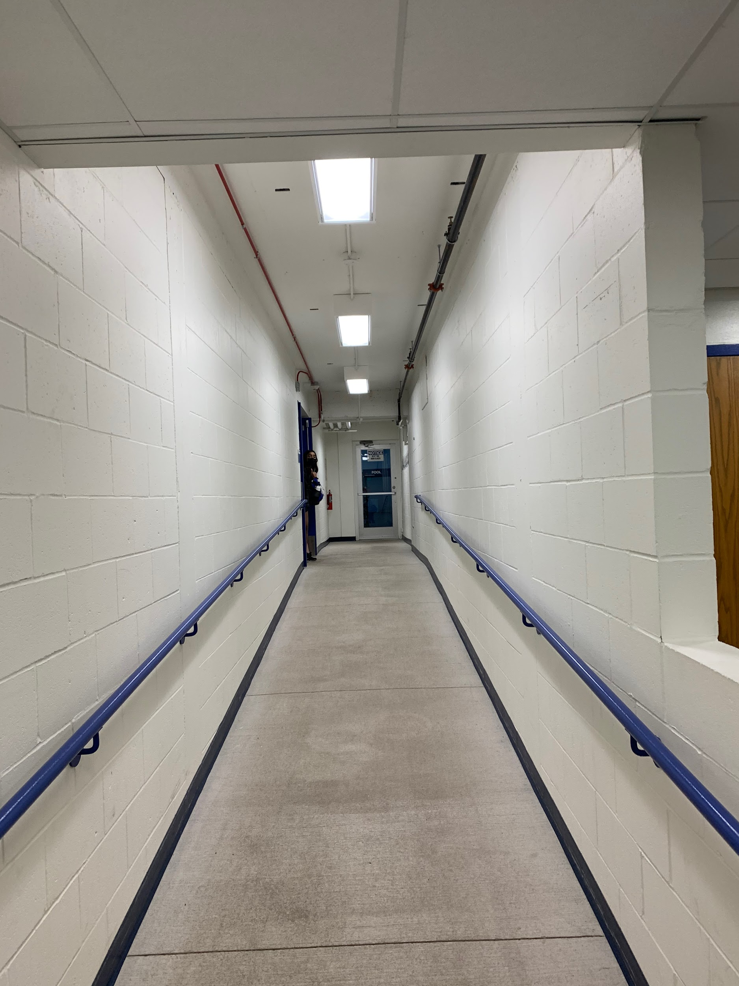
Pool is at the end of the ramp.

If you need to use the restroom, from the pool: go down the pool ramp, and continue down the stairs. Head left down the hallway. There are bathrooms right by the TCO office and the doors to the aamoth lot.
