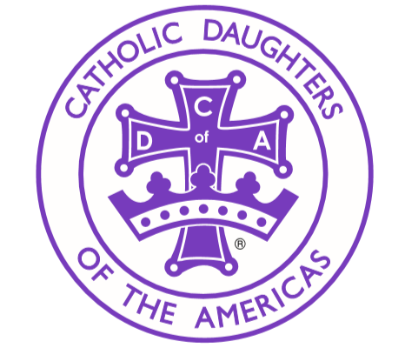
MN CDA Gummi Bears
Court name ______________________ Date_____________________________
What went well?
__________________________________________________________________________________________________________________________________________________________________________________________________________________________________________________________________________________________________________________________________________________________________________________________________________________

What would you like to see done differently?
__________________________________________________________________________________________________________________________________________________________________________________________________________________________________________________________________________________________________________________________________________________________________________________________________________________
How much did your court raise this year?
__________________________________

Please send all court checks made out to MN Catholic Daughters to me at the below address:
Sara Miller
716 14th St N
Moorhead, MN 56560
701-541-1044
saramiller44@hotmail.com

