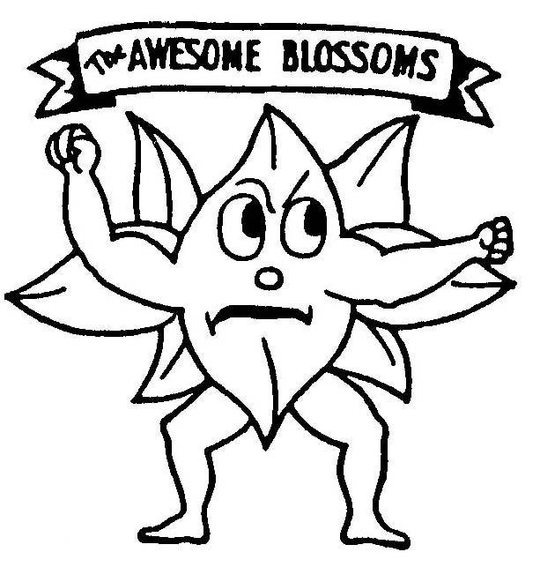

**Blooming Prairie** Elementary

**Awesome** **Blossoms** **Bulletin**

October/November/December 2017

***Monthly Matters & Highlights***

***OCTOBER***

October 8-14 Fire Prevention Week

October 9 Book Fair 3:30-5:30 p.m.

October 16 School Board Meeting 7:00 p.m.

October 16, 17 Early dismissal 1:00 p.m. for ES Conferences

17th 1:30-3:00 p.m.

18th 1:30-8:30 p.m.

October 18 Teacher Inservice-No School

October 19, 20 Education Minnesota - No School

October 23 PTO Fundraiser Orders Delivered 2:30-5:30p.m.

Community Flu Shot Clinic 4:30-7:30 p.m.–HS Library

October 30 Austin Symphony Orchestra Grades 4-6

October 30-Nov 3 Red Ribbon Week (More info to follow.)

***NOVEMBER***

November 3 End of 1st Quarter 1 p.m. dismissal

November 5 Daylight Savings Time Ends

November 7 Picture Retakes-a.m. only

Election Day

November 8 HS Musical Matinee

Send Report Cards Home

November 14 PTO Meeting 6:30 p.m.

November 12-18 American Education Week

November 20 School Board Meeting 7:00 p.m.

November 22 Teacher Inservice-No School

November 23-24 Thanksgiving Break-No School

Nov 26-Dec 8 Students & Staff Food Drive

***DECEMBER***

December 1 Holiday Concert 9:00 a.m. & 1:00 p.m.

December 18 School Board Meeting 5:00 p.m.

December 22 Early dismissal 1:00 p.m.

December 23 - Christmas Holiday Break

January 3 School resumes January 3

**PICTURE RETAKES:**

**November 7th – A.M. ONLY!**

Student absences may be emailed to:

[jnaatz@blossoms.k12.mn.us](mailto:jnaatz@blossoms.k12.mn.us)

Lunch Account information or questions may be directed to: [lhefling@blossoms.k12.mn.us](mailto:lhefling@blossoms.k12.mn.us)

**The first Book Fair is just around the corner! Be sure to stop by the BPES library Tuesday, October 9th from 3:30-5:30. If you can’t attend you can still view and order some of the exciting titles at:** [**www.scholastic.com/fair**](http://www.scholastic.com/fair)

**We hope to see you there!**

***Comments from Chris***

Chris Staloch, Elementary Principal

**It is hard to believe that we are already one month into the 2017 – 2018 school year. Our students have had a great transition back to school and I am very proud of our staff for creating a positive environment for all students at BPES! We look forward to working with parents, students, and our community to continually improve the education that we provide to the students that we serve.**

**We have some new staff for the 2017 – 2018 school year. Jenna Krell is teaching 4th grade, Becky Johnson is teaching 3rd grade, Justin Kiehne is an interventionist, and Amanda Rennie is our new school nurse. Bobbi Meador has also joined our staff as a para professional in our building. We are excited to add each of these new staff members to an already great team.**

**Over the past several years we have seen growth in our student data and are very proud of all of their accomplishments. As we continue to look to improve the academic performance of our students we will look to focus on social and emotional learning opportunities in our building. Social and Emotional learning is an extremely important component of our students’ overall success and one that we will continue to focus on. We will work to build a strong community within our student population in our classrooms and throughout our school. We will continually promote positive behaviors and work to make sure that all students know that we believe in them.**

**As a staff we will focus on improving the reading and writing instruction that we provide by engaging in quality professional development. We are committed to continual learning as a staff to ensure that we provide our students with the best education possible.**

**We will continue to promote positive actions by students through our “Prairie Pride” tickets. Every adult in our building will have these tickets and they will give them to students that they catch doing awesome things. Through a drawing students will be recognized on our BPES Facebook page and in the Owatonna Peoples Press. Our goal is to catch our students being awesome and focus on the positives so our students are encouraged to do the right things.**

**I look forward to a great school year. I look forward to continuing our work together (students, parents, staff, and community) to keep making BPES a great place to educate our youth. I am very proud of our school and the great support we receive from our community. Together we make BPES great!**

**Scoliosis screenings will no longer be conducted for girls in grades 5& 6 as it is no longer required. If you have concerns, screening could be conducted on an individual basis. Please contact Amanda Rennie, school nurse.**