Blooming Prairie Elementary
Awesome Blossoms Bulletin
April/May 2016
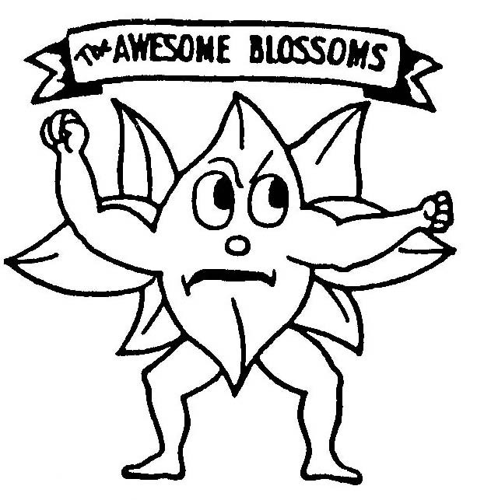

Monthly Matters & Highlights

April
April 1 End of 3rd Quarter-1:00 p.m. Dismissal
April 2 BP Ed Foundation Auction
April 5 Spring BOGO Book Fair 3:30-5:30 p.m.
April 6 Report Cards Sent Home
April 18 School Board Meeting 7:00 p.m.
April 20 Spring Picture Day
April 30 Regional Science Fair

May
May 1-7 Teacher Appreciation Week
May 6 Spring Concert 1:30 p.m.
Grades 4-6, Band and Choir
May 13 PTO Bounce Day (Inflatables)
May 16-21 PTO Play “Robin Hood” Tryouts and Rehearsals - Performances: May 20 - 7:00 p.m. &
May 21 - 1:00 p.m.
May 16 School Board Meeting 7:00 p.m.
May 27 Track & Field Day

June
June 1 Awards Assembly 1:30 p.m.
June 3 End of 4th Quarter
1:00 p.m. Dismissal
June 4 Blossom Blast 10 a.m.
Join Us and have a BLAST!

Field Trip Dates
May 11^{th -} School Patrol/Twins Game
May 17th - 2nd Grade
May 19^{th -} 4th Grade
Kindergarten
May 20^{th -} 6th Grade
May 24^{th -} 4th Grade “Energy Field Trip
May 26th – 1st Grade
May 31st – 3rd Grade
June 2nd - 5th Grade

BP Education Foundation Auctions
April 2nd

3 p. – Silent & 6 p. – Live

Our hope is that we’ll see you there helping to make this an outstanding event.

Thank you for your support.

Comments from Chris
by Chris Staloch, Elementary Principal

It is hard to believe that we are entering the final two months of our school year. The next two months become very busy for our students and staff. We have field trips, end of the year testing, track and field day, and much more. We are proud of what we are accomplishing at BPES and continue to look at ways to improve our school.

This year was our third year of providing Summer School and After School Programming (Grades 1 – 4), officially called “Blossom Academy”. We have experienced many successes and will look to continue this program. We will offer three weeks of Summer School this year and continue our after school programming (Monday through Wednesday). The tentative Summer School dates are: June 6th – 10th, August 8th – 12th, and August 22nd – 26th. Blossom Academy focuses on Reading, Math, and Social Skills. This program is through Targeted Services and the funding comes from outside our school district.

Our MCA testing dates are set. MCA reading testing will be held April 11th through 20th. MCA math testing will be held April 21st through April 29th. Our 5th Grade Science MCA tests will be on May 9th and 10th. Our staff uses these assessments to look at our curriculum and make sure that we are meeting the needs of our students.

We will be offering Spring Pictures again to all of our students (K – 6). We will be doing this through Lifetouch whom we work with in the fall. This is a fundraising opportunity for our school, as Lifetouch will be giving us $2 for every student that they photograph. There is no obligation to parents. We get the $2 whether or not anyone purchases pictures. The pictures are a little less formal and there will be additional information coming home regarding this matter. Many area schools take advantage of this fundraising opportunity through Lifetouch. Those photos will be taken on Wednesday, April 20th.

Blooming Prairie Elementary and High school has been working to implement PBIS (Positive Behavior Intervention and Supports). PBIS in Blooming Prairie is called Prairie Pride. PBIS will provide our staff with two years of training and will help us be more systematic with educating our students on proper behaviors and align our behavior expectations throughout our buildings. The underlying theme of Prairie Pride is to teach behavioral expectations in the same manner as any core curriculum subject. Our ultimate goal is to reinforce positive behaviors and to explicitly teach expectations.

We are making changes to our Day One at the elementary. We will hold our Day One/Open House on Wednesday August 31st. There will be three classroom sessions offered. The classroom sessions will be at 2:00 p.m., 5:00 p.m., and 6:00 p.m. All staff will be here during those times to talk with parents and students. We will start the beginning of the school year with a normal day on September 6th, just like the high school. We are working to accommodate parents work schedules. There will be more information regarding Day One/Open House in the fall packets.
Hopefully winter is behind us and sunshine awaits us. We are looking forward to many days of getting our students outside for recess and finishing the school year on a very positive note. We have wonderful students to work with in our building and I am proud of each and every one of them. Thank you.

