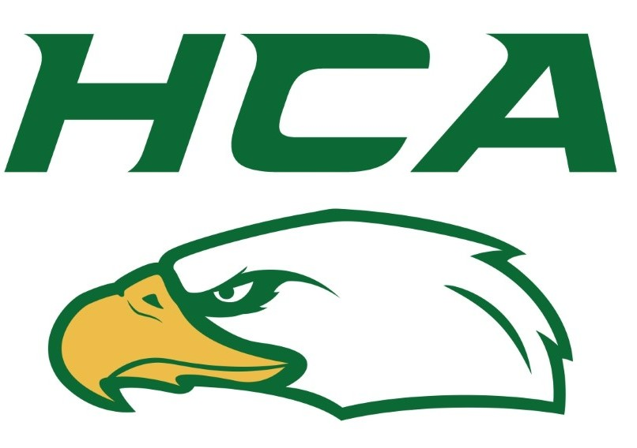
Parent/Athlete Information & Expectations for Heritage Christian Academy Participation
Required: Signature of at least one parent/guardian acknowledging their understanding of the expectations for parents and athletes in order to participate in HCA athletics. Parent/Guardian Signature required at the end of this form.

HCA Athletics Mission:
- “HCA Athletics exist to provide inclusive athletic experiences in a Christ-centered community”

MS Program/HS Sub-Varsity Philosophy
- Play to develop and to “belong”
- Encourage participation for all levels of athletic ability
- MS welcomes multi sport athletes. Please contact the athletic office with questions about overlapping schedules

HS Varsity Philosophy
- Play to win
- Play to develop Godly character in all circumstances
- Rosters comprised of athletes with the highest skill level
- Expectation of 100% in-season participation for all practices, games, and team functions without any outside interference from ‘out of season’ sports or non urgent family scheduling conflicts

Roles
Athletic Directors
    - Provide administrative leadership for all athletic programs
Coach
    - ‘Coaches coach’
Players
    - ‘Players play’. Submit to authority
Parents
    - ‘Parents support and encourage’ and resist the temptation to add coaching input
Communication
- 24 hour rule -
Parents are expected to wait 24 hours to contact a coach when they have feedback regarding their son/daughter’s role on the team or feedback regarding the way a coach has handled a situation. The rationale for the ‘24 hour rule’ is that parents often decide not to contact the coach after 24 hours have passed or, when they do contact the coach, they are in a better frame of mind to do so.
- Matthew 18 principle
If parents or athletes have need for a discussion about a conflict they are expected to go directly to the other party involved (coach, other parent, etc…) to calmly discuss the matter and refrain from gossip or “talking about” the situation with others. If satisfactory resolution is not reached by the initial conversation then the appropriate administrator will get involved to help foster resolution.

PE Credit
- A .5 (1 semester) PE credit will be earned for completion of an entire High school sports season including attending all practices, games, and team events.

Athletic Registrations:
All registrations are to be completed online through Final Forms platform.
Required items:
- Signed Permission to Participate form
    - Signed Concussion Awareness form
    - Completed Sports Physical Form signed by a licensed healthcare professional. Sports Physicals are “current” for 24 months.
    - Completed/Updated Medical History signed annually by a parent.
    - Signed Parent/Athlete Information & Expectations form
    - Payment of $100 MS sports athletic fee $150 HS (paid online through Final Forms registration)

ALL REGISTRATION, FORMS AND FEES NEED TO BE COMPLETE BEFORE PARTICIPATION

Game and Practice Schedules –
  - At the Middle School level, no teams practice or play games on weekends.
  - MS Game schedules and leave times and practices will be emailed out in a sports calendar.
    - Note: date, game and leave times, and locations may change so please refer to the weekly emails, and not a hard copy a coach might hand out.

  - MS Practice schedules: practice days and times will vary depending on high school gym availability, and off campus coach’s schedule.
  - HS game schedules will be communicated out.
  - HS practice schedules are unique to each program and will be communicated by each head coach

Practice/Game Day attire
  - Practice attire:
    - Sport based athletic wear
      - No cut off shirts, no yoga pants.
      - Sport based shoes – depending on the season
  - HS Game day student Athlete attire
    - Home games: wear jersey/program apparel
    - Away games: chapel attire

Academic Eligibility
  - No failing grade in any class
  - Students are not allowed to play in games or travel to away games when on academic probation.
  - Students must maintain a 2.0 GPA with no F's to remain academically eligible
    - Students with an F in any class and/or a GPA below 2.0 will be placed on academic probation.
Academic Probation
If your child has an F in one or more classes and/or has a GPA of 2.0 or below. In accordance with the Parent Student Handbook, he or she is now on academic probation and is not eligible to participate in HCA athletics.
Here are details of the athletic academic probation:
- Grades are pulled on Monday mornings. Those with an F in one or more classes and/or a GPA of 2.0 or below are placed on academic probation, and the following conditions apply:
  - Competition: Your student is not eligible to participate in any competition (games, meets, matches).
  - Practice: Your student may only attend practice if he or she attends middle school student support hours from 3:00-3:45. This means your student will arrive late to practice. Since support hours are offered Monday through Thursday, athletes still on academic probation may not attend Friday practices.
- Grades will be reviewed again at noon on Thursdays. If the student no longer has any Fs and/or a GPA higher than 2.0 (in all classes), he/she will be reinstated and can participate as normal starting that Thursday afternoon.
- Teachers will not be asked to input grades early, and players cannot be removed from academic probation until after grades are reviewed on Thursdays.

Uniforms and Equipment
Uniforms -
- Each MS athlete will be issued a HCA school uniform top prior to the first game. A date & time for uniform collection will be communicated.
- MS Shorts/pants will need to be provided by the athlete, we ask for solid black if possible. HCA PE shorts are perfect
- HS athletes will be issued complete uniforms
- HS coaches may supplement with both required and optional program apparel
Equipment
- Team sport equipment – each sport will provide the necessary practice sport balls, and other shared equipment.
- Athletes must provide personal sport equipment – (knee pads, baseball/softball gloves, golf clubs, etc)

Sports Awards night
  - Last official event of the season. All athletes are expected to attend.
  - Chapel attire for athletes
  - Date will be posted on athletic schedule page as well as emailed out.

Signature of Parent/Guardian: By signing this form I acknowledge the expectations outlined in this document and pledge to abide by them.

X ________________________________________________________

