**Local Evaluation for *Grantee Name***

**2019-2020**

**Overview**

To assist grantees with meeting the local evaluation requirements, the Iowa DOE provides a standardized form for local evaluations of the 21st CCLC Programs. Each grantee is required to complete the local evaluation form with data from the previous school year. Each grantee must submit **one** evaluation that encompasses all centers funded by the grantee. Cohorts 9-13 are to be included for reporting data for the previous school year. Reported data will be from the Summer, Fall, and Spring .

The table below lists the eight required sections of the local evaluation. Each section includes a checklist of required items to include.

The completed form should be saved with the filename <**Grantee** **Name** 21st CCLC Local Evaluation Form 2019-2020>. The form must be completed and submitted in Word format.

***(Note: Instructions and clarifications are shown in RED.)***

|  |  |
| --- | --- |
| Required Section | Complete? |
| 1. General Information |  |
| 1. Introduction/Executive Summary |  |
| 1. Demographic Data |  |
| 1. GPRA Measures |  |
| 1. Local Objectives |  |
| 1. Anecdotal Data |  |
| 1. Sustainability Plans |  |
| 1. Summary and Recommendations |  |

1. **General Information**

|  |  |
| --- | --- |
| General Information Required Elements | Complete? |
| Basic Information Table |  |
| Center Information Table | ✓ |

|  |  |
| --- | --- |
| **Basic Information Table** | |
| **Item** | **Information** |
| Date Form Submitted |  |
| Grantee Name | **Audubon Community School District** |
| Program Director Name | **Carley Williamson** |
| Program Director E-mail | [**cwilliamson@audubon.k12.ia.us**](mailto:cwilliamson@audubon.k12.ia.us) |
| Program Director Phone | **712-304-1287** |
| Evaluator Name | **Christie Crouch, Ph.D.** |
| Evaluator E-mail | [**ccrouch@heartlandaea.org**](mailto:ccrouch@heartlandaea.org) |
| Evaluator Phone | **712-792-3102, ext. 15011** |
| Additional Information from Grantee (optional) |  |

|  |  |
| --- | --- |
| **Center Information Table** | |
| **Cohort** | **Centers** |
| Cohort 11 | **Audubon Elementary School (LAUNCH)** |

1. **Introduction/Executive Summary**

|  |  |
| --- | --- |
| Introduction/Executive Summary Required Elements | Complete? |
| Program Implementation |  |
| * Needs Assessment Process | ✓ |
| * Key People Involved | ✓ |
| * Development of Objectives | ✓ |
| Program Description |  |
| * Program days and hours | ✓ |
| * List of activities | ✓ |
| * Location of centers | ✓ |
| * Attendance requirements | ✓ |
| * Governance (board, director, etc.) | ✓ |
| Program Highlights |  |

Executive Summary:

The Audubon Community School District (CSD) received a federal grant from the 21st Century Community Learning Centers (21st CCLC) program to provide out of school programming during the school year and through summer break. The school district (i.e., administration, teachers) and other community stakeholders determined a need for out of school programming and care for students in the community with working parents. A review of local day care centers on-line and interview with Audubon residents revealed, there is one community-based child care center that serves infant through pre-school age clients. Other options included in-home child care providers which stakeholders described as limited based on the number of students who would need to utilize the care. Community members including parents and grandparents saw the need for additional after school programming to ‘fill the gap between day care and being able to stay home alone’. Stakeholders defined the need as ‘*provide students with a safe and age-appropriate option when parents were not available outside of school hours’*.

The current program runs on school days from 3:30-6:30pm and during the summer Monday through Friday from 9:00am-5:00pm. Both programs are available for students in kindergarten through 4th grade and are run from the grounds of the Audubon elementary school building. The program is staffed by Audubon (CSD) with 7 paid positions including a program director, lead associate and support staff. Staff includes high school students, college students and community members. The management plan includes a leadership committee who hires all staff and a stakeholder’s advisory group that includes community partners, parents, students and district staff.

According to the grantee and monthly attendance data, a typical day has approximately 35 kids and 4-5 adults. This provides a ratio of approximately 7 kids per provider during regular program hours. The LAUNCH after school programming includes a healthy snack, physical activities (e.g., outdoor play, yoga, sport games), academic support through homework help or tutoring, STEM activities, arts and crafts activities and social interactions with peers. The summer program also includes healthy snacks and meal, physical activities, academic support, STEM, arts and crafts, social interactions and additional community and state wide field trips (e.g., pool, trunk or treat, Henry Doorly Zoo, Science Center of IA, community libraries and more). The grant allows Audubon CSD to provide these services to many students who may come from low- or limited-income families and provide these students with experiences or opportunities that may not be available otherwise. While many low- or limited-income families participate in the program, there is no income requirement for attendance. The program is open to all students.

Parents and community partners see the impact and benefit of the program providing opportunities for learning and care for students. Other school districts and communities are beginning to replicate after school programs seeing the benefits to students. Additionally, parents outside of the district boundaries have inquired about summer program access. This is a promising benefit to see how the actions of one program can influence and benefit students beyond their personal reach.

1. **Demographic Data**

|  |  |
| --- | --- |
| Demographic Data Required Elements | Complete? |
| 2019-2020 School Year Attendance Tables |  |
| * 2019-2020 School Year Attendance Summary Table | ✓ |
| * 2019-2020 School Year Attendance Ethnicity Table | ✓ |
| * 2019-2020 School Year Attendance Special Needs Table | ✓ |
| Summer of 2019 Attendance Tables |  |
| * Summer of 2019 Attendance Summary Table | ✓ |
| * Summer of 2019 Attendance Ethnicity Table | ✓ |
| * Summer of 2019 Attendance Special Needs Table | ✓ |
| Attendance Discussion | ✓ |
| Partnerships |  |
| * Partnerships Table | ✓ |
| * Partnerships Discussion | ✓ |
| Parent Involvement Information and Discussion | ✓ |

**2019-2020 School Year Attendance.**

|  |  |  |  |  |
| --- | --- | --- | --- | --- |
| **21st CCLC Program 2019-2020 School Year Attendance *Summary* Table** | | | | |
| **Cohort** | Attendees | *Total Attendance* | *Male* | *Female* |
| ***Leave Blank if NA*** |  | ***Enter #*** | ***Enter #*** | ***Enter #*** |
| **Cohort 11** | All | 67 | 35 | 32 |
|  | Regular* | 30 | 17 | 13 |

*Regular Attendees have attended the program for 30 or more days.

|  |  |  |  |  |  |  |  |
| --- | --- | --- | --- | --- | --- | --- | --- |
| **21st CCLC Program 2019-2020 School Year Attendance *Ethnicity* Table** | | | | | | | |
| **Cohort** | Attendees | White | Hispanic/  Latino | American  Indian/  Alaska  Native | Black/  African  American | Asian/  Pacific  Islander | Unknown  Race |
| ***Leave Blank if NA*** |  | ***Enter #*** | ***Enter #*** | ***Enter #*** | ***Enter #*** | ***Enter #*** | ***Enter #*** |
| **Cohort 11** | All | **60** | **1** | **0** | **2** | **0** | **4** |
|  | Regular* | **27** | **1** | **0** | **2** | **0** | **0** |

*Regular Attendees have attended the program for 30 or more days.

|  |  |  |  |  |
| --- | --- | --- | --- | --- |
| **21st CCLC Program 2019-2020 School Year Attendance *Special Needs* Table** | | | | |
| **Cohort** | Attendees | *LEP* | *Free and Reduced Price Lunch (FRPL)* | *Special Needs* |
| ***Leave Blank if NA*** |  | ***Enter #*** | ***Enter #*** | ***Enter #*** |
| **Cohort 11** | All | 0 | 38 | 6 |
|  | Regular* | 0 | 18 | 4 |

*Regular Attendees have attended the program for 30 or more days.

**Summer of 2019 Attendance.**

|  |  |  |  |  |
| --- | --- | --- | --- | --- |
| 21st CCLC Program Summer 2019 Attendance *Summary* Table | | | | |
| Cohort | Attendees | *Total Attendance* | *Male* | *Female* |
| *Leave Blank if NA* |  | ***Enter #*** | ***Enter #*** | ***Enter #*** |
| Cohort 11 | All | 81 | 43 | 38 |
|  | Regular* | 38 | 21 | 17 |

*Regular Attendees have attended the program for 30 or more days.

|  |  |  |  |  |  |  |  |
| --- | --- | --- | --- | --- | --- | --- | --- |
| 21st CCL Program Summer 2019 Attendance *Ethnicity* Table | | | | | | | |
| Cohort | Attendees | White | Hispanic/  Latino | American  Indian/  Alaska  Native | Black/  African  American | Asian/  Pacific  Islander | Unknown  Race |
| *Leave Blank if NA* |  | ***Enter #*** | ***Enter #*** | ***Enter #*** | ***Enter #*** | ***Enter #*** | ***Enter #*** |
| Cohort 11 | Regular* | **34** | **3** | **0** | **1** | **0** | **0** |
|  | All | **72** | **5** | **0** | **2** | **0** | **2** |

*Regular Attendees have attended the program for 30 or more days.

|  |  |  |  |  |
| --- | --- | --- | --- | --- |
| 21st CCLC Program Summer 2019 Attendance *Special Needs* Table | | | | |
| Cohort | Attendees | *LEP* | *Free and Reduced Price Lunch (FRPL)* | *Special Needs* |
| *Leave Blank if NA* |  | ***Enter #*** | ***Enter #*** | ***Enter #*** |
| Cohort 11 | All | 0 | 46 | 0 |
|  | Regular* | 0 | 27 | 8 |

*Regular Attendees have attended the program for 30 or more days.

**Attendance Discussion.**

|  |  |
| --- | --- |
| Attendance Discussion Required Elements | Complete? |
| General discussion on attendance including | ✓ |
| * Percentage of 21st CCLC attendance compared to total population. | ✓ |
| * Percentage of attendees who are FRPL. | ✓ |
| * Efforts to increase and keep attendance high. | ✓ |
| * Recruitment efforts. | ✓ |
| * Discussion on how contact hours requirement is being met. *60 hours per month (3 hours per day x 5 days a week) during weeks when school is in session (not* *counting Christmas or Spring Break)* | ✓ |

Attendance:

According to the Iowa School Performance Profile and enrollment reports 206 students are enrolled at Audubon Elementary School with an average daily attendance rate of 95%. Approximately 30 students or 15% of the population attend the LAUNCH after school on a regular basis (i.e., 30 or more days) which is a decrease in reported regular attendance for the previous grant year. A total of 67 different students attended at minimum of 1 day. During the summer attendance increases to 38 regular attendees and 81 total attendees with a minimum of 1 day. This increase in total attendance for the summer program reiterates the need for temporary care for students who are in between the stages of staying alone and being at a day care. For both the summer and after school programs more males attend than females which aligns with the slightly higher population of males (58%) in the school.

Of the 15% of students regularly attending the LAUNCH 60% were identified as qualifying for Free and Reduced Price Lunch (FRPL). This is greater than the 52% of qualifying students based on the total school enrollment. The higher rate of students qualifying for FRPL continues into the summer with 56% of all attendees qualifying. Audubon Elementary has a predominately white population, 90% of all students, which is reflected in the ethnicity of LAUNCH attendance. Specifically, 90 % of regular participants are white. LAUNCH attendance closely resembles the population of Audubon CSD with the exception of a slightly greater FRL population.

The LAUNCH strives to maintain and increase kid participation through offering engaging, high quality opportunities and snack/lunch options. Additional efforts include, using a social media page to share updates on activities, pictures, and offer communication with family. All students at Audubon Elementary will be provided with access to a registration form and the opportunity to sign up. Currently, word of mouth, from excited kids, and the need in the community is the most effective recruitment tool.

In accordance with the required contact hours, LAUNCH is open 3 hours daily after school (3:30pm-6:30pm) during in session school days for the 2019-2020 school year. On early dismissal days, Wednesdays, Launch is open from 2:05pm -6:30pm. When school is not in session for winter break Launch is not in session. If there is a weather event and school is closed or dismissed early then Launch is not open. LAUNCH was scheduled to be in session during spring break in March of 2020. However, due to COVID-19 school closures Launch did not remain open. Launch closed on March 13th and did not open the remainder of the year.

Prior to the 2019-2020 school year, Launch provided summer services. During the summer, Launch was open for approximately 9 week, June-August weekdays from 9:00am -5:00pm.

**Partnerships Table.**

|  |  |  |  |  |  |
| --- | --- | --- | --- | --- | --- |
| 21st CCLC Program 2019-2020 Partnerships Table | | | | | |
| Name of Partner  *(Enter name of Partner)* | Type*: Full/  Partial/  Vendor ***(descriptions***  ***below)*** | Contribution Type  ***(From list above)*** | Staff Provided  ***(Describe if applicable)*** | In-kind Value  ***(Monetary Value if unpaid partner)*** | Number of Centers Served  ***(Input the number of centers this partner served)*** |
| AMVC | Full | 3 |  | $500 | 1 |
| ARC (Audubon Rec. Center) | Partial | 3 |  | $250 | 1 |
| Audubon City Pool | Partial | 3 |  | $250 | 1 |
| Audubon City Police Dept. | Full | 3 |  | $100 | 1 |
| Audubon Co. Economic Development | Full | 3 |  | $100 | 1 |
| Audubon Co. Conservation Office | Full | 3 |  | $100 | 1 |
| Carroll Co. Conservation Office | Full | 3 |  | $100 | 1 |
| Guthrie Co. Conservation Office | Full | 3 |  | $100 | 1 |
| Shelby Co. Conservation Office | Full | 3 |  | $100 | 1 |
| Audubon Co. ISU Extension Office | Full | 3 |  | $250 | 1 |
| Audubon FFA | Full | 6,3 | HS Volunteers |  | 1 |
| Audubon State Bank | Full | 3 |  | $500 | 1 |
| Audubon Public Library | Full | 3 |  | $200 | 1 |
| Audubon County Sherriff’s Department | Full | 3 |  | $100 | 1 |
| Audubon Family Chiropractic | Full | 3 |  | $200 | 1 |
| Landmand’s Bank | Full | 3 |  | $500 | 1 |
| Horizon Equipment | Full | 3 |  | $200 | 1 |
| Guthrie Center City Pool | Vendor | 3 |  | -- | 1 |
| DMACC | Full | 3 |  | -- | 1 |
| Lions Club International | Full | 3 |  | $100 | 1 |
| Heartland AEA | Full | 1 |  | $200 | 1 |
| New Opportunities | Full | 3 |  | $100 | 1 |
| Vetter Equipment | Full | 3 |  | $200 | 1 |
| Blank Park Zoo | Vendor | 3 |  | -- | 1 |
| Iowa Cubs | Vendor | 3 |  | -- | 1 |
| USDA Food Program | Full | 4, 7 | Cook for summer meal program | $4902  Meals for Summer Program ($3 per regular attending students per day ) 3 x 38 x 43 days | 1 |

*\*Full – partner works with local program at no cost to the program*

*Partial – partner works with local program by providing discounted costs/rates*

*Vendor – services only provided with a cost to the program*

**Partnerships Discussion. Make sure to discuss what partners do, length of the partnership and how critical the partnership is to the success of the program.**

|  |  |
| --- | --- |
| Partnerships Discussion Required Elements | Complete? |
| General discussion on Partnerships including |  |
| * Summary of partnerships table. | ✓ |
| * Total ~~unpaid and paid partners~~. (all partner types) | ✓ |
| * Efforts to recruit partners. | ✓ |
| * Highlights of partnerships. | ✓ |
| * How partnerships help program serve students. | ✓ |

Partners:

Audubon CSD has historically had a strong community presence and partnership. Since the LAUNCH has started many local businesses have provided support. Some long-standing partners have been AMVC, Landmands Bank, Audubon State Bank, Audubon FFA, Horizon Equipment. Additionally, many county and city offices have provided programming or activity related services. These program services include providing speakers, tours, earning activities, wellness, and physical activities for participants.

According to the grantee, “Many of the entities charge nothing to come present to our group. Our swimming pool gives us a discounted rate as does our Rec Center (ARC).  Many local partners are willing to help out. It is a great community”. Local partners provide life lessons related to finance, health, and love of learning. The small-town community is very willing to engage with the program and recruiting partners is as simple as asking for support.

AMVC had been a high-level partner and provided full funding for summer participants to visit the Henry Doorly Zoo in Omaha. This is a highlight each summer for many of the participants. This is a chance for attendees to go to a world class zoo and experience something that is not available in their local community. Many participants and parents also look forward to the Iowa Cubs game each summer. This field trip typically has the most parent participation. The USDA is also an essential partner providing summer meals for students attending Launch and other children in the community as well as providing a cook for prepare and serve meals. This ensures attendees receive balanced meals daily.

**Parent Involvement Information and Discussion.**

|  |  |
| --- | --- |
| Parent Involvement Information and Discussion Required Elements | Complete? |
| Number and description of parent meetings and/or events. | ✓ |
| Number of parents at each meeting and/or event. | ✓ |
| Description of communication with parents (flyers, letters, phone calls, personal contact, etc.) | ✓ |
| Efforts to increase parental involvement. | ✓ |

Parent Involvement:

The original management plan included a stakeholder advisory committee that included parents. A review of committee notes did not find evidence of parents attending meetings. As a result of the COVID-19 pandemic school closed in March of 2020. A parent survey was not completed in the spring of the 2019-2020 school year.

The program director utilizes social media on an on-going basis to keep parents informed of schedules, activities and provide pictures. Specifically noted, the director posted weekly schedules with a time break down of daily activities and pick up locations if they visited community partners. These posts also included notes for parents of materials or needed items. Parents were encouraged to call, email or text with questions of concerns.

Parents were also asked to be chaperones on some field trips and are welcome to volunteer when time allows. There are no specific indications of on-going parent involvement outside of social media posts. Parents will comment on posts, provide feedback on activities and also offer donated materials for activities.

It is hypothesized that parent involvement was historically, and continues to be, limited as many of the students attending are doing so while parents are at work and alternate childcare is not available. For the 2019-2020 school year, no parent meetings or events were held. Pick up time activities, expanded hours or scheduled after hours events should be considered to increase parent involvement. Yearly enrollment meetings or on-going news letters should be considered for keeping parents involved in the program. Additional recommendations for increasing parent involvement are included in the Recommendations section.

1. **GPRA Measures**

|  |  |
| --- | --- |
| GPRA Measures Required Elements | Complete? |
| GPRA Measures Data Table |  |
| * Name of Assessment Tools Used for Each Measure. | ✓ |
| * Data Entered for all Applicable Measures. | ✓ |
| GPRA Measures Discussion | ✓ |

**GPRA Measures Data Table.**

| GPRA Measures | Number of Regular Student Attendees Needing Improvement | Number of Students Who Improved | Percentage of Students Who Improved |
| --- | --- | --- | --- |
| GPRA Measures 1-3 – Improvement in Mathematics |  |  |  |
| Assessment Tool Used: Math Grades- reported on report cards |  |  |  |
| 1. The number of elementary 21st Century regular program participants who improved in mathematics from fall to spring. | 7 | 6 | 86% |
| 2. The number of middle/high school 21st Century regular program participants who improved in mathematics from fall to spring. | N/A | N/A | N/A |
| 3. The number of all 21st Century regular program participants who improved in mathematics from fall to spring. | 7 | 6 | 86% |
|  |  |  |  |
| GPRA Measures 4-6 – Improvement in English |  |  |  |
| Assessment Tool Used: FAST Early Reading (k-1) or CBM-r (2-4) |  |  |  |
| 4. The number of elementary 21st Century regular program participants who improved in English from fall to spring. | 9 | 7 | 78% |
| 5. The number of middle/high school 21st Century regular program participants who improved in English from fall to spring. | N/A | N/A | N/A |
| 6. The number of all 21st Century regular program participants who improved in English from fall to spring. | 9 | 7 | 78% |
|  |  |  |  |
| GPRA Measures 7-8 – Improvement in Proficiency |  |  |  |
| Assessment Tool Used: FAST Benchmark scores for designated grade level assessment |  |  |  |
| 7. The number of elementary 21st Century regular program participants who improve from not proficient to proficient or above in reading. | 9 | 2 | 22% |
| 8. The number of middle/high school 21st Century regular program participants who improve from not proficient to proficient or above in mathematics. | N/A | N/A | N/A |
|  |  |  |  |
| GPRA Measures 9-11 – Homework and Class Participation |  |  |  |
| Assessment Tool Used: Teacher Interview |  |  |  |
| 9. The number of elementary 21st Century regular program participants with teacher-reported improvement in homework completion and class participation. | 5 | 4 | 80% |
| 10. The number of middle/high school 21st Century regular program participants with teacher-reported improvement in homework completion and class participation. | N/A | N/A | N/A |
| 11. The number of all 21st Century regular program participants with teacher-reported improvement in homework completion and class participation. | 5 | 4 | 80% |
|  |  |  |  |
| GPRA Measures 12-14 – Student Behavior |  |  |  |
| Assessment Tool Used: Student information system; behavior reports |  |  |  |
| 12. The number of elementary 21st Century regular program participants with teacher-reported improvements in student behavior. | 5 | 5 | 100% |
| 13. The number of middle/high school 21st Century regular program participants with teacher-reported improvements in student behavior. | N/A | N/A | N/A |
| 14. The number of all 21st Century regular program participants with teacher-reported improvements in student behavior. | 5 | 5 | 100% |

**GPRA Measures Discussion.**

|  |  |
| --- | --- |
| GPRA Measures Discussion Required Elements | Complete? |
| Total or Regular Attendance Used? | ✓ |
| Discussion of high performing and low performing areas. | ✓ |
| Description of data collecting instrument. | ✓ |
| Discussion of difficulties on any GPRA Measure. | ✓ |
| Assessment of 21st CCLC Program based solely on GPRA Measures. | ✓ |

Math Improvement: Interview with the grantee revealed the following process for reporting on GRPA measures 1-3: Data for math improvement was collected by classroom grades for the 30 regular attendees. “Improvement needed” was determined if the student was performing at below a grade of 80% or a letter grade of C. This analysis revealed a total of 7 regular attendees needing improvement of which 6 made improvement. Improvement was defined by the school district as maintaining the same grade while learning new skills or improving the grade while learning new skills. Math grades were the grades from the first and last quarters of school prior to the closure of schools due to the COVID-19 pandemic.

ELA Improvement/Proficiency: Currently, 25/30 regular attendees from 2019-2020 are enrolled which allows their data to be pulled by the evaluator for GRPA measures 4-8. Of the 25 students, 5 students met the benchmark for CBM-reading and 11 met the benchmark for the early reading composite, which left 9 students to need improvement in the area of ELA. Analysis of those 9 students revealed that 7 students improved both the numeric score and the percentile rank. The other 3 students showed increases in the numeric score but percentile ranks did not increase indicating that gains were not significant on oral reading. While these students may be not have increased the reading rate it may be possible these students improved other reading skills not measured in the reading rate (e.g., phonics/accuracy). Within the 7 students showing improvement, 2 students made significant gains to move from not proficient to proficient on CMB-reading. The ELA scores used for evaluating improvement were the fall and winter screening scores of 2019-2020 school year. Spring scores were not available due to the COVID-19 pandemic.

Homework and Class Participation: Interview with the grantee revealed the following process for reporting on GRPA measures 9-11: Data for homework and class participation was collected by interview with classroom teachers of regular attendees. Teachers reported 5 students need improvement and 4 of these students improved (80%). There is not a significant amount of homework at the grade levels served by LAUNCH therefore, it is hypothesized the improvement was seen mainly in class participation or in class work completion.

Student Behavior: Behavior data was extracted from the student information system at Audubon Elementary. Behavior data is collected as office referrals or incidents reported by staff. According to the GRPA report 5 regular attendees “needed improvement” in the area of behavior (having some form of behavior referral). According to the reported data all 5 students demonstrated improvement. Per Interview with the grantee, “If students continue to have behaviors while attending LAUNCH they may be asked to not return”. Therefore, if a student continues to attend and become a regular attendee then behaviors must improve, which accounts for the 100% improvement rate.

1. **Local Objectives**

|  |  |
| --- | --- |
| Local Objectives Required Elements | Complete? |
| Local Objectives Data Tables |  |
| * Rating of each Objective as listed below. | ✓ |
| * Full Methodology used for measurement. | ✓ |
| * Justification for Rating | ✓ |
| Local Objectives Discussion | ✓ |

**Local Objectives Data Tables.**

**Cohort 11 Table**

| Cohort 11 Objectives | Objective Rating | Methodology/Justification for Rating |
| --- | --- | --- |
| 80% of Students regularly attending LAUNCH will meet the K-6 benchmark on the FAST | **Did not meet the stated objective** | **A review of data in the Panorama MTSS system for proficiency indicates that 16/25 or 64% of students still enrolled in the Audubon CSD met the benchmark for proficiency in the winter of 2020 on the designated grade level assessment.** |

**Local Objectives Discussion.**

|  |  |
| --- | --- |
| Local Objectives Discussion Required Elements | Complete? |
| * Statistical Analysis as Applicable. | ✓ |
| * Improvement over more than one year as observed. | ✓ |
| * Applicable graphs, tables, and/or charts. | ✓ |
| * Details on methodology and ratings as needed. | ✓ |
| * Clarification for objectives not met. | ✓ |
| * Clarification for objectives not measured. | ✓ |

Local Objective: The data used to calculate the proficiency level was based on the Winter 2020 benchmark period. Data was not collected in the spring of 2020 as a result of school closures during the COVID-19 pandemic.

The local objective for the LAUNCH program is to demonstrate 80% or better rate of proficiency on literacy benchmarks. A review of student level data indicates that 64% of students who regularly attended LAUNCH in 2019-2020 and still are enrolled to access data were proficient. This includes 11 students meeting the earlyReading benchmark (K-1) and 5 students meeting the CBM-r (2-4) benchmark. 5 of the 11 students meeting the earlyReading benchmark for foundational skills also met the benchmark on CBM-r for oral reading fluency. This is a difference from 2018-2019 evaluation. Several hypotheses arise as possible explanations for the significant change in the percent proficient. First, the data was reported last year directly by the school to the local evaluator and it was unspecified if the data were for all students who attended or regular attendees. This year the local evaluator was able to extract the data by student names based on the regular attendees list. This change may explain the difference. Another possible reason for the change in data may be the time of year when data was collected. In previous years data used for the local objective was collected during the spring benchmark and as noted above this data was collected in the winter with approximately 4 months less of instruction and/or practice. Finally, 72% of the K-4 population was considered to be proficient at the winter 2020 benchmark widow. School districts are expected to be at 80% proficiency which is not the current reality for either the school or the LAUNCH program. A systematic change may need to occur as the current curriculum is not deemed sufficient for all students to meet minimum grade level requirements.

Utilizing the LAUNCH program after school may be an opportunity to impact the system as a whole to provide targeted interventions to students as extension of the school day.

1. **Anecdotal Data**

|  |  |
| --- | --- |
| Anecdotal Data Required Elements | Complete? |
| Success Stories | ✓ |
| Best Practices | ✓ |
| Pictures | ✓ |
| Student, teacher, parent, and stakeholder input. |  |

Anecdotal: The LAUNCH Program is a success in Audubon. It is able to provide after school programming to 25%+ of the school population. These students are now provided with appropriate adult supervision after school and during the summer. In addition, they are provided with a variety of enriching activities and healthy foods. This a success in that it is filling the “gap” that was seen in the community.

The elementary school principal, Sam Greave, has been a key stakeholder in the continued success of the LAUNCH. Mr. Graeve wrote the original grant alongside some other school staff. He continues to be instrumental in the advisory group, collecting and reporting data and ensuring staffing. He also donates the space after school and during the summer. The school space allows for students to easily transition from the school day to the after school program and is equipped for elementary aged students. This cuts down on transportation time and costs.

Many teachers saw success with students as well as reported through informal conversations.

**Success Stories**

|  |  |
| --- | --- |
| Success Stories Required Elements | Complete? |
| Specific Examples. | ✓ |
| Key People Involved | ✓ |
| Quotes from participants, teachers, parents, etc. | ✓ |
| Include objectives showing large increases. | ✓ |

Success Story: Each year as part of the *Live Healthy Iowa* initiative LAUNCH plans a wellness activity. During the fall of 2019 LAUNCH sponsored a community 1-mile wellness walk. In addition to the 23 student attendees 16 community members or parents participated. It was a simple activity of walking and listening to music but it connected the community, parents and students and it was a fun for all and much appreciated.

“We should do this more often. This was great!”

“Thanks for putting this together. It’s so nice to get out and just walk with the kids.”

“It’s so nice to just walk and listen to the music.”

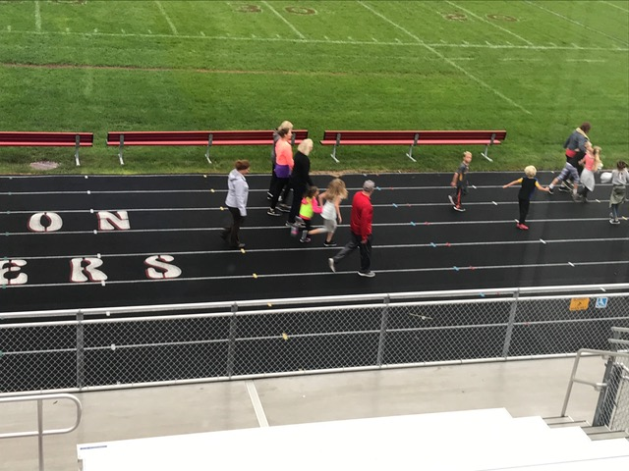

**Best Practices**

|  |  |
| --- | --- |
| Best Practices Required Elements | Complete? |
| Description of the practice/activity. | ✓ |
| Methodology of measuring success of best practice. | ✓ |
| Information on why practice/activity was implemented. | ✓ |
| Impact of practice/activity on attendance. | ✓ |
| Impact of practice/activity on student achievement. |  |

Best Practice: LAUNCH recognized a need from parents and the community and planned to remain open during Spring Break for the 2019-2020 school year with approximately 1/3 of regular attendees signed up for the week. This would be considered a best practice because it recognized the need for students to continue to have supervision, meals and activities even when school was not in session. In previous years, LAUNCH did not stay open during this time and parents had to arrange other childcare. This demonstrates the programs ability to adapt to continue meeting needs in the community. When the COVID-19 pandemic closed schools the same week as the LAUNCH Spring Break program the program remained committed to meeting the needs in the community and provided meals for students signed up for the week. This ensured, at least, partially that student needs were being met.

**Pictures**

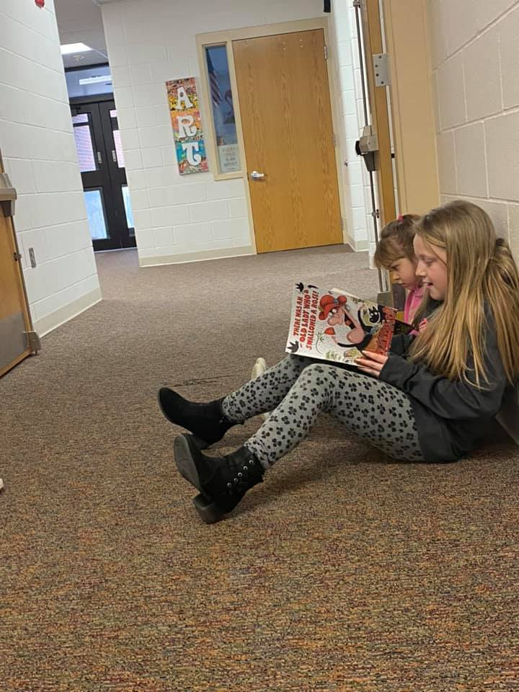 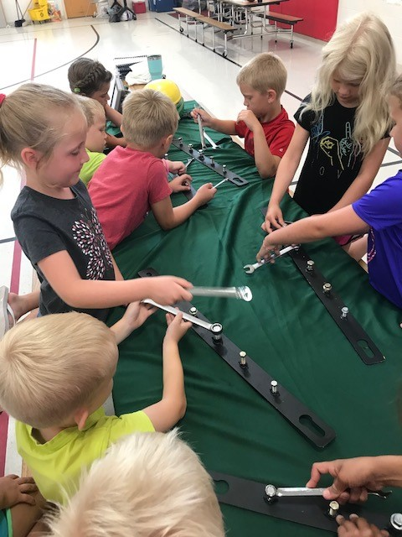 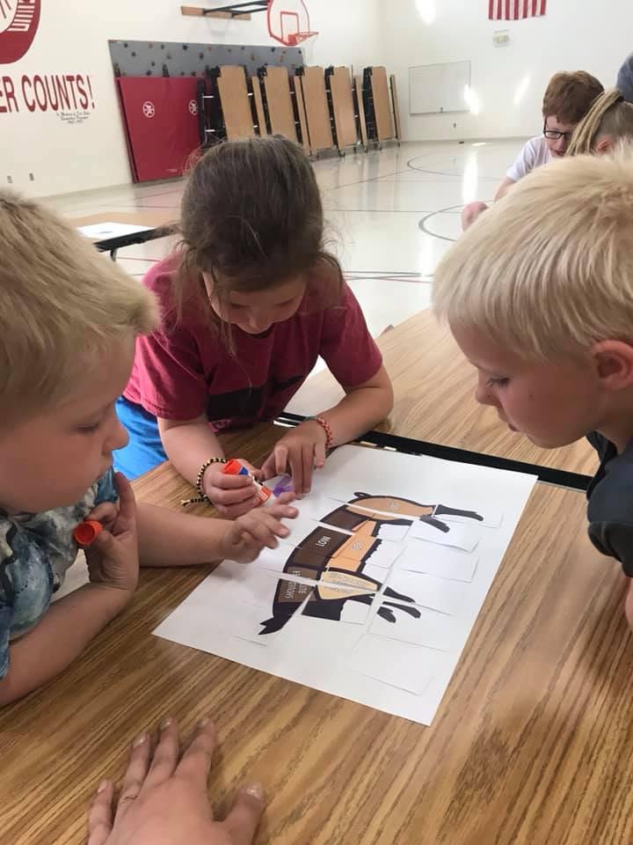

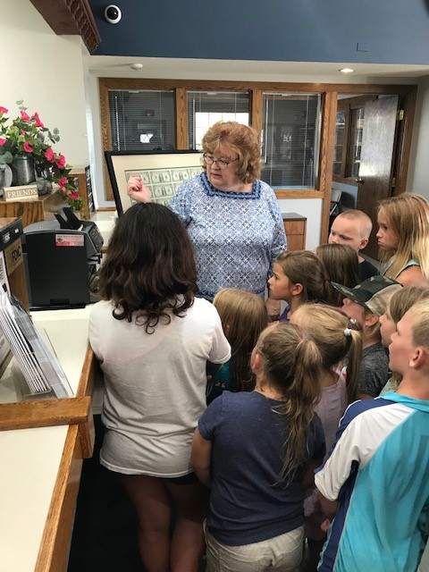 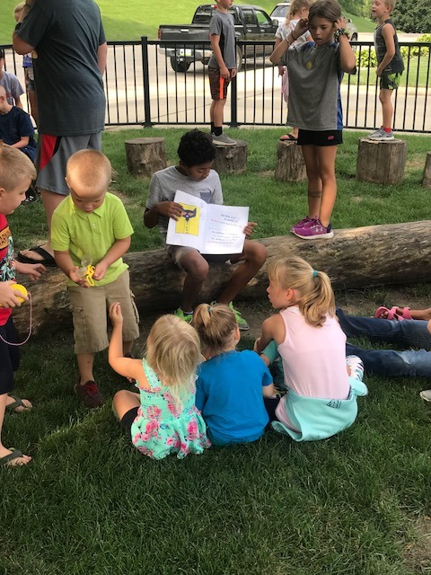 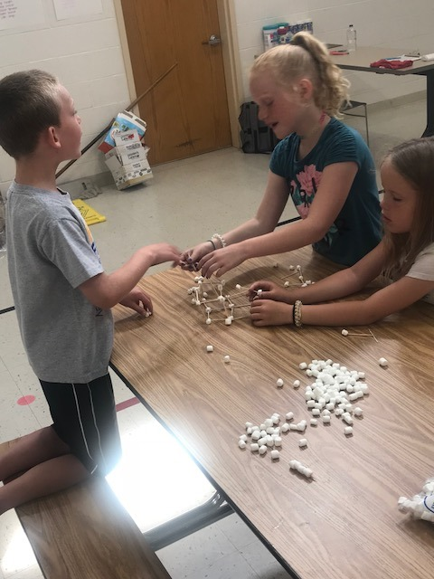

**Student, teacher, parent, and stakeholder input**

|  |  |
| --- | --- |
| Student, teacher, parent, and stakeholder input Required Elements | Complete? |
| Quotes from student, teacher, parent, and stakeholders. | ✓ |
| Quotes from partners. | ✓ |
| Quotes should be attributed (titles can be used but names only with permission). | ✓ |
| Showcase success of the program, especially for student attendance, behavior and academic success. |  |

Stakeholder Input:

*We look forward to these next two years of Launch with our daughter, and I would highly recommend this program to any parent who has not experienced it. Launch truly is life-changing. ---Parent JR*

Email from a parent:

Our seven year old second grader suffers from Childhood Anxiety Disorder and ADHD. She has been in the Launch program for two years (Kindergarten, 1st, and now 2nd Grade).  
  
The compassion shown by the Launch workers is so incredible it brings tears to my eyes even thinking about all they have done for this child, and so many more children too. Even before she was diagnosed, our daughter struggled with overwhelming worry/anxiety. She was constantly watching clocks, worried when someone would be there to get her. The staff worked with her to console her when she cried, and they helped us implement a system where she had a drawn picture of a clock in her bag with the clock showing 5:30 PM that she could check if she became worried. Some days she was so over anxious that she was in tears, wasn’t very outgoing and I would arrive to find Launch teachers calming her by coloring pictures, having her show off things she had learned at dance class, and just simply being a friend to her. They have all went over and beyond their call of duty not only for our child, but obviously for many kids. It is heartwarming to know that our kids are in good hands while we are at work, that they are reading, having fun, dancing, and get to be kids!  
  
The progress shown in our daughter's social skills has been exceptional. Her school teachers, play therapists, family and Launch instructors have been instrumental in the progress we have seen. I don’t know where we would be without our local Launch program!

Even though some kids with special circumstances are not always easy to deal with, this Audubon Launch staff has shown patience and kindness to all. They seem to just know when a kid needs to be given a little grace and even just know when those kids need a friend!

1. **Sustainability Plans**

|  |  |
| --- | --- |
| Sustainability Plans Required Elements | Complete? |
| Original plan from grant application summary. | ✓ |
| Discuss formal sustainability plan if applicable. | ✓ |
| How program will continue without 21st CCLC grant funding. | ✓ |
| How partnership contributions will help the program continue (refer to partnership table from section 3). | ✓ |

Sustainability: Audubon CSD plans to sustain the current program through current grant money and strong community support through local and county partners. The majority of activity funding is provided by local partners either by in-kind donations or providing learning opportunities for students. Currently, the grant provides financial support for other activities provided at a discounted rate (e.g., community pool), transportation to activities out of safe walking distance and staff salary. The use of the school building and grounds is donated by the school district. In addition, summer meals can be provided through the USDA grant to all children in the community providing a financial break for the LAUNCH program. A feasibility study may need to be done to determine if the program is sustainable without the use of grant funds to continue the same level of engaging activities and dedicated staff.

1. **Summary and Recommendations**

|  |  |
| --- | --- |
| Summary and Recommendations Required Elements | Complete? |
| Summary of program. | ✓ |
| Dissemination of local evaluation. | ✓ |
| Recommendations for local objectives. | ✓ |
| Recommendations on future plans for change. | ✓ |

**Summary of Program**

|  |  |
| --- | --- |
| Summary of Program Required Elements | Complete? |
| Reference introduction section. | ✓ |
| Showcase successes of program. | ✓ |
| Highlight items contributing to program success. | ✓ |
| Include exemplary contributions from staff, teachers, volunteers and/or partners. | ✓ |

Summary of Program: The program runs on school days from 3:30-6:30pm and during the summer Monday through Friday from 9:00am-5:00pm. Both programs are available for students kindergarten through 5th grade and are run from the grounds of the Audubon elementary school building. According to monthly attendance data, a typical day has approximately 30-40 kids and 4-5 adults. This provides a ratio of approximately 10 kids per provider during regular program hours. The LAUNCH after school programming includes a healthy snack, physical activities (e.g., outdoor play, yoga, sport games), academic support through homework help or tutoring, STEM activities, arts and crafts activities and social interactions with peers. Approximately 50 students or 25% of the population attend the LAUNCH after school on a regular basis (i.e., 30 or more days). The LAUNCH strives to maintain and increase kid participation through offering engaging, high quality opportunities. Audubon CSD has historically had a strong community presence and partnership. Since the LAUNCH has started many local businesses have provided support. According to the grantee, “Many of the entities charge nothing to come present to our group. Our swimming pool gives us a discounted rate as does our Rec Center (ARC).  Many local partners are willing to help out. It is a great community”. Local partners provide life lessons related to finance, health, and love of learning. The small-town community is very willing to engage with the program and recruiting is as simple as asking for support. The 21APR data indicates that the Launch program is providing benefit to more than half of the students who need on-going help and attend. These students are receiving tutoring and homework help which is then translating into the classroom according to the teacher survey results. ELA improvement was the lowest reported score with 78% of students showing improvement. While 80% of the student needing improvement in math improved their scores. A significant highlight was the teacher interview data and behavior report data, which revealed that of the 4/5 students improved homework completion and class participation and 5/5 students improved behaviors. These is a highlight of the program because these are areas of school functioning that can impact future success. The LAUNCH is a success in Audubon. It is able to provide after school programming to 25% of the school population. These students are now provided with appropriate adult supervision after school and during the summer. In addition, they are provided with a variety of enriching activities and healthy foods. This a success in that it is filling the “gap” that was seen in the community.

**Dissemination of Local Evaluation.**

|  |  |
| --- | --- |
| Dissemination of Local Evaluation Required Elements | Complete? |
| Exact url where local evaluation is posted (required by US DOE). | √ |
| Discussion of other methods of Dissemination (Board reports, community meetings, person to person, e-mail, etc.) |  |

We have discussed our Launch Kid Club program at a number of board meetings and at our most recent SIAC meeting on October 14, 2020.

URL:

**Recommendations for Local Objectives.**

|  |  |
| --- | --- |
| Recommendations for Local Objectives Required Elements | Complete? |
| Objectives to be changed and reasons why. | ✓ |
| Objectives to be added. | ✓ |
| Include objectives not met. | ✓ |
| Include objectives not measured. | ✓ |

Local Objectives: At this time, data reported by Audubon CSD indicates that the students attending LAUNCH are not proficient in reading or math. It is recommended to keep the reading objective but also add an objective for math. The program may also add an objective that states how much time is dedicated to supporting the academic skills.

**Recommendations on Future Plans for Change.**

|  |  |
| --- | --- |
| Recommendations on Future Plans for Changing Required Elements | Complete? |
| Changes in activities. | ✓ |
| Changes in recruitment efforts. | ✓ |
| Changes in partnerships. | ✓ |
| Changes for sustainability plans. | ✓ |
| Other changes as suggested by governing body. |  |

Recommendations on Future Plans for Change:

It is recommended that the LAUNCH program director continue to build family engagement and family interactions. Family engagement and involvement has a strong correlation to increased student grades, attendance, test scores, positive behaviors and graduation rates. An after-school program should be considered an extension of the school system and school day. Therefore, LAUNCH is another avenue to include parents who may not be able to participate during the school day. Suggestions to build parent involvement include creating a parent advisory committee and having a table at open house and conferences. A committee can help determine activities, reach out to community resources and engage fellow parents. An informational table can help increase participation and encourage parents to interact with program staff while bringing additional awareness to community members and parents.

The use of social media is a great asset; however, research supports a variety of contact methods to meet the most number of parents and gain meaningful involvement. Utilizing differentiated contact methods is recommended, (e.g., newsletter, outreach phone message.

Another recommendation would be an extension of the current program. An extension of the program could include morning hours prior to the school day, extended hours during conferences and extended hours during the summer. This may increase attendance for parents who work earlier in the day. A final recommendation would be to revisit transportation as an option during the summer. This would allow kids with parents who work and can not drop off to attend.

Additionally, I would recommend partnering with the school to provide additional targeted interventions with students needing improvement in reading and math. This will provide an extension of the school day, benefit the student and may decrease a time demand on classroom teachers.

The final recommendation relates to the utilization of the Positive Behavior Interventions and Support (PBIS) framework. Currently, Audubon CSD utilizes PBIS during the school day providing consistent expectations and feedback about behavior. Carrying over the use of the expectations, feedback and acknowledgement to the after school program would help link the two programs together and provide support and consistency for students and staff. This may include providing professional development to the after school staff on PBIS and other social emotional behavioral mental health (SEBMH) practices.

Additional recommendations are included in previous sections (e.g., sustainability study and additional local objectives).

**UNEXPECTED DATA**

Like most school districts in Iowa, Audubon CSD closed in March 2020 due to the COVID-19 pandemic. The LAUNCH program is housed in the Audubon Elementary building and therefore, was also closed. No data is available for Spring Assessments in math or reading. In addition, parent and teacher surveys were unable to be completed. Data was mostly pulled from existing data sources including social media and the student information system. Data will be impacted again for the summer of 2020 and also the 20-21 schoolyear.