SMART Systems SMARTeR

ONLINE ORDER REQUEST
The Online Order Request allows the user to fill out an electronic requisition order form to any active vendor in your district’s Smart Finance vendor listing.
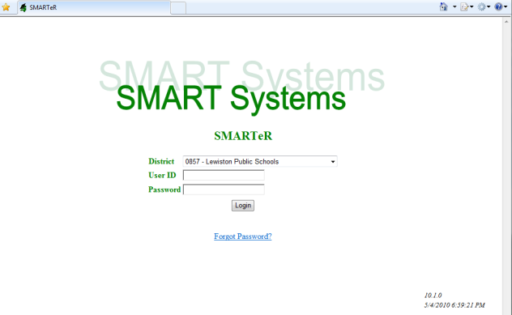

- Log onto the SMART Systems SMARTeR website.
- Enter your User ID and password.
- Click on Login.
- Click on Requests and Approvals > Purchasing > Order Request Form.
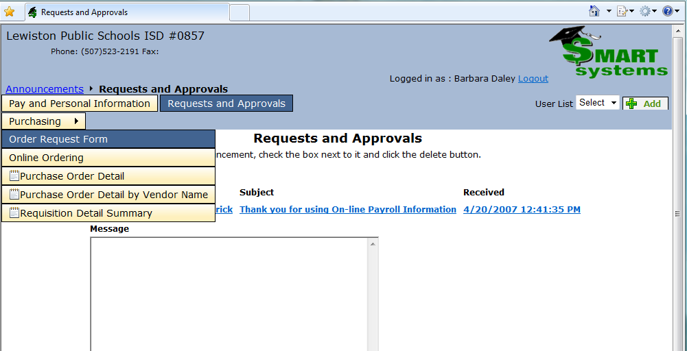
- To start a new order, click on the “Start Cart” button. To retrieve a cart click on the “Retrieve Cart” button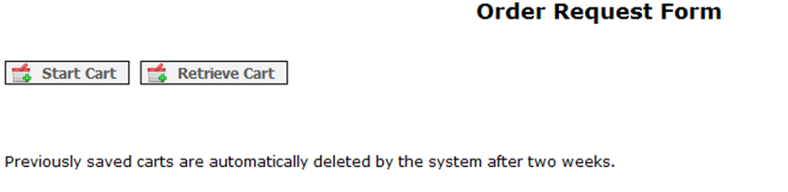

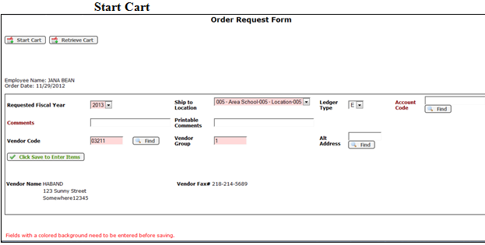

- The Requested Fiscal Year field will auto populate. Change it if necessary.
- Select a Ship to Location from the drop down list. This is a required field.
- Enter in a comment. The comment field is used for any information that the user would like the Business Office to know such as indicating a specific grant to be used for coding, or perhaps, a specific site should be charged for the items, etc. It can also be left blank.
- The Vendor Notes/Prints on PO field would be used for any information that the user would like printed on the completed Purchase Order.

- Vendor Code is a required field. Enter a Vendor Number or click on the Find to lookup the Vendor Number.
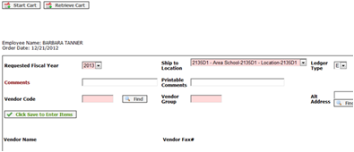

- Select a vendor from the list. If your vendor is not listed, please contact the Business Office to create a vendor for you.

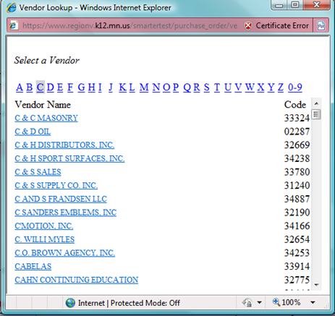

- If there is an alternate vendor address, enter the Address Code into the Alternate Address field or click on the Find for an available list.
- Click on the “Click Save to Enter Items” button to save the vendor information.

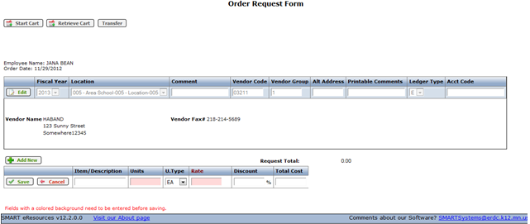
- In the Item/Description field, enter the catalog number then the item description. There are 250 characters available in this field.
- Enter the number of Units.
- The Unit Type will default to EA. Change it if necessary.
- Enter the Rate.
- Enter a discount percent if applicable.
- Click the Save button to save your row.
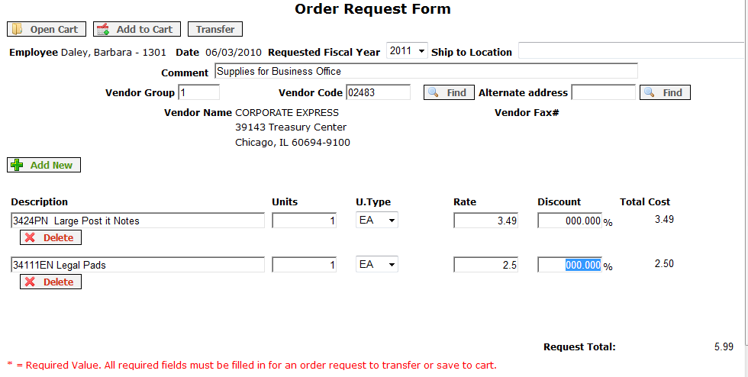

- To add another row click Add New. When adding a new row or editing a row, the window changes to edit mode and you will not see the rest of your order. However, it is there. Once you click on save, all of your items will be listed.

- At this point you can repeat the above steps until finished.
- Print your order before you transfer it to SMART Finance.
- When finished, click on the Transfer link.
- You will receive the message “Your Order Request has been transferred to SMART Finance”.
- If you are interrupted and wish to save the unfinished order, click Add to Cart. The order will be available for you to finish for two weeks. If two weeks time passes, the order will be automatically deleted from SMARTeR.
- If you wish to place another order, repeat steps 5 through 26.
- Otherwise click Logout.

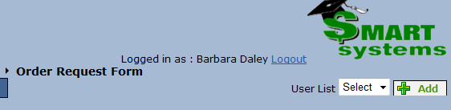

To retrieve items from a Saved Cart
- Click on the “Open Cart” button at the top of the page.
- You will receive a list of all of your saved items.
- After you click on a row, it will display that request that was selected.
- Continue following the previous steps as needed.

