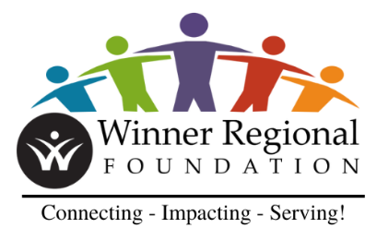 | Winner Regional Health & Wellness Foundation  Scholarship Application - 2025

Who may apply: Any high school senior in Winner Regional Healthcare Center’s service area (Tripp, Todd, Gregory, or Mellette Counties) planning to pursue higher education in a medical or healthcare field. Up to two (2) two-thousand and five hundred ($2,500.00) scholarships may be awarded.

All contents of the application MUST be typed!

Please read the instructions of the application carefully and follow them as provided.

Name:
Home Address:
 |  | Street |  |  |  |  | City |  |  |  |  |  |  |  |  | Zip
Phone #:
 | Home # |  |  |  |  |  |  |  |  | Cell #
High School Name:
Graduation Date: |  |  |  |  |  |  |  |  | Cumulative GPA:
Technical School, College or University Planning on Attending:
Healthcare Field Planning to Enter:
Signature of Applicant: |  |  |  |  |  |  |  |  |  |  |  | Date:
Required Attachments:
- Essay: Attach a typed essay (no more than three pages double spaced) detailing the following information:
- Plans for future study and why you are pursuing your chosen healthcare field.
- Involvement in healthcare related activity(s), volunteer and/or paid.
- On a separate sheet, please include a list of school, church, and/or civic activities you belong to.
- Enclose three letters of reference (one from a school personnel, one from a community member, and one from an employer or a coach from an extra-curricular activity).
- Attach an official high school transcript.
- All attachments must be typed and one-sided.

Applicant Requirements: (If awarded a scholarship, the following conditions shall be met).
- Must maintain a C average on a 4.0 GPA scale.
- Must provide the following documents by January 30, 2025 for the scholarship to be paid:
- A letter from a professor stating the applicant is enrolled in the respective discipline.
- A letter from the applicant’s advisor stating the applicant has maintained a C or above GPA.
- A statement of the applicant’s current balance from the technical school, college or university Finance Office.
- Up to one-page summary (double spaced) of how the scholarship positively impacted you to pursue your degree.
- The above content shall be sent to Michael DiGrazia at michael.digrazia@winnerregional.org

Other Details:
- Your signature authorizes us to use your name, photo, and relative material in advertising and press releases.
- Dependents of Winner Regional Healthcare Center employees, Governing Board members, and Foundation Board members are eligible for the Winner Regional Health and Wellness Foundation scholarship program.
- The scholarship shall be paid directly to the College or University the applicant is enrolled in.
- The scholarship shall be applied solely to the applicant’s tuition.
- The scholarship shall be paid during the second semester during the month of February, after all above content has been submitted.

Applications must be postmarked by April 28, 2025 and sent to:
Winner Regional Health and Wellness Foundation
Attention: Michael DiGrazia, President
745 E 8th St.
Winner, SD 57580

Thank you for your application and we wish you the very best in your post-secondary educational goals.

Applications will be reviewed and decided on by the Scholarship Committee.

Revised: 02-23-2024

