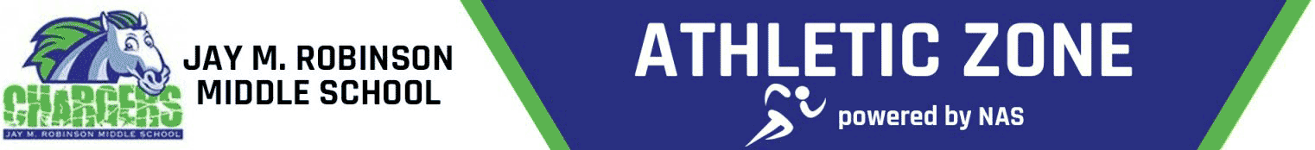
The Jay M. Robinson Booster Club is a group of parents whose primary objective is to provide our children with positive student-athlete experiences at Jay M. Robinson Middle School. The JMR Booster Club works to enrich the athletic experience for all students. Our primary goals are to:
- Raise funds for essential equipment, uniforms, and facility upgrades.
- Promote school spirit and community engagement around our athletic programs.
- Provide opportunities for parents to be actively involved in their children's extracurricular activities.
Your support is vital to the success of our athletic programs! Here are a few ways you can contribute:
Attend a Meeting: The Booster Club will hold monthly meetings. If you’re interested in attending a meeting to learn more, please let us know by reaching out to a member of our Booster Club at jaymrobinsonathletics@gmail.com.
Volunteer: There are various volunteer opportunities, from helping at games to assisting with fundraising events. Please be on the lookout for volunteer signup opportunities throughout the year!
Donate: Financial contributions of any size have a huge impact. You can donate online by clicking on the QR Code listed below. All donations are greatly appreciated.
Questions about the Athletic Booster Club? We would love to hear from you. Please email jaymrobinsonathletics@gmail.com or complete the below portion of this form with your contact information and a member of our Team will respond as soon as possible. Thank you and Go Chargers!
Name:
Phone Number:
Email Address:

