How to register and pay for current athletics team:
Log onto the Fort Mill District website here…
http://www.fortmillathletics.com
Scroll down and click on the icon that reads “Student Athlete Registration Is Open / Click Here To Register”
Scroll down to High School Registration and select Banks Trail Middle
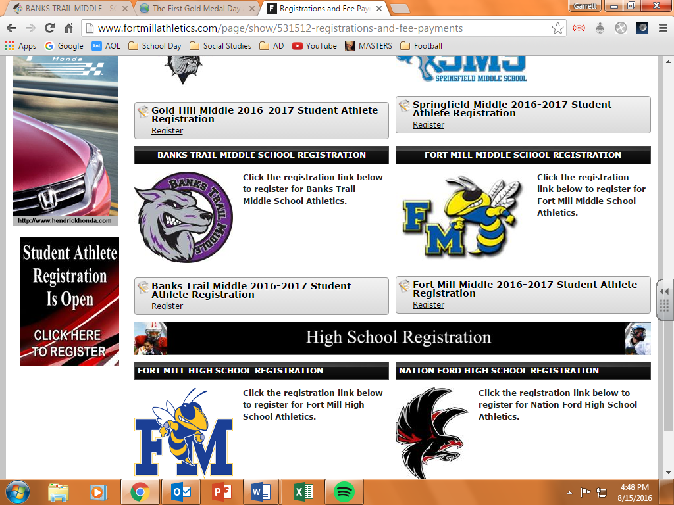
Log in or create an account if your student is new to the Fort Mill School District Athletic program.
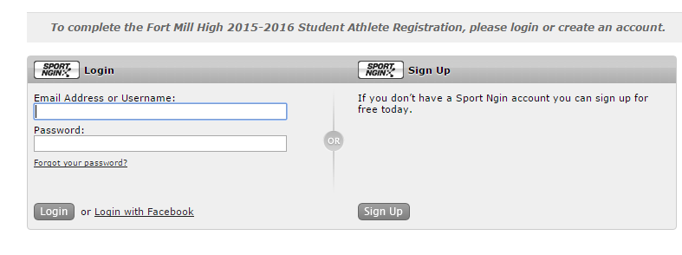
Select the student you are registering or select A New Student.
From this point the system walks you through filling out the remainder of the information needed.

