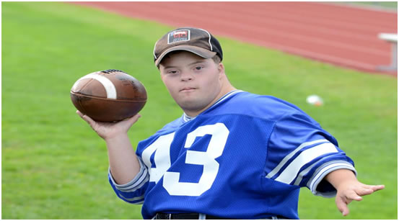
OCIAA Tyler Muise MVP Award Application
Nominee: __________________________________________
School District: ______________________________________
Sports Program: _____________________________________
Years Participated: ___________________________________
Athletic Director Signature: ____________________________
The Tyler Muise MVP Award celebrates and acknowledges the unique ways in which students with special needs positively impact an interscholastic athletic program. These students give their time and effort to enhance the experience of all those around them and ask for nothing in return. The OCIAA is proud to honor the recipient of the Tyler Muise MVP Award at the annual OCIAA Senior Scholar Athlete Breakfast.
Requirements:
- Nominee shall be a current special needs student that works with an interscholastic athletic program.
- A letter of recommendation for this award shall be sent from both the School District (Athletic Director, Coach, Teacher or Administrator), and a Captain of the team the student participates with.
Full Applicant package should be returned to us by April 30th, 2021.

