 | RIVER BEND EDUCATION DISTRICT  1315 S Broadway Street  New Ulm, MN 56073  ph(507) 359-8700  fax (507) 359-1161

RE: Password protecting your documents containing student information.

When submitting any Physical Holding forms or Seclusion forms to River Bend which contain student information, we ask that you password protect the document to protect your student’s privacy, as well as to follow Data Privacy laws. This process is not difficult and creates a message of security for both your district and River Bend.

(For a MAC)
1. After completing the document, click on WORD.
2. Select PREFERENCES...
3. A pop up box will appear, click on SECURITY in the third row
4. Another pop up box will appear. In the box that says “Password to Open” enter a password. (district initials + RBED)
5. Click OK.

(For a PC)
1. After completing the document, go to FILE.
2. Select INFO.
3. Select PROTECT DOCUMENT.
4. Select ENCRYPT WITH PASSWORD.
5. Create your password in the pop up box. (district initials + RBED)
6. Click OK

PHOTO DIRECTIONS (for MAC)
1.Click on Word (upper right corner) and then click on Preferences
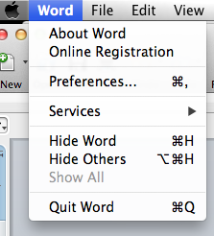

2. Click on SECURITY in the third row when the pop up box appears.
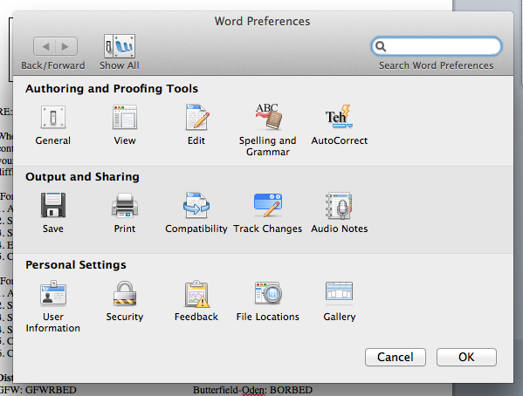

3. In the box that says “Password to open” enter the password for your district (see above). Click OK
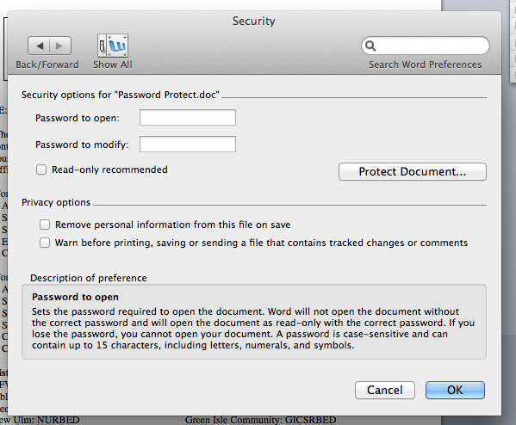

Photo Directions for PC…see below.

Photo Directions for a PC
1. Upon completion of your document, click on FILE, scroll down and click on INFO and click PROTECT DOCUMENT.
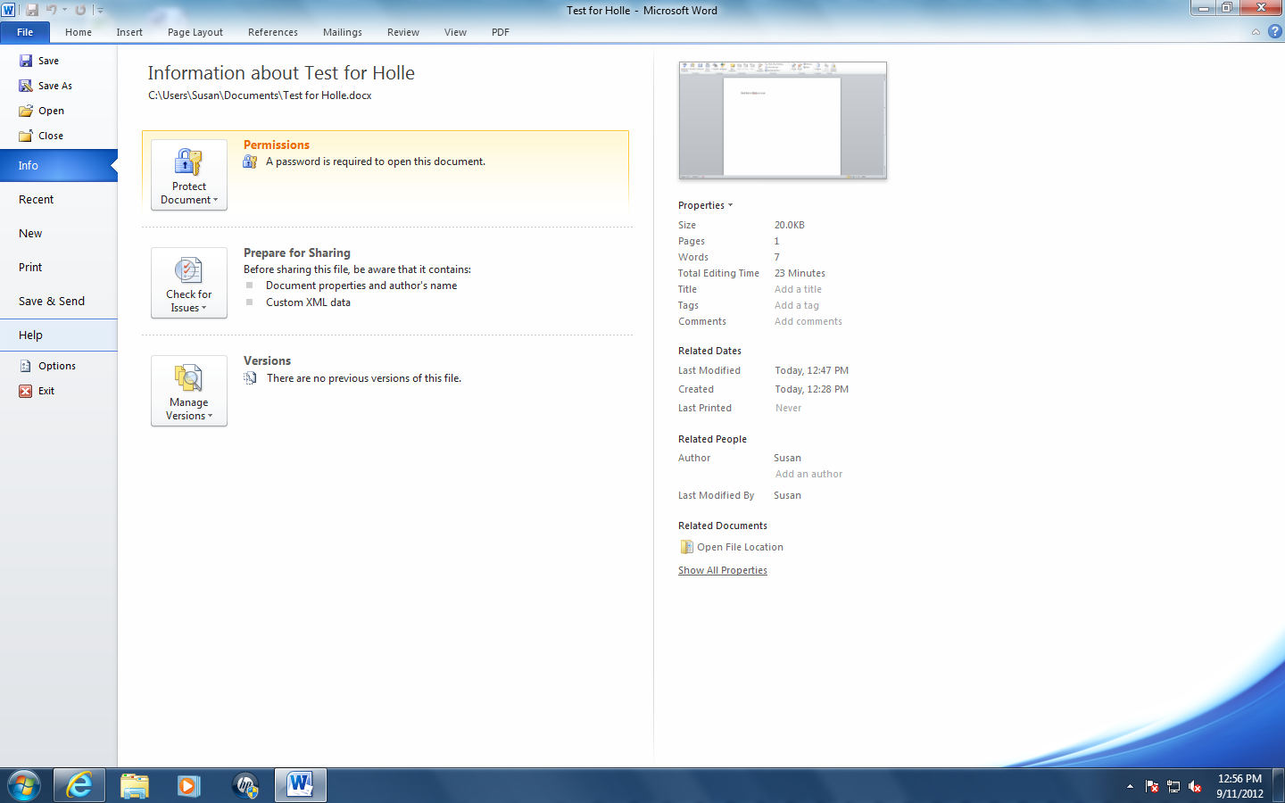

2. Click on ENCRYPT WITH PASSWORD.
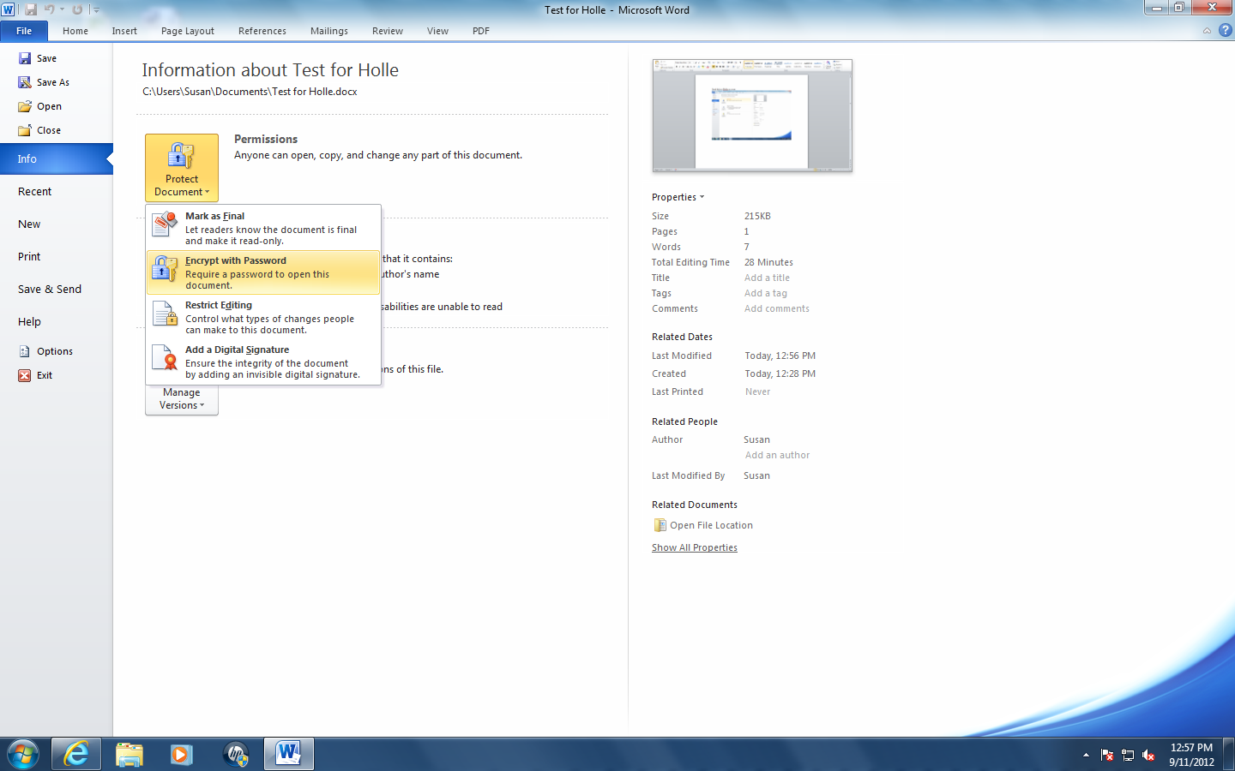

3. Enter the password (see above) in the box and hit OK.
