Mrs. Quade’s Weekly Newsletter
 September 16 – 20, 2013
---------------------------------------------

This week we worked through the story Wilson Sat Alone. The students seemed to really enjoy this story. Over the weekend, please have the students read the story and sign the share sheet. Next week, we will be doing our first theme test. We will not have a story next week. We will be doing a review on some spelling words. The students will receive these words on Tuesday.
Next week we will begin testing on Chapter 2 in Math. Please start reviewing coins at home to get ready for Chapter 3. We will be working on recognizing coins and counting money.
On Thursday, we will be celebrating Johnny Appleseed’s birthday. We will be making homemade applesauce as a class. Please have your child bring an apple or two for the homemade applesauce we will be making.
I hope to see everyone at conferences next Thursday night and Friday morning. The students are very excited to share their Monarch Butterfly portfolios with their families.
Next week is Homecoming Week here at W-K!!!! Below is a breakdown of the dress up days and activities taking place. I am encouraging everyone to bring $1 on Tuesday so they can get their face painted by the SADD group. We will be going as a class to get our faces painted.
HOMECOMING WEEK (September 24-27)
Monday-NO SCHOOL
Tuesday-Strips and Dots Day/ Face Painting $1:00 (SADD Face Painting in Elementary 8:00-9:00 AM)
Wednesday-Crazy hair, hats and socks
• Homecoming Parade 7:00 PM
• Community Bonfire/Coronation 7:30 PM-9:00 PM
• Coronation 8:00
Thursday-Falcon Spirit Day
• ELEMENTARY PEP FEST 8:10-8:45 AM
Friday-NO SCHOOL
• Booster Club Tailgate Party 6:00 PM
• Football Game 7:00 PM
• Elementary Dance line Performance @ Halftime
Homecoming Items for Sale: Beads $0.25 and Pom poms $1.50 and
YOUTH/ADULT T-shirts $10.00
Our classroom Wise Owl of the Week was Landyn Walters. Landyn enjoyed reading his favorite book to us on Wednesday. His favorite book is Lego City 3,2,1 Liftoff! Today he brought in his favorite snack. Landyn’s favorite snack is Wafers and Gogurts. It was fun to learn more about Landyn this week. Next week we will not be having a Wise Owl of the Week. On September 30th Sammy Jo Gusa will be the Wise Owl of the Week.
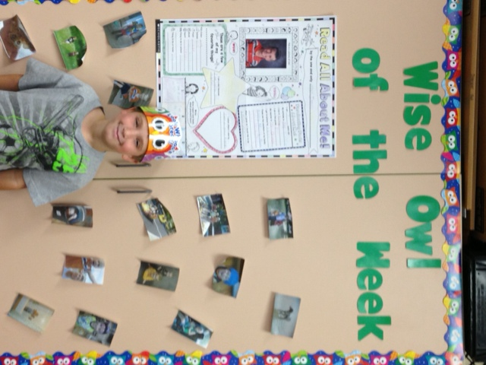

Upcoming Events:
Monday, September 23- No School
Thursday, September 26- Conferences from 5-8:30
Friday, September 27- No School
Conferences from 8-12

Today our Secret Reader was Benny Swanson. Benny is a new Wabasha Police Officer. The students enjoyed listening to Benny. They also had fun asking him a lot of questions. Thanks Benny!!!

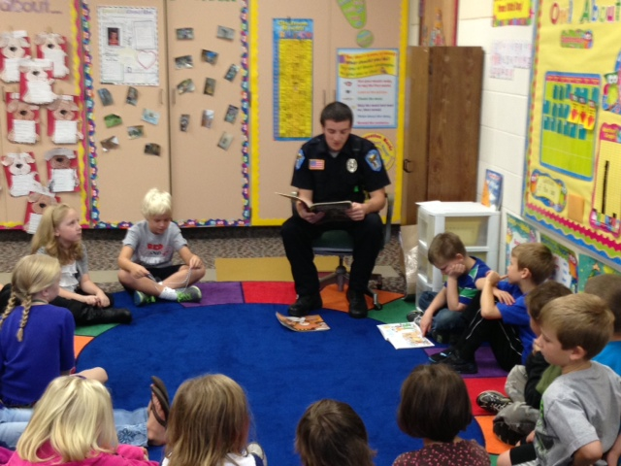

Have a good weekend~ Mrs. Quade



