B

**Wabasha - Kellogg**



**The Falcon Nest**

**2025 Summer Handbook**

m

School Age Care with Your Child in Mind

June 2, 2025 through August 22, 2025

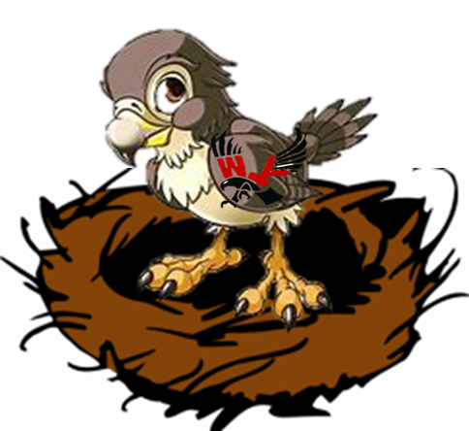

**OUR MISSION: To foster the emotional, social, and physical growth of our children registered Age 3 thru 5th grades in a safe, fun, caring, and respectful environment.**

Welcome to the Falcon Nest. We are looking forward to spending time with your children and getting to know you.

Some of the FUN we have....

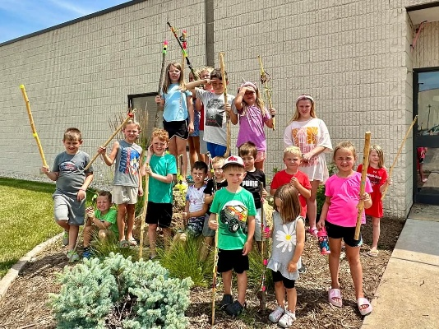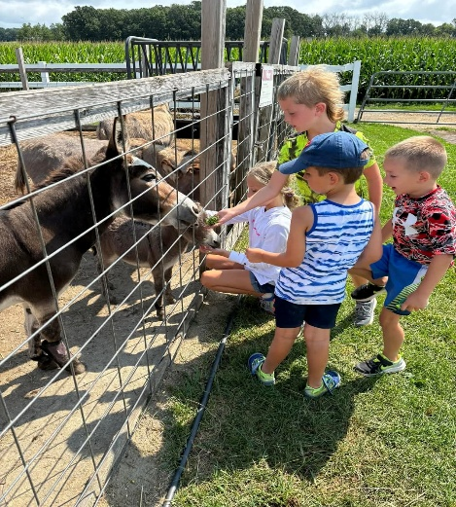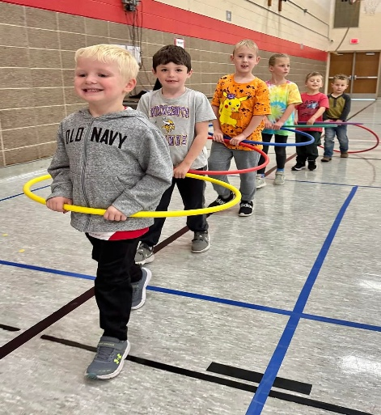

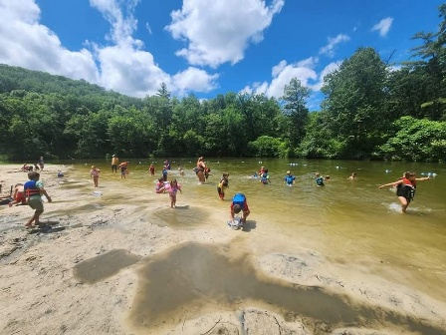

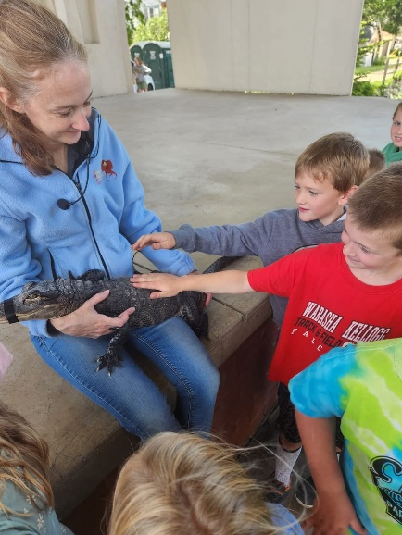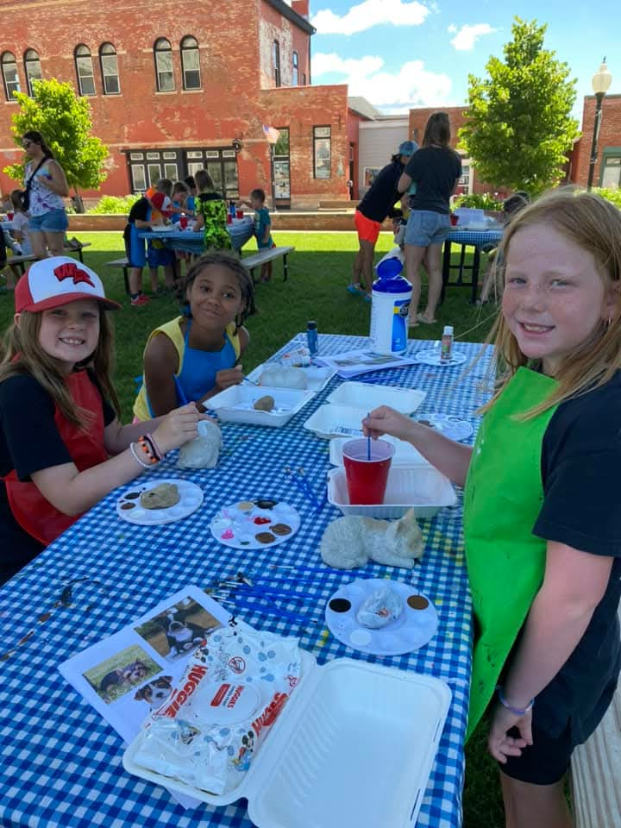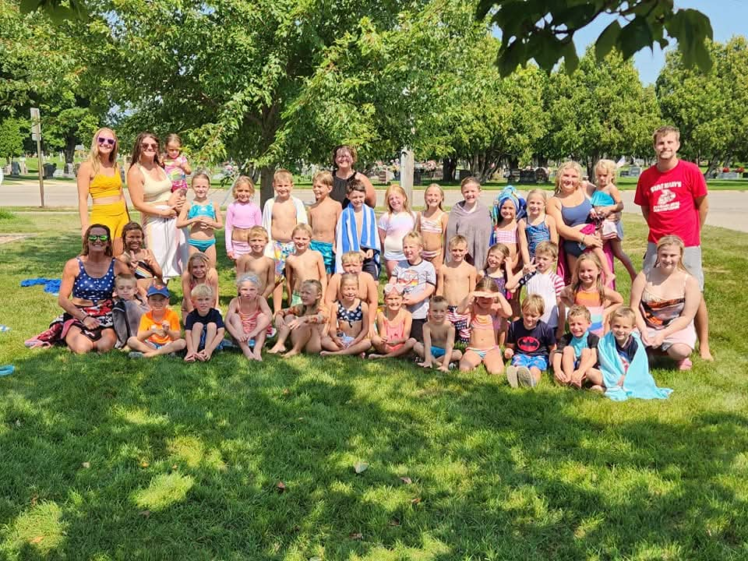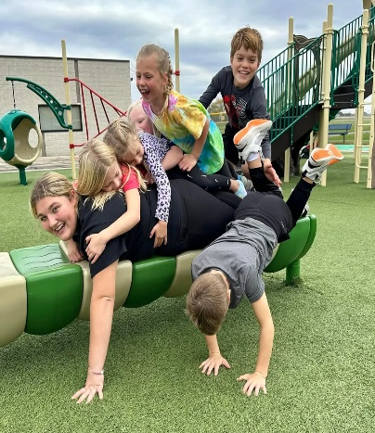

This handbook may be changed or amended at any time. Parents will be notified of any changes that are made.

**Goals**

1. To create a place that is trusting, inviting, comfortable, and flexible for children, parents, and staff.
2. To provide a caring staff that will work to meet the emotional, physical and social needs of the children.
3. To promote respect of each child and their respect of others and encourage responsibilities and social skills.
4. To maintain a schedule that provides academic support and age-appropriate activities.
5. To allow each child to explore and express their individual creativity and interests and grow in confidence and self-esteem.

**Contact information**

The Falcon Nest Coordinator: Chrysti Sartain

Wabasha-Kellogg School District #811

2113 East Hiawatha Drive

Wabasha, MN 55981

651-565-3559 ext. 330

Email: [thefalconsnest@wkfalcons.org](mailto:thefalconsnest@wkfalcons.org) & [csartain@wkfalcons.org](mailto:csartain@wkfalcons.org)

Department of Human Services: 651-431-6500

Child Care Assistance Program: 651-565-3351

**Registration**

Registration is required. Please notify us immediately of any changes to your address, phone number, or other important information. **All children must be fully toilet trained to attend – NO EXCEPTIONS.**

**SUMMER INFORMATION**

**Hours**

* 6:30 a.m. - 6:00 p.m. We reserve the right to adjust our hours of operation to the needs of our families
* Closed:
  + Monday, May 26th – Memorial Day
  + May 26th to May 30th CLOSED (training/room cleaning/maintenance)
  + Thursday, June 19th- All offices closed
  + Thursday & Friday, July 3rd & 4th

Workshop Days prior to start of school – Last Day is August 22nd, Closed August 25th to August 29th.

**FEES**

**Registration:** $20 per child/$40 family maximum

**Full Day:** $33.00

**Half Day:** $20.00 (5 hours or less)

**Transit: $2.50 one way Bluff Country Bussing: TBD…. Some activities have a fee.**

**PROCEDURES**

**Billing**

Bills are completed on a weekly basis. They are placed in your family folder on Mondays and payment is due by Friday of the same week. A $5.00 late fee will be added the following Monday if the bill has not been paid.

Your bill will be mailed to you if your child is not scheduled to attend the program within a week’s time. Payment will be due immediately upon receipt.

If you do not pay your bill in full each week and a payment plan has not been set up with the coordinator, you may be notified after your bill is two weeks past due, that your child will not be able to attend the program. Once payment has been made in full, services may continue as long as your account stays current.

Some of our local trips, we use the Transit bus, there is a fee of $2.50 per trip. There may also be a small bus fee for out of town trips.

**ALL BILLS FOR THE SUMMER PROGRAM NEED TO BE PAID IN FULL BEFORE THE START OF THE SCHOOL YEAR. IF IT IS NOT PAID, YOU WILL NOT BE ABLE TO ACCESS THE SCHOOL YEAR PROGRAM UNTIL THE BILL IS PAID IN FULL.**

**Summer Supplies Needed for Each Child:**

1. Sun Screen **4.** Swim clothes & towel (pool days)
2. Bug Spray **5.** Water Bottle
3. Bag (to carry items) **6.** Change of clothes

**All items need to be labeled with your child’s name**.

**Calendar**

Monthly calendars are due by the 20th of each month for the following month. Blank calendars will be available in the family folders. Once your schedule is submitted and if you have a change, please notify The Falcon Nest staff immediately. LATE CALENDARS will result in your child not being able to attend the program for two days after your calendar is received and a late fee of $5.00 will be charged to your billing statement. Falcon Nest staff will not be contacting parents for missing calendars.

**Communication**

If your child will not be attending on a scheduled day, you need to notify The Falcon Nest staff as soon as possible. The best form of communication is The Falcon Nest email. If staff is not made aware that your child is not attending, you will receive one warning. If a no show happens after the one warning, you will be charged for the scheduled time (full or half day per your monthly calendar).

**Dress and Belongings**

Children should be dressed comfortably and appropriately for the weather while adhering to the dress code set forth by the school district. Toys, videos, and electronics may be brought from home and shared with friends. These may not be weapons or promote violence of any kind. It is your child’s responsibility to keep track of all of their belongings. The Falcon Nest is not responsible for any lost, stolen, or broken items. Staff will not keep track of your child’s belongings. Each family will have a locker available to them at the school to keep their child’s items in.

**Drop Off/Pick Up**

Parents/Guardians are **REQUIRED** to drop off and sign in your child into the program every day. Please do not let your child come into the program by themselves. A staff person needs to acknowledge that your child is present and will not sign in or sign out your child.

Please make contact with a staff member so that we know your child is being dropped off/leaving. Please contact The Falcon Nest if someone who was not listed on your registration form will be picking up your child. **If you pick your child up after 6:00 pm, $5.00 will be added for every 5 minutes you are late.**

**Family Folders**

Each family will have a family folder in The Falcon Nest room. Please make sure you are checking this folder at least once a week at a minimum. All information needed regarding the program will be placed in the family folders.

**Field Trips**

The Falcon Nest is planning on taking field trips throughout the summer. Permission slips will need to be signed prior to the field trip or your child will not be able to attend. There will not be Falcon Nest staff available if your child elects not to go on the field trip. You will be billed for any additional costs related to the field trips. Please do not send cash for the field trip cost. These amounts will also be indicated on the permission slips. Please make sure your child has proper attire/shoes for the scheduled field trip.

If your child has behavioral issues while on a field trip, you may be contacted by staff to come to the location of the field trip to pick up your child, no matter the location. You will be billed for the entire scheduled time your child would have attended that day. Field trips are a privilege and not a right for the children. If we feel that your child with be a safety concern, we may ask that they not attend field trips until we can get the behaviors under control.

**Inclusion of Students with Specific Needs:**

SACC values children with disabilities as an integral part of our diverse community. Our program will make reasonable accommodations as needed to make physical and social inclusion successful.

If your child has a specific need, such as a disability, diagnosis, health condition, or has an Individual Education Plan (IEP) for special education services, please indicate so during registration. It is important to disclose your child’s specific needs so that SACC may provide the necessary accommodations to support your child. Before starting with the program, a team meeting will need to take place.

**Snacks/Lunches**

You will be responsible for providing a lunch and a drink for your child on the days they attend summer Falcon Nest. Please **NO** pop or candy. We do have a microwave/freezer/refrigerator available to store lunches. However, do not send microwavable lunches and make sure your child’s lunch has an ice pack or something that will keep their lunch cold on field trip days.

We try to encourage healthy eating habits. A morning and afternoon snack will be provided. This snack is designed to curb your child’s appetite – not fill them up.

**MEDICATION, ILLNESS AND INJURY**

**Allergies**

Parents or guardians must advise the Coordinator of The Falcon Nest program directly of any allergies. This must be done prior to your child attending the program. The Coordinator will obtain documentation regarding the allergy that will be stored in your child’s folder. This will include a description of the allergy, specific triggers, avoidance techniques, symptoms of an allergic reaction, and procedures for responding to an allergic reaction as well as your doctor’s contact information.

Staff will review this information at a minimum yearly unless the parent/guardian provides changes regarding the child’s allergies. At this time, staff will be notified immediately.

Information regarding your child’s allergies will be kept on site and will be taken on any field trips that the program takes. If your child has a food allergy, information must be readily available to staff where food is being prepared and served.

**Illness**

Please do not bring your child to The Falcon Nest if they have experienced a fever of 100 or greater, vomiting, diarrhea, or indicate any other type of illness at home. If your child should become ill while at The Falcon Nest, parents will be notified immediately. You must pick them up as soon as possible. If you cannot be reached, we will contact alternative numbers provided. Your child will be in supervised isolation from the other children in the program until picked up to help avoid spread of the illness. **A child must be free of all symptoms for 24 hours before returning to The Falcon Nest.**

**Immunizations**

All children attending The Falcon Nest need to provide updated required immunization records with the school yearly. These records are reviewed by the school nurse, are a part of your child’s school file and accessible to the staff at The Falcon Nest.

**Infectious Disease**

Children may NOT attend or remain at The Falcon Nest if they are found to be contagious with illness or infestation. Parents/Guardians will be notified if their child has been exposed to any illnesses/infestations via written statement that will be posted by the sign in/out sheet of such exposure as soon as the program is made aware of the contagious reportable disease. Some of the most common are: impetigo; strep throat; conjunctivitis (pink-eye); ringworm-children may return after 24 hours of treatment beginning; chicken pox and shingles- children may return after all blisters are dried into scabs; and head lice and scabies-children may return after 24 hours of treatment has begun and no live lice are found. Your child will be placed in supervised isolation from the other children in the program until picked p to help avoid spreading of the illness/infestation. This may require isolation to a separate room near The Falcon Nest room.

**Please be courteous and mindful of your child’s illness for the health/safety of The Falcon Nest staff and other children who attend the program**.

**Injuries**

If your child incurs a minor injury, staff will administer basic first aid. We will also inform you about the injury when you pick up your child or you will be called if necessary. The staff person who attended to the child will also write up an accident report.

In an emergency when immediate attention is needed, or is perceived to be life threatening, we will call 911 immediately and then contact the parent. If the child requires emergency medical treatment, determined by medical personnel, a staff member will accompany the child to the hospital until you arrive.

**Medication**

If your child must take medication at The Falcon Nest, prescription or over-the-counter, we must have a medication authorization form filled out prior to administration. Medicine must be in its original container for both prescription and over the counter with a label stating the child’s first and last name. The Falcon Nest staff and the parent must sign in all medication. Dosage authorized by you may not exceed the dosage indicated for the child’s age/weight on the container. A doctor’s order is necessary to administer an increased dose. The doctor’s order must be filled out for the summer program, separate from the school year. Orders from the school year will not be accepted. The school nurse is not available during the summer program. Children are not allowed to carry medications (prescribed or over-the-counter) to and from the program. Authorized and trained staff will document all medication given while attending the program. This will include the child’s full name, name of the medication, the date, time and dosage and the staff member’s signature who administered the medication.

All medications are kept in a double locked secured area and only authorized trained staff are allowed access to the medication. Medications will not be administered to a child whose name is not indicated on the label and will not be given if the medication has expired. If a medication has expired, the parent will be notified and given a time limit to have the medication picked up. If not picked up by the date given, it will be properly destroyed, per school policy.

Written permission will need to be obtained from the parent or guardian in order to apply sunblock and/or bug spray and can only be administered per instructions on the product unless other written instructions are provided by a licensed health care professional. Proper storage will also be according to the directions on the original container. Each member of the family can use Sunblock and bug spray. However, it will not be shared with other children attending the program.

**BUILDING & PREMISES**

The area used by The Falcon Nest will be clean and in good repair. Each summer, the program will close for one week for routine inspection, maintenance and cleaning. Sharp objects, medicines, cleaning supplies and chemicals will locked and secured at all times.

Staff will properly handle and dispose of bodily fluids and other infectious fluids by using gloves, disinfecting surfaces that come into contact with such fluids and dispose in a securely sealed plastic bag.

**TRANSPORTATION**

Our program, from time to time, will take field trips. Transportation is by school bus (longer trips) or the local transit bus (in town trips). Your child must abide by all rules set by the bus/transit company. Continued violations may result in your child not being allowed to participate in field trips.

**EMERGENCY PREPAREDNESS**

Our program will follow the school’s emergency handbook (located in all classrooms/offices in the school) with regards to all types of emergencies, including but not limited to, fire, severe weather, bomb threats, intruder, and lock-downs. Children attending the program receive training during the school year (fire drills, ALICE, tornado). Staff will review the emergency plan yearly and will go over evacuation drills at least quarterly with the child. Staff will relocate to the wrestling room in the event of severe weather and we need to relocate. The Falcon Nest coordinator will provide training each calendar year on the emergency plan and keep documentation for each staff member. Handbook is available for review upon request.

**MANDATORY REPORTING**

A mandated reporter is a person who, because of his/her profession, is legally required to report any suspicion of child abuse or neglect. All staff members are trained as mandatory reporters through the Wabasha-Kellogg School District annually. All staff must comply with these reporting requirements. Mandatory reports are made directly to the Wabasha County Department of Social Services at 651-565-3351 or to the Maltreatment Intake line at 651-431-6600 for reporting suspected maltreatment of a child in a certified childcare center. Falcon Nest staff are responsible for reporting any observed incidents and will not shift responsibility of reporting to another staff member or to the coordinator.

The Falcon Nest Coordinator will keep documentation of all training pertaining to Mandated Reporting. The DHS Commissioner will be notified within 24 hours of the death of a child in the program or an injury to a child in the program that requires treatment by a physician. An injury or incident report must be submitted to DHS as documentation of any incidents meeting the criteria.

**PARENT ACCESS**

Parents or guardians shall have access to their child at any time while attending our program. If there is a Court Order permitting a parent from contact with their child, a copy of that Order must be provided to the program. This document will be kept in a confidential file and will only be available to staff. Any changes to Court Orders need to be relayed to the Coordinator of the program as soon as possible.

**BEHAVIOR & DISCIPLINE POLICY**

The Falcon Nest works to provide a safe, positive environment for the children and adults involved. We are here to nurture, enhance, and support your child’s development and decision-making abilities. Discipline will be implemented through positive redirection and problem solving. Staff is trained to focus on positive behavior rather than negative behavior. Every child is expected to behave in a manner that is meets the expectations of The Falcon Nest program and School District. Children are encouraged to work out disagreements between themselves. However, if inappropriate behavior continues or is severe in nature, intervention may be required. If intervention techniques prove unsuccessful, a behavior incident report will be filled out and a plan for dealing with the behavior will be developed. Since the children are supervised in a group setting, their behavior is not expected to routinely require one-on-one supervision.

**Discipline Steps & Protocol**

1st Step Child receives a verbal warning for inappropriate behavior. A fix it plan may be

implemented. This will be discussed with the child and parent and both will be asked to

sign it as an acknowledgment. You will be provided with a copy of the plan.

2nd Step Child will be removed from the situation and discussion/mediation will follow.

3rd Step Consequences, such as a loss of privileges, will be determined and enforced.

4th Step Child will be asked to fill out a **Behavior Incident Report** and have a discussion with the

Coordinator.

**Behavior Incident Report**

If a child reaches the 4th step in the Discipline Steps & Protocol or when behaviors and/or student actions are serious in nature including but not limited to the following:

**🡪** violent outbursts with or without profanity **🡪** leaving the room/building/group without permission

**🡪** willfully hurting other children or staff **🡪** stealing

**🡪** damaging property or throwing objects **🡪** verbal or physical abuse towards staff or children

**🡪** inability to conform to the rules of the program

This may result in removal from the program for the remainder of the day and will result in a Behavior Incident Report to be completed.

A completed Behavior Incident Report will be signed by your child, the parent/guardian, and the coordinator.

**1st Behavior Incident Report**

Parents, child, and staff will discuss the behavior to resolve the situation.

**2nd Behavior Incident Report**

Parents will be notified. The child will be asked to take a 1-3 day leave of absence from the program, depending on the severity of the incident.

**3rd Behavior Incident Report**

Parents will be notified. The child will be asked to take a 3-5 day leave of absence from the program or be asked to leave the program indefinitely, depending on the severity of the incident.

* When families are notified that their child needs to be removed from the program for the day they will need to make arrangements for the child to be picked up within one-half hour of the phone call. Families will also be billed for the entire time your child was scheduled to be in the program for that day.

** If a child takes off running from staff, parents will be notified and it will be an immediate dismissal from the program for the rest of the day. This is a safety issue for your child and the other children in the program. You will be billed for the entire time your child was scheduled to be in the program for that day.

**Dismissal from the Program**

Wabasha-Kellogg ISD #811 reserves the right to dismiss students from The Falcon Nest School Age Child Care program.

**Thank you for choosing The Falcon Nest and for giving us the opportunity to get to know you and your child. If you have any questions or concerns, please contact the Coordinator at any time.**

**We are happy to have you here!**

June 2025

|  |  |  |  |  |  |  |
| --- | --- | --- | --- | --- | --- | --- |
| Sunday | Monday | Tuesday | Wednesday | Thursday | Friday | Saturday |
| 1 | 2 | 3 | 4 | 5 | 6 | 7 |
|  | First Day!!!!! |  |  |  |  |  |
| 8 | 9 | 10 | 11 | 12 | 13 | 14 |
|  |  |  |  |  |  |  |
| 15 | 16 | 17 | 18 | 19 | 20 | 21 |
|  |  |  |  | CLOSED |  |  |
| 22 | 23 | 24 | 25 | 26 | 27 | 28 |
|  |  |  |  |  |  |  |
| 29 | 30 |  |  |  |  |  |
|  |  |  |  |  |  |  |
|  |  |  |  |  |  |  |
|  |  |  |  |  |  |  |

June 2025

|  |  |  |  |  |  |  |
| --- | --- | --- | --- | --- | --- | --- |
| Sunday | Monday | Tuesday | Wednesday | Thursday | Friday | Saturday |
| 1 | 2 | 3 | 4 | 5 | 6 | 7 |
|  |  |  |  |  |  |  |
| 8 | 9 | 10 | 11 | 12 | 13 | 14 |
|  |  |  |  |  |  |  |
| 15 | 16 | 17 | 18 | 19 | 20 | 21 |
|  |  |  |  |  |  |  |
| 22 | 23 | 24 | 25 | 26 | 27 | 28 |
|  |  |  |  |  |  |  |
| 29 | 30 |  |  |  |  |  |
|  |  |  |  |  |  |  |
|  |  |  |  |  |  |  |
|  |  |  |  |  |  |  |

**Wabasha - Kellogg**



**The Falcon Nest**

**Summer 2025 Registration Form**

School Age Care with Your Child in Mind

Accepting children Age 3 thru 5th grade

**The Falcon Nest Summer Program will run June 2 until August 22, 2025**

Enrollment Date_______________Reg. Fee: $20 per child/$40 max **X if paid/CK #**

\*\*\***Please provide child full name, First, Middle & Last**

1) Child’s Name____________________ Birth Date____________ Grade______ Fee pd ___

2) Child’s Name____________________ Birth Date____________ Grade______ Fee pd ___

3) Child’s Name____________________ Birth Date____________ Grade______ Fee pd ___

4) Child’s Name____________________ Birth Date____________ Grade______ Fee pd ___

**Parent/Guardian #1**_______________________ Relationship to Child(ren)________________

Phone______________________________ Alternate Phone_____________________________

Address______________________________ City/State/Zip_____________________________

Email address__________________________________________________________________

Place of Employment____________________________________________________________

**Parent/Guardian #2**_______________________ Relationship to Child(ren)________________

Phone______________________________ Alternate Phone_____________________________

Address______________________________ City/State/Zip_____________________________

Email address__________________________________________________________________

Place of Employment____________________________________________________________

**Child/Children reside with** MOM________ DAD________ BOTH_________ OTHER_______

Emergency Contact Information (**NOT** a parent/guardian)

**Emergency Contact #1**

Name___________________________Relationship to Child(ren)_________________________

Address____________________________City/State/Zip________________________________

Phone____________________________Alternate Phone_______________________________

**Emergency Contact #2**

Name___________________________Relationship to Child(ren)_________________________

Address____________________________City/State/Zip________________________________

Phone____________________________Alternate Phone_______________________________

**Emergency Contact #3**

Name___________________________Relationship to Child(ren)_________________________

Address____________________________City/State/Zip________________________________

Phone____________________________Alternate Phone_______________________________

Non-Parent/Guardians Authorized to Pick up Child(ren)

Name______________________________Relationship to Child(ren)_____________________

Phone Number____________________________________

Name______________________________Relationship to Child(ren)_____________________

Phone Number____________________________________

Name______________________________Relationship to Child(ren)_____________________

Phone Number____________________________________

Please list ALL people **NOT** authorized to take your child from The Falcon Nest: ___________

______________________________________________________________________________

______________________________________________________________________________

Child(ren)’s Medical Provider Information

Name___________________________________Clinic_________________________________

Address_________________________________City/State/Zip___________________________

Phone __________________________________

**______________________________________________________________________________**

Child(ren)’s Dental Provider Information

Name___________________________________Clinic_________________________________

Address_________________________________City/State/Zip___________________________

Phone __________________________________

Does your child have any special needs that we should know about? (Allergies, medications, behavior problems, etc...) _________________________________________________________

______________________________________________________________________________

______________________________________________________________________________

Please list some of your child’s hobbies or special interests:

______________________________________________________________________________

______________________________________________________________________________

Is there any other important information we should know about your child(ren) and/or family to help us provide the best possible care? _____________________________________________________________________________

_____________________________________________________________________________

I have read and understand the content of The Falcon Nest Handbook and agree to the childcare rates and schedule expectation. I am responsible for following the policies and procedures in it and agree to comply with them.

**I Do** or **Do Not** (please circle one) give consent to have pictures or video of my child taken by news media or The Falcon Nest staff.

**I Do** or **Do Not** (please circle one) give consent to have The Falcon Nest staff administer sun screen and/or bug spray to my child per manufacturer’s instructions.

I authorize the staff representing The Falcon Nest to give consent for the necessary emergency medical care while my child is in their care. I understand I will be responsible for all medical expenses.

Parent Signature: ______________________________________ Date:________