Measuring Student Achievement/Assessment
Minnesota Comprehensive Assessment (MCA), MCA/GRAD
The MCA’s are reading and mathematics tests used to measure student and district progress toward the state’s academic standards. These tests were given in grades 3-8, 10 and 11 in the spring of 2013. The percentage of students meeting or exceeding standards for reading and math has remained fairly consistent since MCA testing began. However, the score required for meeting standards has increased over the last several years. The charts and narrative below reflect district results.
Percentage Demonstrating Proficiency on the 2013 MCA-III and MCA-II Math Tests

Chart 1 MCA-III Math (Grades 3-8)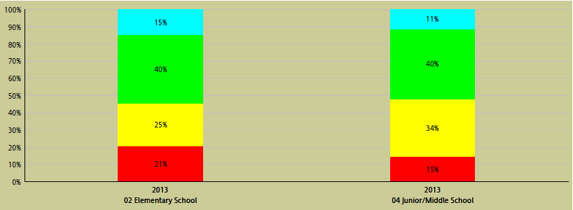

MCA-II Math (Grade 11)
Chart 1 shows the percentage of Caledonia elementary, middle school and 11th grade students exceeding (BLUE), meeting (GREEN), partially meeting (YELLOW) and not meeting (RED) mathematics standards.

Comparison of Caledonia and State 2013 MCA-III and MCA-II Math Percent Proficient
Chart 2 MCA-III Math (Grades 3-8)
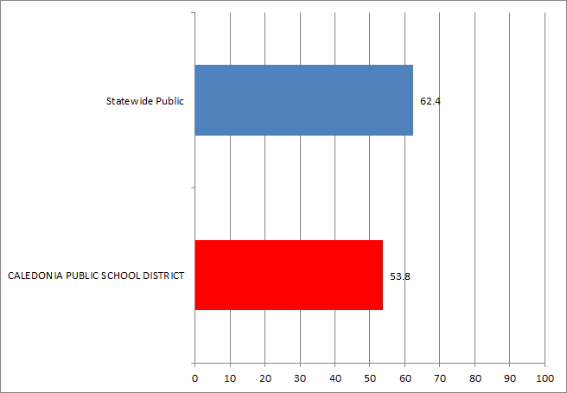
MCA-II Math (Grade 11)
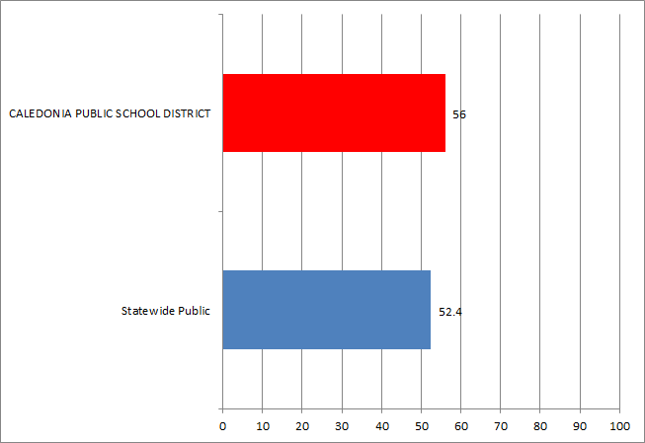
Chart 2 above is a comparison between Caledonia students and students across the state.
Chart 3.
Percentage Demonstrating Proficiency on the 2013 MCA-III Reading Tests
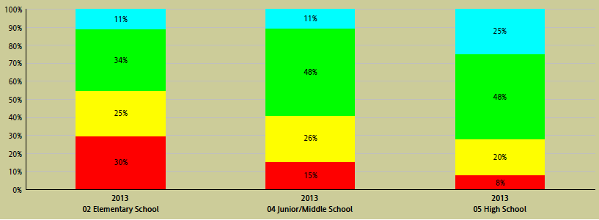
Chart 3 shows the percentage of Caledonia elementary, middle school and 10th grade students exceeding, meeting, partially meeting and not meeting reading standards.

Chart 4.
Comparison of Caledonia and State 2013 MCA-II Reading Percent Proficient
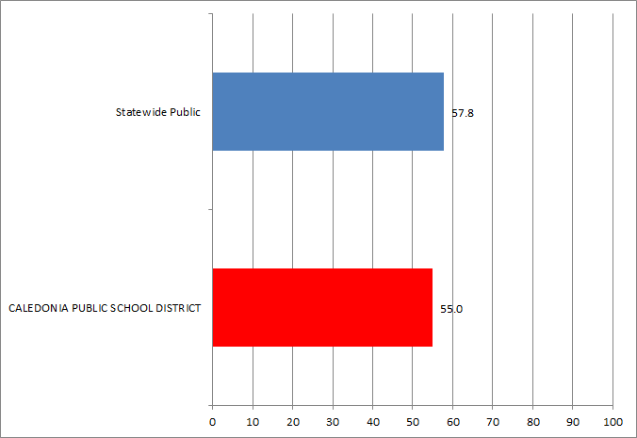
Chart 4 is a comparison between Caledonia students and students across the state. Caledonia students performed below the state as a district in reading.

Chart 5.
Percentage of Caledonia Elementary Students Exceeding, Meeting, Partially Meeting and Not Meeting MCA-III Reading Standards by Grade Level
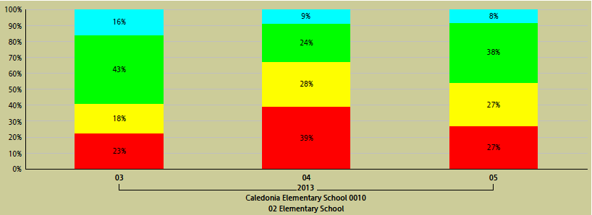

Chart 5 shows the percentage of elementary students by grade level exceeding, meeting, partially meeting and not meeting reading standards.
Chart 6.
Percentage of Caledonia Middle School Students Exceeding, Meeting, Partially Meeting and Not Meeting MCA-III Reading Standards by Grade Level.
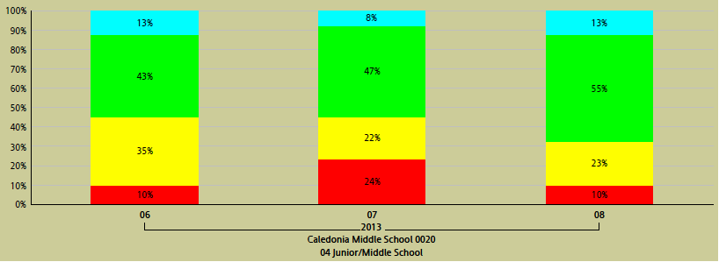
Chart 6 shows the percentage of middle school students by grade level exceeding, meeting, partially meeting and not meeting reading standards.

Chart 7.
Percentage of 10th Grade Caledonia High School Students Exceeding, Meeting, Partially Meeting and Not Meeting MCA-III Reading Standards
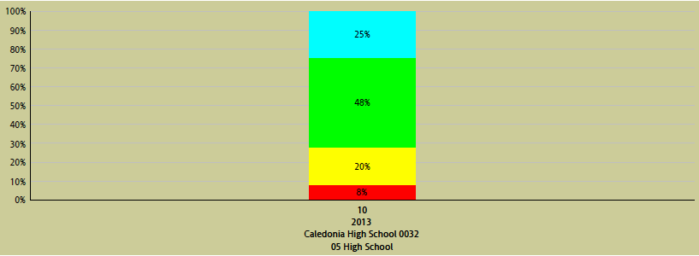

Chart 7 shows the percentage of 10th grade students exceeding, meeting, partially meeting and not meeting reading standards.

Chart 8.
Comparison of Percent of Students by Grade Level in Caledonia and State Proficient in Reading
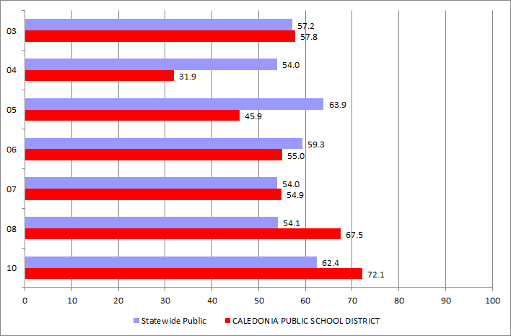
Chart 8 is a comparison between Caledonia students and students across the state. Caledonia students out-performed the state in grades 3,7,8, and 10.

Chart 9.
Percentage of Caledonia Elementary Students Exceeding, Meeting, Partially Meeting and Not Meeting MCA-III Math Standards by Grade Level.
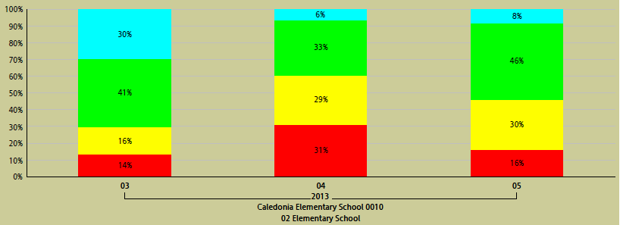
Grade Level

Chart 9 shows the percentage of elementary students by grade level exceeding, meeting, partially meeting and not meeting math standards.

Chart 10.
Percentage of Caledonia Middle School Students Exceeding, Meeting, Partially Meeting and Not Meeting MCA-III Math Standards by Grade Level.
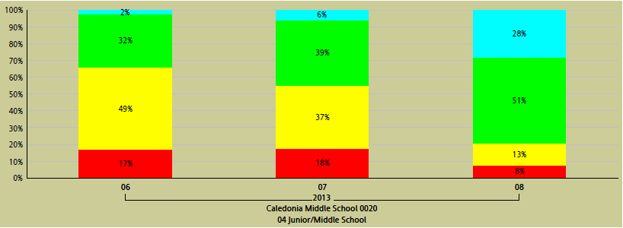
Grade Level
Chart 10. shows the percentage of middle school students by grade level exceeding, meeting, partially meeting and not meeting math standards.

Chart 11.
Percentage of 11th Grade Caledonia High School Students Exceeding, Meeting, Partially Meeting and Not Meeting MCA-II Math Standards.

Chart 11 shows the percentage of 11th grade students exceeding, meeting, partially meeting and not meeting math standards.

Chart 12.
Comparison of Percent of Students by Grade Level in Caledonia and State Proficient in Math
MCA-III Math (Grades 3-8)
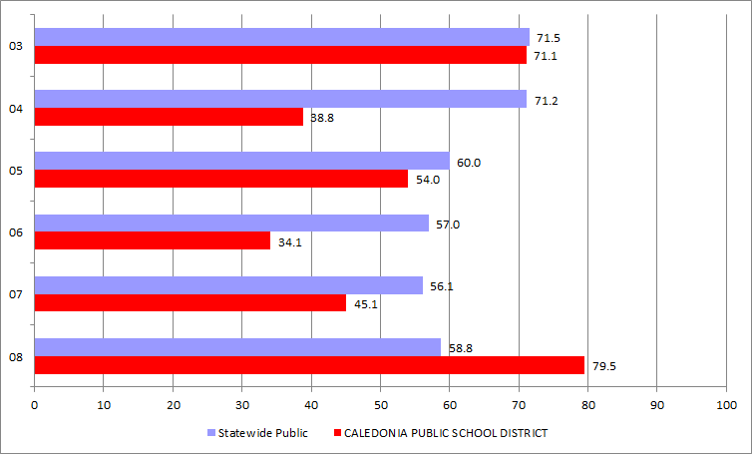

MCA-II Math (Grade 11)
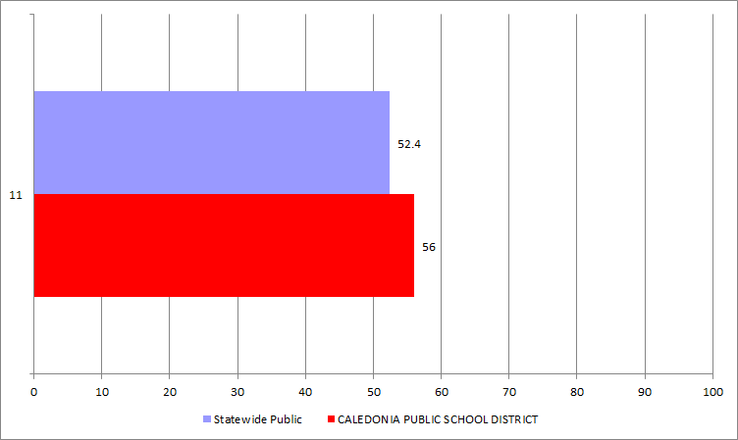
Chart 12 compares student proficiency levels in Caledonia against the state.

Chart 13.
Comparison of Percent Proficient in Reading across Grade Level in Caledonia by Gender Compared to State
2009-2013 district All MCA Accountability Tests Reading % Proficient by gender
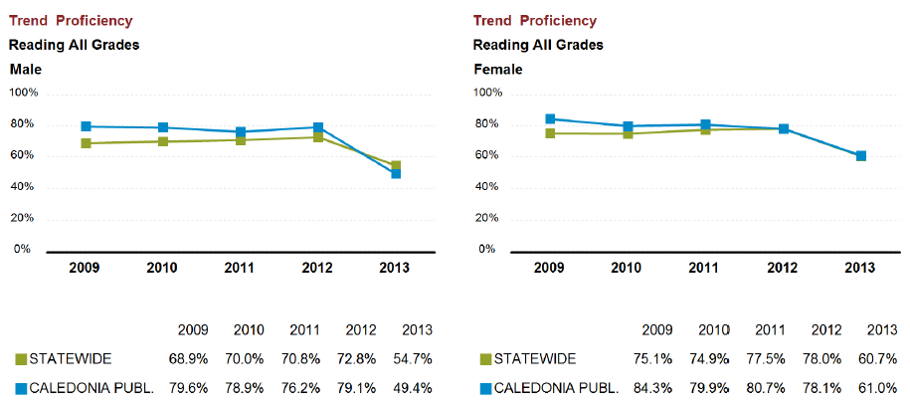
Chart 13 compares Caledonia males and females on the MCA reading assessment from the years 2009– 2013. The trend over time represents females out performing males in reading.

Chart 14.
Comparison of Percent Proficient in Math across Grade Level in Caledonia by Gender Compared to State
2009-2013 district All MCA Accountability Tests Math % Proficient by gender

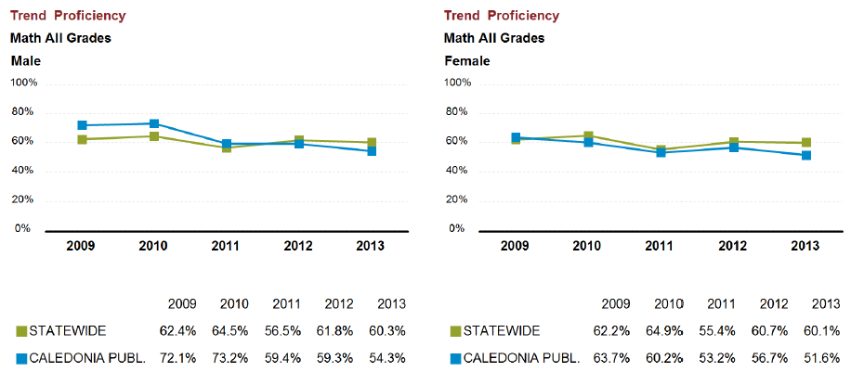
Chart 14 compares Caledonia males and females on the MCA math assessment from the years 2009 – 2013. The trend over time represents emales out performing females in math.

Chart 15.
2013 MCA-III and MCA-II Math Percent Proficient by Special Education Status Compared to the State
MCA-III Math (Grades 3-8)
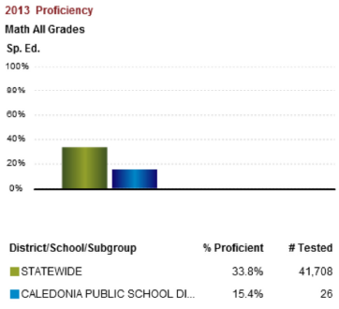
Chart 15 compares Caledonia special education student to the state special education students in math. In 2013 fewer Caledonia special education students scored proficient in math compared to the state\

Chart 16.
2013 MCA-III Reading Percent Proficient by Special Education Status Compared to the State.
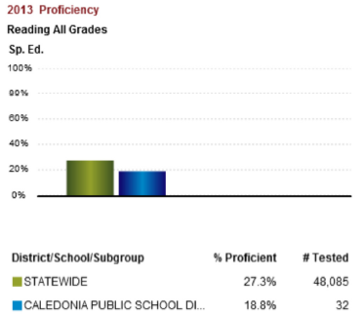
Chart 16 compares Caledonia special education students to the state special education lower percent score proficient in reading compared to the state.

Chart 17.
2013MCA-III and MCA-II Math Percent Proficient by Free/Reduced Lunch Status Compared to the State.
MCA-III Math (Grades 3-8)
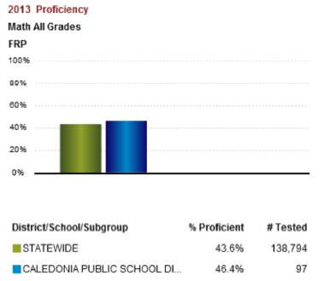

MCA-II Math (Grade 11)
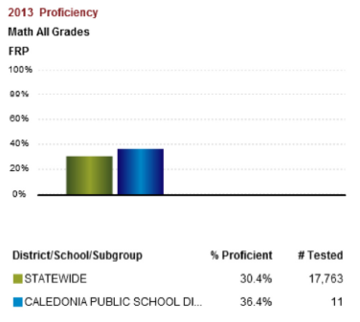

Chart 17 compares Caledonia free and reduced lunch status students to the state free and reduced lunch status students in math. This chart indicates in grades 3 – 8 and 11 Caledonia percent is higher than the state.

Chart 18.
2013 MCA-III Reading Percent Proficient by Free/Reduced Lunch Status Compared to the State.
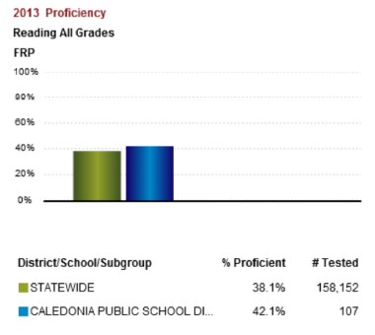
Chart 18 compares Caledonia free and reduced lunch status students to the state free and reduced lunch status students in reading. This chart represents that Caledonia free and reduced students had a higher percentage pass the reading test compared to the state.

Minnesota Comprehensive Assessment Graduation Test
Minnesota Comprehensive Assessment, MCA-II/GRAD is a required assessment for high school students. The written composition assessment is taken in grade 9, the reading assessment is taken in grade 10, and the mathematics assessment is taken in grade 11. Students must obtain a satisfactory score on each of these tests to graduate from a public school in Minnesota. 93.2% of freshman and sophomore students passed the writing test required for graduation. 72.1% of sophomore students passed the reading graduation test. 56.1% of junior students passed the math graduation test. Students not passing will be provided remediation opportunities and will be able to retake the assessments every six weeks until they pass the graduation test. 33% of students who retook the math assessment in the summer of 2013 passed.
The district met adequate yearly progress (AYP) in reading for all sub categories (ethnicity, gender, economically disadvantaged, special education. The district met adequate yearly progress (AYP) in reading and math for all sub categories (ethnicity, gender, economically disadvantaged, special education), with the exception of the ethnicity cell for math as a district and as the elementary school.

