2014-15 Caledonia Area Public Schools
World’s Best Workforce Report Summary
In accordance with Minnesota Statutes, section 120B.11, a school board, at a public meeting, shall adopt a comprehensive, long-term strategic plan to support and improve teaching and learning that is aligned with creating the world's best workforce. The school board must publish an annual report on the previous year’s plan and hold an annual public meeting to review goals, outcomes and strategies. An electronic summary of the annual report must be sent to the Commissioner of Education each fall.

This document serves as the required template for submission of the 2014-2015 report summary. Districts must submit this completed template by December 1, 2015 to MDE.WorldsBestWorkForce@state.mn.us.

Worlds Best Workforce Stakeholder Engagement and Committee – We have a committee of stakeholders that represent school administration, school board, teachers, parents, and business leaders. Members of our WBWF included the following people:
- Ben Barton – Superintendent
- Gina Mienertz – Elementary Principal/Curriculum Director
- Paul DeMorett – MS/HS Principal
- Jared Barnes – School Boar/Parent
- Jean Meyer – School Board
- Angela Stigeler – Parent
- Cindy Colleran – Support Staff/Parent
- Janelle Field Rohrer – Teacher
- Dan McGonigle – Parent
- Eric Jerviss – Tech. Coordinator/Parent
- Sherri Allen – Parent
- Amanda King – School Board/Parent
- Faith Rytilahti – Parent
- Emily Ranzenberger – Student
- Brenna Werner - Student

The committee accomplished a great deal in its first year. The committee created a stakeholder survey that went out to all the parents of our community. In addition, the committee partnered with the Caledonia school board and the Spring Grove School District to participate in multiple systems planning sessions that was facilitated by the South East Service Cooperative. The systems planning included updating mission, core values, reviewing big questions, and the adopt of BOLD steps for the future. The committee will continue to meet and review progress, create new surveys to stakeholders, and plan to move our BOLD steps for the future forward.

We have created a district web page that hosts our Worlds Best Workforce Work. You can find it at: http://cps.k12.mn.us/page/3770

We did not hold a separate meeting outside of a regular school board meeting for our annual report. We provided our annual report at a regular scheduled school board meeting in October and November. We reported our data and shared goals for the upcoming year at these meetings. We do plan to have a separate meeting on this in January of this year.

District Mission, Core Values, AIMS, and Goals
District Mission
To provide the best education to empower all learners to thrive in our changing world
District AIMS and Goals
High Student Achievement
- All graduating students are prepared for career and/or post- secondary education.
- Curriculum, instruction, assessment, and professional development are aligned in a clear process of learning.
- Researched based best practices are implemented into all academic and extra-curricular areas.
Optimal Teaching and Learning Environment
- Community partnerships are promoted to enhance student and community relationships.
- Progressive technology is available to expand students’ preparation for career and/or post-secondary education.
- District Core Values are integrated throughout the school community.
Efficient and Effective Operations
- Facilities are safe, well maintained and promote a learning environment.
- Professional “best practices” learning and training opportunities are provided for all staff and implementation of these practices is supported.
- At least an 8% operating reserve is achieved by the 2018 school year.

Values
Integrity
We hold ourselves accountable for fostering a culture of good citizenship built on honesty and respect for all individuals.
Collaboration
We serve our students, staff, and community by embracing our diversity and working together as good stewards of lifelong learning.
Innovation
We embrace ideas that move us beyond our current levels of success and challenge us to build ever-greater learning opportunities.

Big Questions
- What steps will we take to ensure our school district is recognized with pride by community, staff, students, and families as a leader in innovative teaching and learning?

- How will we engage our stakeholders (students, prospective families, parents and guardians, private industry, community services, alumni, staff, and board) so that each contributes to the mutual growth and success of both our schools and the communities we serve?

- How will we integrate innovative planning, development, and instructional design to personalize education for all students?

Caledonia Bold Steps
- Explore options and feasibility of flexible learning year implementation.
  - Start with ADSIS – year-round for struggling learners and personalize schedules.
  - Idea: flipped ag course.
  - Summer school options for all students
  - Develop a task force to investigate a balanced calendar.
- Create opportunities to invite partnerships in community.
  - Strategies: volunteerism, service learning for students, apprenticeship opportunities.
  - Parent engagement: Design and implement a broad set of strategies to increase parent engagement.
- Seek out opportunities for personalized learning for students, staff, and community to enhance learning and accountability.
  - Invite community to take college level courses in our school.
  - All day every day 4-year-old free pre-school.
  - Personalize professional development.
  - Collaborate with local businesses to jointly assess their training needs and assist them in meeting those needs (with instructors, designing assessments, designing training).
- Create a curriculum plan based around cornerstone assessments which rely on project based learning that allows students to assimilate and articulate cumulative learning using 21st century skills.
  - Integrate 21st century spaces.
  - Institute a capstone project as a graduation requirement.
  - Engaged learning.
- Develop and implement effective plan that supports positive school climate and district culture.
  - Develop marketing and communications that support this bold step.
  - better inform parents, using multiple strategies – about what we are doing to educate their children.
  - Institute a robust marketing campaign for current realities in the school.
  - Develop and implement a planning model that increases staff engagement.

Follow-Up
- Develop a flow-chart or other visual to organize these Bold Steps into realistic, actionable items with management timelines and responsibilities.
- Identify and document existing strategies, initiatives that align with these Bold Steps.
- Identify individuals/groups who will volunteer to be assigned to work on specific Bold Steps and/or strategies.
- Identify existing initiatives that could be de-prioritized or eliminated to provide time and opportunity for new focus areas.

Goals and Results/Broad Outcomes Impacted
Note that the 2014-15 plan did not create SMART goals for each of the 5 areas associated with the WBWF plan. Our WBWF committee will work to create SMART goals for the 2015-16 plan.

All Students Ready for Kindergarten
We use multiple measurements to identify Kindergarten readiness. The following programs work in partnership to get all students ready for Kindergarten: Early childhood screening, Hand in Hand Preschool, Early childhood family education, Kindergarten Academy, Preschool teachers assess students in home and community day cares, Early Childhood Special Education Preschool Integrated Program, Head Start, Houston County Early Childhood Initiative, PreSchool Teachers Collaborate with K-1 teachers in PLCs.

All Students in Third Grade Achieving Grade-Level Literacy
We have not met our goal of having all students at grade level for reading by 3rd grade. We have a detailed literacy by 3rd grade goals and plan, RtI problem solving and intervention data; Title I. SMART goals, data, ADSIS programming, and we have changed our curriculum for reading and are currently implementing the first year of Reading Streets

Closing Achievement Gap(s)
As we review our updated Multiple Measurement Data (MMR), we have found that we have made significant improvement in this area. Our elementary school went from being a “continuous improvement” school to “reward” school. We are analyzing our Title 1 and ADSIS programming to increase growth.

All Students Career- and College-Ready by Graduation
We have analyzed the ACT results from the last 5 years and have found that Caledonia is at the state average. We have between 75% and 85% of our graduates take the ACT yearly. We have developed a details College and Career Readiness Plan. Our counselor has gone to several training put on by MDE and is modifying our plan on a regular basis.

All Students Graduate
We have a goal that all of our students will graduate and we have been largely successful at achieving this goal. Historically, some of our struggling students had left our school to attend an Alternative Learning Center (ALC). Over the last year we have not referred one student to an ALC. This is due to increased interventions being implemented at the HS. We had one student that did not graduate last year. That gives us a 98% graduation rate.

Identified Needs Based on Data
Our schools use a variety of tools to measure and determine students’ academic growth and proficiency of grade level standards. These tools range from informal assessments observed during classroom activities to formal, mandated assessments such as the Minnesota Comprehensive Assessment (MCA). Educators can use these assessments to identify the needs of the students and adjust instructional strategies to meet the needs of their students and encourage individualized academic growth. We assess students the following ways: Early Childhood Screening, MCAs, NWEA MAP, AIMS Web, EXPLORE, PLAN, and ACT data as well as high school credit completion and graduation rates.
We have identified the following needs – increase proficiency in reading, mathematics, science at the elementary and secondary levels for all students, reduce the readiness and achievement gaps of our Special Education student population at the elementary school. We have found based on our Multiple Measurement Report (MMR) that we need to put more of an emphasis on student growth regardless of achievement level.
Supporting Data
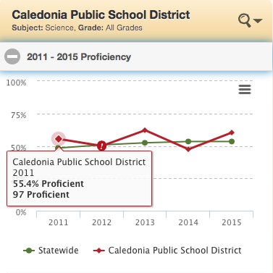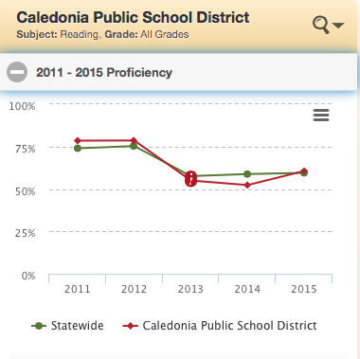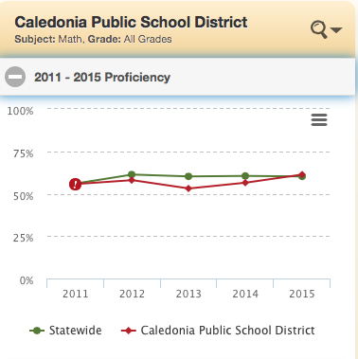

District Supports Category

Students
- Elementary – Preschool student needs are addressed by differentiation, flexible grouping, and special education. Elementary student needs are being addressed through flexible grouping for reading and mathematics; Adoption of new reading and math curriculum materials that are better aligned with standards, Differentiation of instruction based on data, 1:1 computing environment in grades 4-5; iPad technology available on a daily basis to support and individualize instruction; Response to Intervention (RtI) support; Positive Behavior Intervention Supports (PBIS); Multi Tier Systems of Support with ADSIS and Title 1; special education instruction; After school and summer Targeted Services programming.

- Secondary – Student needs are being addressed through differentiated courses for language arts, mathematics and science; 1:1 iPad technology available 24/7 for individualized student instruction, research and collaboration;; After school and summer Targeted Services; special education; HS focus on problem solving and critical thinking, double academic engaged time in reading and math for students below grade level, and college in the schools courses.

Teachers and Principals

Implementation of comprehensive principal development and evaluation system; collaborative planning for new comprehensive teacher development and evaluation system; comprehensive teacher and principal professional development program; weekly job-embedded professional learning communities (PLCs) for all teaching staff; Access to and training for effective use of technology for instruction and collaboration offered during the school year and throughout the summer; Access to academic data analytics software and support from our Hiawatha Valley Assessment Coordinator; PBIS coaches; Collaborative responsibility for development of site improvement plans, including SMART goals, activities, benchmarks and evaluation strategies.

Systemic, Building or District

Weekly job-embedded Professional Learning Communities (PLCs); Staff training and professional development for licensed and non-licensed staff; Academic data analytics support; PBIS coaches, MN State Teacher Evaluation Pilot; Collaboratively developed and implemented Site Improvement Plans.

Visual Representation of District Supports and Best Practices

Best Practice Strategies and Action Steps
Caledonia Area Schools is a work in progress toward transforming to provide the best education possible to prepare our students to thrive in the 21st Century. We have set building goals and action plans, created PLCs with embedded time within the day to focus on action plans to meet building wide goals. We have adopted a teacher evaluation system that requires teachers to create goals and action plans that are aligned with building and PLC goals. Our Professional Learning Communities (PLCs) focus on staff development and implementation of the following best practices: book studies on differentiation of instruction, analyzing data through our data warehouse and NWEA, Interdisciplinary unit planning, creation of learning targets and formative assessments matched to each target, technology integration, team/co-teaching with Special Education and Title One, planning for extra academic engaged time through ADSIS or targeted services, and processes to increase problem solving and critical thinking.

Current Student Achievement Plans
Site Improvement Plans; PLC achievement plans; School Readiness Plan; RtI, PBIS; Elementary Continuous Improvement Plan; Literacy by Third Grade Plan; Title I Plan; Title II Professional Development Plan; Principal Development and Evaluation Plan; Teacher Development and Evaluation Plan; Student Transition to College and Career Readiness Plan; Targeted Services Plans; and Individualized Education Plans (IEP).

Key Indicators of Implementation Progress
Site SMART Improvement goals, Principal and Teacher Goals and Action Plans; Action Plans and Site Progress Reports; PLC SMART improvement goals; Title I, II and III annual reports; Assessment Reports; Academic data analytics reports; credit completion; graduation rate

