**Upcoming Trainings in McLeod County and Surrounding Areas**

[Check out the calendar for National Alliance on Mental Illness (NAMI) Minnesota](https://namimn.org/namimn-events/event-calendar/)

[2B Continued Events](https://www.2bcontinued.org/events/)

**CBD and parents’ attitudes about giving it to children**

Author: Beata Mostafavi

Most parents say CBD for kids should require a doctor’s prescription, while 7% have given or considered giving it to children for medical reasons.

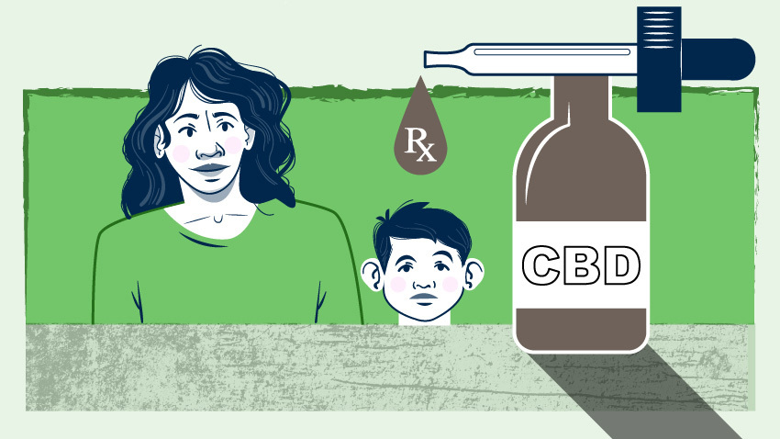

Products containing cannabidiol, or CBD, a chemical compound naturally found in marijuana and hemp, have been used in recent years to help adults manage medical issues like chronic pain and mood disorders.

While its use is much more limited in children, some CBD products have been marketed for minors as well.

But despite the wide availability of CBD, parents have limited knowledge about it, with a third thinking it’s the same as using marijuana, suggests the University of Michigan Health C.S. Mott Children’s Hospital National Poll on Children’s Health.

And while the majority haven’t even considered having their child use a CBD product, three in four parents appeared open-minded about the possibility, saying it may be a good option for medical care when other medications don’t work.

“There is very little data on how CBD may impact children’s developing brains and only certain types of situations when it’s considered for pediatric medical reasons. Still, CBD has become much more accessible and widely advertised, with some companies claiming benefits for kids,” said Mott Poll co-director Sarah Clark, M.P.H.

The nationally representative poll report is based on responses from 1,992 parents of children 3-18 years surveyed in October 2021.

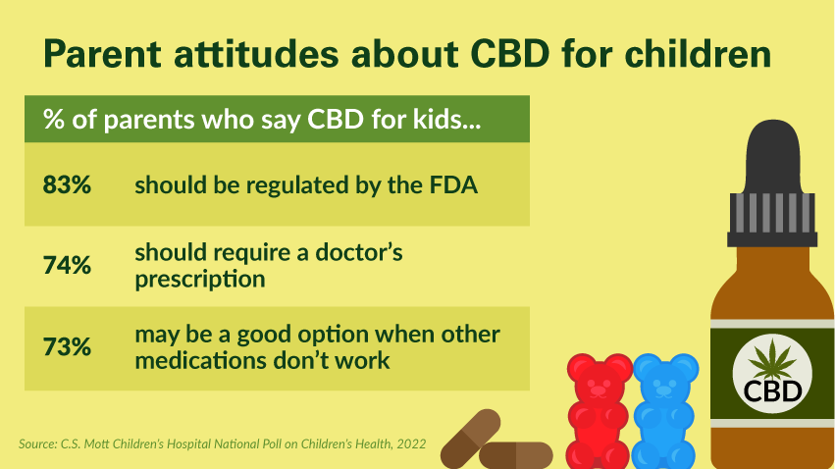

Seven percent of parents have given or considered giving their child a CBD product, with the most common reasons including anxiety (51%), sleep problems (40%), attention deficit hyperactivity disorder, or ADHD, (33%), muscle pain (20%), autism (19%) and to make their child feel better in general (13%).

Among parents who say they’ve given or considered giving CBD to their child, less than a third have talked with their child’s health care provider about CBD use.

And while three quarters of parents felt CBD for children should require a doctor’s prescription, only 63% rated the recommendation of their child’s doctor as a strong factor in deciding whether to give their child a CBD product.

"Anecdotal stories of children benefiting from CBD may sound alluring but just because it’s a plant product doesn’t necessarily make it safe or effective in children." Sarah Clark, M.P.H.

“Our poll suggests most parents have very limited knowledge about CBD products,” Clark said. “It’s important for parents to inform their pediatrician or other healthcare providers if they’re considering CBD use in kids so that they can discuss potential risks.”

Most parents cited side effects as the most important factor in deciding whether to give their child a CBD product. Other considerations included whether it was tested for safety in children, how well it works in children, approval of the U.S. Food and Drug Administration and product reviews.

The majority of parents have never used a CBD product themselves, while 24% have tried it and 5% use a CBD product regularly, according to the poll report.

**Many unknowns on side effects**

CBD products are sold online and in stores that specialize in CBD products, as well as in supermarkets and drugstores and come in many forms, including oils, topical ointments, vaping, edibles and gummies.

The FDA has only approved one purified form of the drug substance CBD for children to treat rare seizures that don’t respond to medication. Studies have also looked at CBD use in children with hyperactivity, anxiety, sleep problems and depression but research remains limited.

Side effects could include sleepiness, fatigue, and diarrhea, and experts have raised concerns about CBD’s potential to interact with other medications and adversely impact the liver. But since CBD products have not undergone rigorous testing for FDA approval, the rate and severity of side effects remain unclear, particularly for children.

To be legal, CBD must have less than .3% of tetrahydrocannabinol, commonly referred to as THC, the chemical that produces most of marijuana's psychological and “high” effects. Many manufacturers purport to contain close to 0% THC, but the lack of regulation of CBD products also raises questions about quality control in the production of various products, experts say.

“Parents who see promotional content claiming CBD benefits kids with certain conditions should be aware that products seen online or in stores are not regulated by the FDA and may be mislabeled,” Clark said. “This makes it difficult for parents to know exactly what they’re buying and what their child may be exposed to.

“Anecdotal stories of children benefiting from CBD may sound alluring but just because it’s a plant product doesn’t necessarily make it safe or effective in children. We need more evidence to understand CBD’s short- and long-term side effects in kids.”

[Source](https://healthblog.uofmhealth.org/childrens-health/cbd-and-parents-attitudes-about-giving-it-to-children)

**NAMI/Ipsos Poll: Teens Struggling with Their Mental Health, but Parents and Schools Can Help**

ARLINGTON, Va., Aug. 30, 2022 /PRNewswire/ -- A new National Alliance on Mental Illness (NAMI) Teen Poll, conducted by Ipsos, found that teens who are struggling with their mental health are looking to their schools and parents for information and support.

"While the pandemic has taken a toll on our young people's mental health, which was already showing troubling signs, this poll of young people shows that adults and schools have the opportunity — and an obligation — to help," said Daniel H. Gillison Jr., CEO of NAMI.

According to the poll, about 1 in 4 teens have been diagnosed with a mental health condition, and 64% feel the world is more stressful now than when their parents were their age. While teens are comfortable talking about mental health, they often don't start the conversation. Almost all the teen respondents (95%) who seek mental health information from their parents or guardians trust them, but initiating these conversations is still a hurdle that teens need help overcoming: Only about half (48%) say they talk to their parents or guardians regularly about their mental health.

Parents can help by normalizing mental health conversations early on and by acknowledging their own emotions and coping strategies. To help parents, NAMI offers NAMI Basics, a no-cost educational course for parents of children with mental health conditions and is available both in-person and on demand.

The poll also found that teens are looking to schools to play a role in mental health, and they trust the information they get there. Seven in 10 teens agree that schools should teach about what mental health is, and 68% want their school to share information about treatments. Teens also think that schools should offer mental health days (67%). A dozen states have already passed laws providing these days, a policy NAMI supports.

Additionally, about 4 in 5 teens who seek mental health information from their teachers say they trust those adults, which provides a large opportunity for schools. NAMI Ending the Silence is a presentation program for middle- and high-school youth that provides essential information about mental health, as well as a personal story from a young person with a mental health condition.

Additional Resources for Parents: NAMI Basics OnDemand and local NAMI Family-to-Family Support Groups as well as the NAMI Kids, Teens and Young Adults section.

Methodology: This poll was conducted by Ipsos on behalf of NAMI between July 15–Aug. 1, 2022, using the probability-based KnowledgePanel®. It is based on a representative sample of 1,015 U.S. teens (ages 12-17) recruited through their parents. The margin of sampling error is plus or minus 3.5 percentage points at the 95% confidence level.

The National Alliance on Mental Illness is the nation's largest grassroots mental health organization dedicated to improving the lives of individuals and families affected by mental illness. Join the conversation at nami.org | facebook.com/nami | instagram.com/namicommunicate | twitter.com/namicommunicate #Together4MH

[SOURCE National Alliance on Mental Illness](https://www.prnewswire.com/news-releases/namiipsos-poll-teens-struggling-with-their-mental-health-but-parents-and-schools-can-help-301614459.html)

**Rise in Prescription Drug Misuse and Abuse Impacting Teens**

The fastest-growing drug problem in the United States isn’t cocaine, heroin, or methamphetamines. It is prescription drugs, and it is profoundly affecting the lives of teenagers.

According to National Institute on Drug Abuse (NIDA) DrugFacts, prescription drug misuse and abuse is when someone takes a medication inappropriately (for example, without a prescription). Sadly, prescription drug misuse and abuse among young people is not an insignificant problem. According to National Survey on Drug Use and Health (NSDUH) data on youth and young adults, more than 5,700 youth in 2014 reported using prescription pain relievers without a doctor’s guidance for the first time.

A common misperception is that prescription drugs are safer or less harmful to one’s body than other kinds of drugs. However, there is a range of short- and long-term health consequences for each type of prescription drug used inappropriately:

Stimulants have side effects in common with cocaine, and may include paranoia, dangerously high body temperatures, and an irregular heartbeat, especially if stimulants are taken in large doses or in ways other than swallowing a pill.

Opioids, which act on the same parts of the brain as heroin, can cause drowsiness, nausea, constipation, and, depending on the amount taken, slowed breathing.

Depressants can cause slurred speech, shallow breathing, fatigue, disorientation, lack of coordination, and seizures upon withdrawal from chronic use.

These impacts can be particularly harmful to a developing adolescent brain and body. Our brains continue to develop until we reach our early- to mid-twenties. During adolescence, the pre-frontal cortex further develops to enable us to set priorities, formulate strategies, allocate attention, and control impulses. The outer mantle of the brain also experiences a burst of development, helping us to become more sophisticated at processing abstract information and understanding rules, laws, and codes of social conduct. Drug use impacts perception—a skill adolescent brains are actively trying to cultivate—and can fracture developing neural pathways. Additionally, as our brains are becoming hardwired during adolescence, the pathways being reinforced are the ones that stick. If those pathways include addiction, the impact may lead to life-long challenges.

As with any type of mind-altering drug, prescription drug misuse and abuse can affect judgment and inhibition, putting adolescents at heightened risk for HIV and other sexually transmitted infections, misusing other kinds of drugs, and engaging in additional risky behaviors.

**Solutions**

Here are several ways to minimize prescription drug misuse and abuse among young people:

Education: One in four teenagers believe that prescription drugs can be used as a study aid and nearly one-third of parents say that they believe that attention-deficit/hyperactivity disorder (ADHD) medication can improve a child’s academic or testing performance, even if that child does not have ADHD. Parents, children, and prescribers must be educated on the impact of prescription drugs on the developing brain.

Safe medication storage and disposal: Two-thirds of teens who misused pain relievers in the past year say that they got them from family and friends, including their home’s medicine cabinets, making it important to safeguard medicine in the home, according to the Partnership for Drug-Free Kids. Safe storage and disposal of medications diminish opportunities for easy access.

Prescription drug monitoring: Many people are calling on doctors and pharmacies to better monitor how (and how often) drugs are prescribed. Doctors more readily hand out prescription painkillers than they did ten years ago, and, according to some sources, pharmacists do not habitually check prescription drug registries, which help to identify potential over-prescribing and misuse.

In addition, educating adolescents and their parents about the risks of drug misuse and abuse can play a role in combating the problem. The National Institute on Drug Abuse (NIDA), a component of the National Institutes of Health (NIH), created the website NIDA for Teens: The Science Behind Drug Abuse to educate teens, their parents, and teachers on the science behind prescription drug misuse and abuse. Developed with the help of teens to ensure relevance, NIDA scientists created a site that delivers science-based facts about how drugs affect the brain and body so that young people will be armed with better information to make healthy decisions.

[Source](https://www.samhsa.gov/homelessness-programs-resources/hpr-resources/rise-prescription-drug-misuse-abuse-impacting-teens)

**Mental Health Disorders and Teen Substance Use**

**Why it's especially tempting — and risky — for kids with emotional or behavioral challenges**

Writer: Caroline Miller

Clinical Expert: Sarper Taskiran, MD

When teenagers are struggling with emotional problems, they often turn to alcohol or drug use to help them manage painful or difficult feelings. In this they are not different from adults. But because adolescent brains are still developing, the results of teenage “self-medication” can be more immediately problematic.

In the short term, substance use can help alleviate unwanted mental health symptoms like hopelessness, anxiety, irritability and negative thoughts. But in the longer term it exacerbates them, and often ends in abuse or dependence. Substance use escalates from experimentation to a serious disorder much faster in adolescents than it does in adults, and that progression is more likely to happen in kids with mental health disorders than in other kids.

“The rule of thumb is that almost half of kids with mental health disorders, if they’re not treated, will end up having a substance use disorder,” explains Sarper Taskiran, MD, a child and adolescent psychiatrist at the Child Mind Institute. A 2016 study of 10,000 adolescents found that two-thirds of those who developed alcohol or substance use disorders had experienced at least one mental health disorder.

Substance use also interferes with treatment for mental health disorders and worsens the long-term prognosis for a teenager struggling with one. How can we help these young people avoid the substance use trap when the deck seems to be stacked against them?

**Why are kids with mental health disorders prone to substance use?**

Kids who are anxious or depressed may feel more emotionally “even” if they drink or smoke marijuana. For socially anxious kids, it can quiet the anxiety enough to allow them to function in peer groups. And since their friends do it, it’s not stigmatized the way taking medication is.

“Pre-gaming is a lot about anxiety,” notes Jeanette Friedman, MSW, who works with families of adolescents with substance use problems. “The kids are saying ‘Let’s go have some fun before we go to the real party.’ But in fact, most of them feel like they need it to calm down enough so they can walk into a group where they’re going to feel exposed and criticized.”

A teen with anxiety might start by smoking marijuana to calm down before social events, and soon find himself smoking every morning just to get to school. “I’ve had very stressed-out kids say, ‘I get high before I go to school because I’m so anxious when I think about the start of the school day,’ says Ms. Friedman. “‘If I smoke a little weed, I don’t feel so anxious.’”

Kids who are depressed may use alcohol or marijuana to cheer themselves up, Dr. Taskiran notes, and blunt the irritability that is a symptom of adolescent depression. “They know there’s something wrong with them,” he says. “They’re not taking pleasure in things, they’re not feeling happy. So if their peers are offering a drug that makes you happy, that’s often the first thing they turn to.” Substance use can quiet negative thoughts that plague depressed kids.

It’s also common for children with mental health or learning disorders to develop self-esteem problems, a sense that there’s something wrong with them or that they’re flawed. When these children reach adolescence, with its focus on fitting in, notes Ms. Friedman, “they really want to be normal and they don’t feel normal. And that means they’re more vulnerable to somebody passing around a drug, because they’re just trying to feel better.”

**Why is alcohol use riskier for teenagers?**

Alcohol affects teens differently from adults. While adults tend to get more subdued and slowed down by alcohol, in adolescents it’s the opposite. They tend to become more energetic, engage in more risky behavior and get more aggressive.

Dr. Taskiran uses the example of driving. “When adults drink and drive you worry about slowing of the reflexes and lapses in attention, like missing a stop sign,” he explains. “But with adolescents, we’re worried that they’re going to get more activated. It’s not that they won’t see the red light, but they might try to run it.”

This is especially dangerous for kids with ADHD, who are already impulsive. And substance use makes depressed teenagers more prone to impulsive suicidal behavior. “The adolescent will still be depressed,” says Dr. Taskiran, “but the things that usually hold him back won’t be there while he’s intoxicated, like love for family or the belief that he’s going to get better.”

**Why teenagers get addicted sooner**

Adolescent alcohol or drug use accelerates very quickly when an untreated mental health disorder is present. ”Within months we can see problematic use,” says Dr. Taskiran.

Why are they different than adults? In the adolescent brain, pathways between regions are still developing. This is why teens learn new things quickly. This “plasticity” means the brain easily habituates to drugs and alcohol. “If you start drinking at 30, you don’t get addicted nearly as fast as if you start drinking at 15,” adds Ms. Friedman.

Alcohol and drugs also affect the same brain regions that are at play in behavior disorders like ADHD and ODD, says Dr. Taskiran. Teenagers who have those disorders get more satisfaction from the substance — and are more likely to become addicted. “Biologically they get more from the drug,” he adds, “so that’s why they get more hooked on it.”

It’s important to know that substance use can disrupt a young person’s life even if he is not technically dependent on the drug. This is especially true for youth with mental health disorders. “You might not see withdrawal, you might not see the craving, which are the hallmark symptoms for dependence,” says Dr. Taskiran. “But the impact in his social life and academic life, or in terms of his mental wellbeing, might still be large.”

**Why substance use makes depression and anxiety worse**

“Self-medicating” with recreational drugs and alcohol works temporarily to alleviate symptoms of anxiety or depression because they affect the same brain regions that the disorders do. But the result is that teens feel even worse when not using. That’s one reason substance use is a risk factor for suicide in kids with depression, Dr. Taskiran notes.

Another negative effect of substance use is that it undermines treatment. First, it diminishes a teenager’s engagement in therapy, and hence its effectiveness. Second, if she is taking prescription medication, it may lower the effectiveness of that medication. “The drugs and the medications target the same areas of the brain,” explains Dr. Taskiran. When meds have to compete with drugs or alcohol, they are less effective. “Also, it’s not uncommon with kids who are using substances to be noncompliant with their meds.”

**Psychosis and substance use**

Michael Birnbaum, MD, is a psychiatrist who heads an early treatment program for young people who have had a first psychotic episode, usually signaling the onset of schizophrenia. Dr. Birnbaum estimates that at least 50 percent of his patients have at least some history of drug and alcohol use. Getting a handle on substance use is important for the recovery process, he says. “Folks who are still using are more likely to struggle with ongoing psychotic symptoms, and also are more likely to have a relapse.”

Most of the people who come to the early treatment program have just come from a hospitalization, he notes, and they are eager to make sure that doesn’t happen again. “So part of the discussion is how do we prevent a relapse?” he continues. At Dr. Birnbaum’s program, clinicians work to understand what substance use was doing for the patient. “It may seem obvious to us,” he says. “’Okay, you need to stop using now.’ But there may be other reasons for continued use that, to the patient, outweigh the risks.”

Dr. Taskiran echoes that approach. “The last thing I’d say from the get-go to one of my patients is, ‘Marijuana is bad for you,’ because the kid has heard that from teachers, parents, TV, everywhere. So instead what I say is, ‘What is it doing for you? What are you getting out of it?’”

All behavior serves a purpose, even if it’s self-injurious or risky behavior. “If you’re trying to take something away from a teenager, you need to replace it with something,” says Dr. Taskiran. “So instead of just saying, ‘Don’t do that, it’s bad for you,’ we’re trying to replace the need for substance with a coping strategy, with tools for coping without the substances.”

[Source](https://childmind.org/article/mental-health-disorders-and-substance-use/)