**SPECIAL MEETING of the SCHOOL BOARD of EDUCATION**

**Lester Prairie Public Schools**

**Monday September 12th, 2019 7:15 am**

**Lester Prairie School Media Center**

Roll call was taken and the following board members were present: Corbey Hentges,  Steve Ziermann, Megan Stifter Knoll, Rebecca Heimerl, Brian Heimerl, and Mary Otto Staff: Alice Daak, Administration present: Mike Lee, and Melissa Radeke.

Pledge of Allegiance was led by Steve Ziermann.

**Approval Agenda**

* Motion by Otto second by Stifter-Knoll to approve the Consent Agenda as present and or modified

**Vote: 6 for, 0 against**

**Discussion of Purchase of Residential Property at 300 2nd avenue North, Lester Prairie**

1. Pursuant to Minnesota Statutes 13D.05, Subd. 3, the meeting will close to develop or consider offers or counter offers for the purchase of said property.

* Motion by Otto second by Ziermann to approve the closure of the meeting.
  + Discussion took place
  + Alice Daak presented projected budget with purchase
* Motion by Ziermann and 2nd by Otto to go with proposal II offer for purchase of the property located 300 2nd Avenue North, Lester Prairie.

**Vote: 6 for, 0 against**

**Open Session - Board Action**

* Motion by Otto and 2nd by R. Heimerl to approve the opening of the meeting.

**Vote: 6 for, 0 against**

**Meeting was adjourned at 7:36 AM**

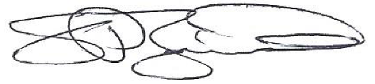

*Steven D. Ziermann, Clerk ISD #424*