Six-Year-Old Student
Our main challenge with this student is:
- Getting her to communicate within the classroom to either her peers or adults when at school.

Describe the behaviour so someone else can understand what it looks like
- No facial expression is shown in the classroom
- Occasional wetting herself towards the end of the day
- Shutting down when directly asking her a question
- Playing alone outside/standing on the numbers until the bell rings
- Students saying she is unable to talk as she does not talk both inside or outside in the classroom
- Joins in some classroom activities depending on if they have been undertaken previously
- Wary of new people in the space
- Occasionally whispers an answer to some staff members
- Will point and nod/shake her head inconsistently when asked a question.
- She enjoys helping a teacher

Academically this child is
Unable to assess in many curriculum areas due to her lack of communication.

Things we have already put in place are
- Communication book
- Daily classroom job
- Welcoming/talking to her with a friendly face
- Relationship building

We believe the level of parent support might be
Very supportive.

Any other comments or questions
She will often make small gains in a week then after the weekend go backwards again.

Trigger | Target | impacT
Interaction with adults and peers | Selective Mutism  (severe anxiety) | Avoids connecting with others
Revise the Environment | Replace the Behavior | Reframe the Response
I have given you many choices to implement with her based on your knowledge of her- It’s all spelled out for the three columns.

- The following pages are your choices:

Anxiety
Intervention | Revise Environment | Replace Behavior | Reframe Response
- Acupressure  http://tinyurl.com/accupressure4kids  For anxiety, stress, worrying- When students feel their heart begin to race- here is a technique they can be taught to help themselves self-regulate:  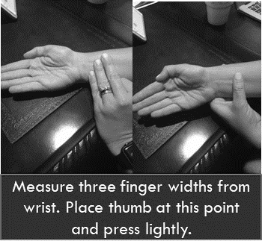  This slows down the heart rate and allows the student to calm down and focus on what is important. Whether or not you believe in acupressure, it works as a diversion which takes the student’s mind off their anxious focus. | This might be one of the tools you use in the calming area.  You might have a poster of this in the calming area. | This is a replacement behavior taught in private. It can be taught during check-in/check-out. A video can be made.  I like this strategy because a secondary student could use it and no one would know they were using a strategy. | Adult gives a secret signal of behavior specific praise when they see a student using this strategy.

Intervention | Revise Environment | Replace Behavior | Reframe Response
- Blue Beanbag Calming Area  http://tinyurl.com/targetbeanbagblue  (request through www.donorschoose.org )  For tantrums, anxiety, stress, verbal or physical aggression. You might wonder why blue? In the philosophy of Feng Shui, blue is a calming color. I prefer a pleather beanbag for two reasons: 1) critter resistance and 2) it is cool to the touch. Students with anger issues, anxiety, stress, or aggression tend to have increased heart rates which increases their core body temperature. The bean bag is like a cool hug. At the point of being upset, a child cannot be hugged into good behavior. However, training them when they aren’t upset to go to the blue beanbag and do their breathing exercises will help them calm themselves down.  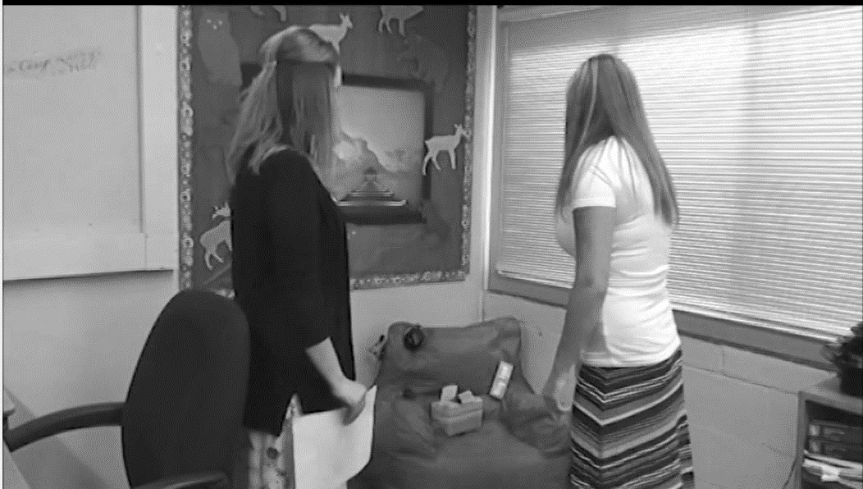 | This is a place in the classroom where anyone can go to get their thoughts together. I usually have the teacher model by acting like the computer is bothering them. They tell the class, just a minute- this is aggravating. I need to get myself together. They go over and model breathing technique, stress balls, 60 bpm music, and other calming activities.  Tell class, anyone can get frustrated. It’s okay, but we must respond in an appropriate way. This is the way to respond. | Students are taught what to do when they go to the calming area (hokey pokey clinic).  - Breathing  - Music  - Stress ball  - Affirmations | Adults not only model how to use, they give praise for using the calming spot appropriately.  Remember, what gets attention is where behavior grows.

Intervention | Revise Environment | Replace Behavior | Reframe Response
- Brain Gym  http://www.braingym.org/  https://www.alertprogram.com/  For disorganization, anxiety, stress, sleepiness, and impulsiveness. Brain Gym and the Alert program are two programs that teach students how to rev up their engines or slow their engines down. The program also has activities for connecting the right side of the brain with the left side of the brain and to get the synapses flowing before a test. They are great programs to use in the classroom. | One of the components of Brain Gym is a well hydrated brain, so allowing water bottles on the desks is very important. | This is a replacement behavior system that helps students learn how to regulate their own body. They have worked to make a program that works for young and older students. | Again, teacher giving behavior specific praise when they see students using the brain gym or alert strategies.  For most of the students, this should be done in private.
- Check-in/Check-out (CICO)  http://tinyurl.com/hawkencico  Check-in/Check-out is a wonderful program that can be used for anxiety, self-esteem, disorganization, verbal outbursts, verbal aggression, physical aggression (before it begins), and lack of ownership.  I really like the video produced by Dr. Leanne Hawken – the link is on the left. It’s a great one to show the entire staff and discuss which students would benefit from using the system. It’s geared for tier two students- however, it would be useful for those at-risk students as well. | The environmental component of this strategy is to set up a consistent person for the student to check-in and check-out with each day. This should be a positive person who cues the student on what is coming up for the day. At the end of the day, the check-in/check-out person checks to see how the day went and help the student process. | Replacement behaviors can be taught in CICO because it is one on one or small group.  If a child has anxiety about performance, a CICO instructor could pre-teach upcoming assignments and let the student know the answers to a few questions ahead of the introduction. | Behavior specific praise for appropriate responses.  Guiding reflection for times when the response was inappropriate. The nice thing is this is done in private and decreases anxiety issues.
Intervention | Revise Environment | Replace Behavior | Reframe Response
- Chewing Gum  http://tinyurl.com/chewgum4focus  For anxiety, impulsivity, hyperacusis, and stress.  - Chewing gum reduces anxiety  - More socially acceptable than chewing on pencils, shirts etc.  - Oral activity is calming  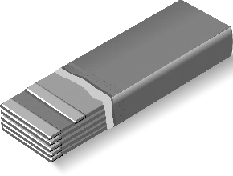  - Actually, dulls background noise by activating the Eustachian tube for students who find it hard to focus in noisy classrooms.  - Kids who chew gum during tests do 26% to 36% better. | First it must be allowed in the environment for all. It can’t be okay to chew gum in one class and not in another. | Students must be taught how to chew and how to dispose.  They need to understand why it is allowed. | Again, behavior specific praise (positive or negative about the use of gum)  All praise needs to be given in private for students with anxiety.
Dark Chocolate http://tinyurl.com/darkchocolateisgood  For students with anxiety, attention deficit hyperactive disorder (inattentive), and sleepiness.  - Research indicates a small piece of dark chocolate boosts memory, alertness, and concentration, and its special chemicals even decrease anxiety.  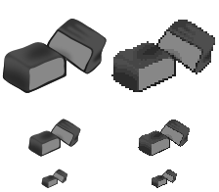  - They sell small bite size bars of dark chocolate- especially on test days- pass them out. | Again, must be allowed in the environment. It can not be allowed in one classroom and not in another.  We are talking about one piece- not a bag. | Student must be taught how to use the dark chocolate. This can be handled in CICO. For instance, “Today is Tuesday. Let’s talk about what’s going on today. When do you think your piece of dark chocolate would help you most?” | Adult gives appropriate responses to the student’s choice of when to take their dark chocolate piece.  “You chose to take your dark chocolate right before your math test. I think that was a wise choice.”

Intervention | Revise Environment | Replace Behavior | Reframe Response
- Equal Choices  - Research indicates that when we want to direct a student’s behavior, the best way is to offer equal choices. The choices must be equal and not a threat paired with a choice. “Do this or lose recess” is not an equal choice. Do you want to write your math problems with the red pencil or the green pencil is an equal choice. What happens when the choices are equal is that the synapses stay firing in the pre-frontal cortex. This means the student is thinking rather than going to brain stem.  - We have since found the choices should be offered from the right side of the student  - When information comes in the right ear, it is processed on the left side of the brain (the language processing side of the brain). When information comes in the left ear, it is processed on the right side of the brain (the creating thinking side of the brain). “I can think of ten other things I’d rather do than your fancy math paper.”  - Important caveat- not up close and creepy- just from the right side  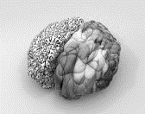 | Proactively plan for equal choices- make sure you know what you have on hand that you can offer as an equal choice.  Don’t offer something you aren’t willing to stand by. | See the last comment in the reframing the response- this is the behavior teaching part of this. | Teacher offers equal choices from right side of student.  Use a “non-threatening tone”.  Get on child’s level if they are on the floor or in a chair. (Don’t posture up against them)  What if they don’t choose one of your two choices? Choose for them. “I see you are not ready to choose. I’ll choose this time.” Quickly, they will learn to choose for themselves.

Intervention | Revise Environment | Replace Behavior | Reframe Response
- Good Breakfast (Eggs and Oatmeal)  http://tinyurl.com/eggsbrainfood  http://tinyurl.com/oatmealbrainfood  To increase test scores. Right before the high stakes tests- send home this information to parents. Breakfast is so important and what the students eat is even more important.  Don’t skip breakfast. Students who eat breakfast score higher on tests and report less test-related anxiety. Best bets? Eggs for brain-boosting choline, and oatmeal for a calming increase in serotonin levels. | There are two ways to look at this: 1) Invite parents to an open house and share the research with them on the importance of this breakfast choice or 2) Invite your business partner to come in and cook breakfast for the students at least one day a week. | Teach students the importance of what goes into their body affects what comes out of their body in behavioral responses. | Pretty much, adults can say things like, “Wow, I can tell you all ate a healthy breakfast this morning because I’m seeing a lot of brain power.” This helps children make better choices at home. This way we aren’t belittling anyone- they just might make a better choice the next day.
--Music (60bpm)  http://www.shortlist.com/entertainment/music/scientists-discover-most-relaxing-tune-ever  www.behaviordoctor.org- go to material download and check out videos.  To decrease aggressive behaviors and alleviate anxiety:  Music research tells us that our heart rates will match the music we are listening to. Also, research on students with aggressive behaviors tells us their heart rates jump up to 147 beats per minute (on average) a full 45-90 seconds prior to aggressive act. If we can intervene, by playing 60 bpm music (the resting heart rate), the students will be calmer. | Play 60 bpm music in the background- soft enough to talk over.  Have headphones set up to a listening station that is preset for 60bpm music when students need to calm. | Teach students the importance of what comes in is what behavioral response comes out.  Mathalicious has a great lesson on Jenn Ratio. | Model, oh my heart beat seems to be racing a bit due to stress. I think we should dim the lights and turn up the music for a few minutes. Let’s take a minute to write about what we are thinking in our journals.

Intervention | Revise Environment | Replace Behavior | Reframe Response
- Nature Pictures  http://behaviordoctor.org/calmingvideos.html  http://alexandria.tue.nl/extra2/afstversl/tm/De_Jonge_2011.pdf  For students with anxiety.  A University of Michigan research study found that looking at 7 minutes of nature pictures reduced anxiety before a test. The music link above is paired with nature pictures. You can show this before test with or without the music. | Make sure you have nature pictures in prominent places and make sure your most anxious students are facing a nature picture. | Privately have a student with anxiety choose an anchor picture to put in the front of their notebook. | Again, modeling the response. I was so frustrated last night because the computer program just kept spinning. I got out my picture of the icy forest that I love, and it just really helped me calm down and wait for the program to come up.
- Refrigerator Tubing for Kids Who Chew on Pencils  http://www.nationalautismresources.com/cheweze.html  Students who chew on their pencils because of anxiety. Take a pencil with you to a lumber yard and ask where the refrigerator tubing is located. Figure out which one fits on the end of a pencil and purchase a yard or two of it. It’s going to cost you less than $5. Push it on top of the pencil and cut it off even with the eraser. Then push it down a bit further so the eraser is free to be used. This will keep the student from chewing up the metal and chewing on the wood of the pencil. The tubing is food grade so it’s safe. | Having this available in the room for students who chew. | Teach student to slip it on their pencil (this can be done in CICO). Teach them to chew on that rather than clothing or metal pencil bands. | Whisper, “Good choice putting that on your pencil. I like how you are thinking proactively.”

Intervention | Revise Environment | Replace Behavior | Reframe Response
- Taking Off Shoes and Wiggling Toes  http://tinyurl.com/wiggleyourtoes  http://www.helpguide.org/mental/quick_stress_relief.htm  Taking off your shoes and wiggling your toes reduces anxiety. In Iceland, Korea, New Zealand, and Australia- I found the students were barefoot. Interesting that all these countries beat us in resilience and many times beat us in academic achievement. | The environmental part is allowing shoes to be off. Have baby powder mixed with cornstarch if you work with older students. I worked with very low socio-economic students at one point and I had fresh socks. The special needs classroom washed the student socks during the day and returned them at the end of the day. They wore their own socks home. | Teach students that when they feel stressed, they take their shoes off and wiggle their toes. | Think about it, “What’s the first thing you do when you get home?”
- Tools to help fidget  http://tinyurl.com/selfregulationtips  Anxiety, Anger, or Stress. Teach students how to calm themselves down using breathing techniques, stress balls, cognitive behavior modification etc. | Having a variety of stress reducing tools in the room is very important. Age appropriate tools are important. | Teach student to follow your rules for tools. Here are mine:  - Must stay with you  - Must be quiet  - Must be one-handed  - Must help you pay attention | Model the appropriate use of fidget tools for self-calming

Intervention | Revise Environment | Replace Behavior | Reframe Response
- Using Lavender to Decrease Anxiety  http://www.naturalmedicinejournal.com/article_content.asp?article=289  Decreasing Anxiety. This is the research behind spritzing the room with lavender discussed earlier. | Spritz the room before the students come in. (Several drops of lavender oil in a water spray bottle) | If a student is extremely anxious, I have made them little sachets they can keep in their pocket. | Model appropriate use of sachet if needed.  My daughter uses a diffuser in the classroom. If she forgets to plug it in, the students ask for it. They believe it helps.
- Walk and Talk  http://www.calmclinic.com/anxiety/treatment/walking-works  To Decrease Tantrums. One of the best ways to calm a student down and give them some proprioceptive input is to allow them to walk around the hallways for a few minutes with an available adult. Just walk and talk- | This involves an adult going with a student who cannot be left unsupervised. If the student can be alone for three trips up and down three doors up and three doors down- they no talking- they just use positive affirmations. | Teach student when they can use this. I use a token and they can only use it once a day (or once an hour) depending on the needs of the student.  When the token is gone-it’s gone. It teaches them to self-regulate and budget use of a tool. | Behavior specific praise for appropriate use of tool.

Intervention | Revise Environment | Replace Behavior | Reframe Response
- Video Modeling or Video Self-Modeling  - This is used to teach the students a replacement behavior. You have to find the time to make the video; however, it can be sent home or put on an iPad for the student to watch in private.  - For examples of video modeling- www.pbisvideos.com  - For examples of video self-modeling https://www.youtube.com/watch?v=nZv9sBtQbHE&t=5s | You will have to find the time to make the videos (it’s more appropriate when they include students they know or in the case of video self-modeling when it is the student in the video. | Use video to help students learn replacement behaviors.  Tons of research on this. | Call the parents in and ask them to go over the video in the morning before the student comes to school.  This lets the student know that home and school are working on the same thing.  It also lets the home know what is expected.
- Writing About Anxiety for Ten Minutes  http://news.uchicago.edu/article/2011/01/13/writing-about-worries-eases-anxiety-and-improves-test-performance  Anxiety. The University of Chicago has found that writing about your anxiety for ten minutes reduces anxiety. Many teachers have the students do this and then take the writing and wad it up and throw it away- like “I’m done with worrying about that.” | Making the time. | Teaching the student to use this as an exercise to alleviate anxiety. | Model and give behavior specific praise.
- Yoga Breathing  http://kidsyogaguide.com/  Anxiety, Anger, Stress. Teach students how to regulate themselves by using yoga breathing. It brings oxygen to the frontal cortex instead of leaving the student with only a brain stem to do the thinking. | Making the time | Teaching the student to use this as an exercise to alleviate anxiety. | Model and give behavior specific praise.

