Teaching a Young Student How to Calm Down
For any of us, learning to control our emotions is difficult. For a young child dealing with huge emotions- it can be insurmountable.
Any other comments or questions

We need to teach these skills when the student is not “drunk” on emotion.

Trigger | Target | impacT
Triggers can be varied from child to child | Losing control of one’s inner locus of control | impacT could be varied as well depending on the reactions of those around (escape attention, escape task, gain attention, sensory input, sensory overload reaction, escape pain- the list goes on)
Revise the Environment | Replace the Behavior | Reframe the Response
- We need to teach the student how to calm down. In order to do this, we need an amygdala recalibration station in the room. This is not a punishment area. This is a place to get your thoughts together. Here’s what we like in the area:  - Blue pleather beanbag (blue is a calming color and pleather absorbs the coolness from the floor)  - Music source that is playing 60 beats per minute music  - Nature pictures visible  - Fidget tools that cannot become thrown weapons (yarn pompons are good)  - Pictures of how to calm down- smell the flower- blow out the candle or smell the flower/make a wish on the dandelion.  - For older students it can be directions: put your tongue behind your front two teeth, close your mouth, breathe in through your nose to the count of four, breathe out of your nose to the count of four- repeat ten times.  - For some students it can be breathe in as you trace up one side of your finger and breathe out as you trace the other side of your finger  - Provide talking points cards to help students use their words to express feelings. | - Using video modeling or video self-modeling we need to teach the breathing technique. There are many out there. Here are some of my favorites:  - Just Breathe https://www.youtube.com/watch?v=RVA2N6tX2cg&t=66s  - Tracing Your Finger https://www.youtube.com/watch?v=sh79w9pn9Cg  - 4-7-8 Breathing Technique https://www.youtube.com/watch?v=Uxbdx-SeOOo  - Tongue behind two front teeth http://behaviordoctor.org/materialdownload/trainingvideos/Blake's%20Movie%20on%20Calming%20Down.mp4  - Sometimes, pacing helps student calm down- so you can set up parameters for where they can pace. “You can pace in the back of the classroom by the science center.”  - We need to teach students the signs that they are getting anxious, angry, upset. If you feel yourself starting to tighten your jaw, clench your fists, feel your heart rate increasing, start to feel hot- you need to go to the calming station (whatever you choose to call your area: hokey pokey clinic, amygdala recalibration station, calming clinic, etc.)  - Teach them to turn on the music to the 60 beats per minute music.  - Teach them to sink into the beanbag and start their breathing exercises.  - Teach them to look at the nature pictures  - Teach them to be able to use their talking points card- see example below. | - Practice with students/children every morning – this will only take about three minutes. It sets the tone for the day.  - When the student/child uses the calming area give them tons of praise for using the area- refrain from pointing out anything they did incorrectly. Later on when you practice with the students/children again- you can point out the area they did not do correctly without naming them specifically.  - Keep in mind that many of the children who lose their locus of control have been through some sort of trauma and they are dealing with huge emotions. It’s important for us to keep our heart rate cool, calm, and collected.  - You might develop a secret signal you use to help the student know it’s time to go to the calming corner. If you see them clenching their jaw, getting a bead of sweat on their philtrum, tops of their ears getting red, a thrush mark on their throat, their nostrils flaring, or their chest beginning to heave- use your secret signal that says, “It’s okay, go to the calming corner and work it out.” This can be a tug on your ear, hugging yourself, tapping your watch, things like that. The less talking you do the better.  - If the child does lose control again (and they will for a while), just be calm with them and talk them through all the steps you’ve taught them once they are cool, calm, and collected.  - If the child is disrupting the classroom and refuses to go to a calming area or leave the room, do not transport them. You will get hurt or the child will get hurt. (Tons of Lawsuits) Remove the class. Have a code word you say. All the students know this means to grab their (social studies book etc.) and go to the library. Have a spot in the library where they can work while you calm the child down back in the classroom. Some people might think this is not the appropriate thing to do- trust me, learning is not occurring when a child is tearing up the room. Take the class to the library and have an assistant, aide, or counselor who works with the class, so their learning can continue. (You need to set this up ahead of time and have a student whose job it is to go tell that person they are needed). You stay and work with the student who needs you desperately because they are dealing with emotions bigger than they are. Just be calm in dealing with them. Once they are calm, you can say, “let’s talk about what happened while we straighten up the room together.” Help the child process. Getting mad at them and telling them how disruptive they were will only push the trauma deeper and cause future issues. (I’ve watched people try to belittle a child into good behavior.)

Thinking Cards
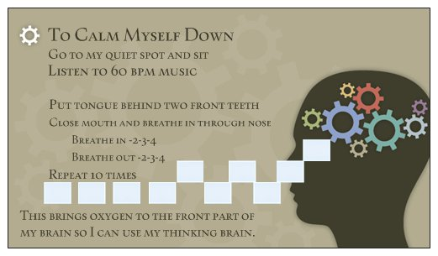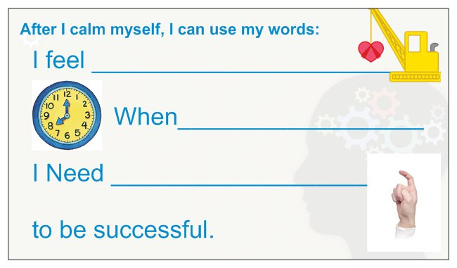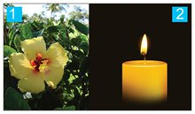Young children we teach to smell the flower and blow out the candle- we have them repeat 10 times (we give them 10 pompons to use to count- they drop them into a decorated empty Kleenex box).

I get these printed at a company that prints business cards. I laminate them and give them to students to keep with them. I also recommend keeping them in the calming area or make a blown-up poster version of them.

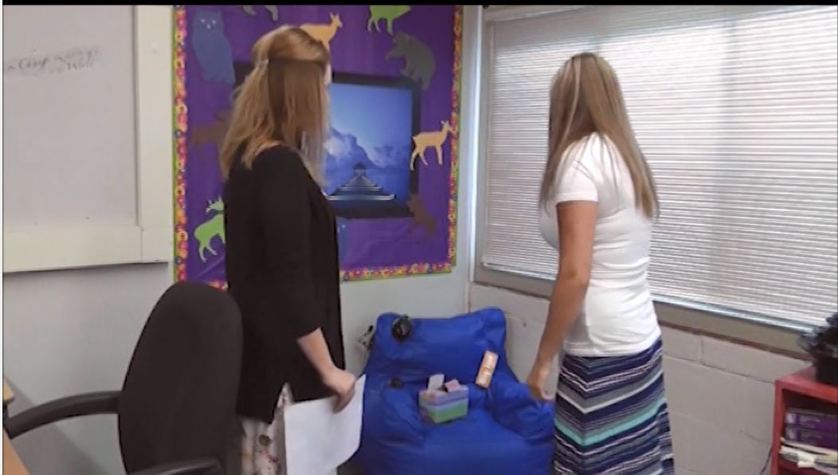
Picture of a simple calming corner

We also have many calming videos – nature pictures paired with 60 beats per minute music available on www.behaviordoctor.org under materials and then calming videos.

