**Second** occurrence will result in communication from the Community Education Department and if necessary and official warning will be issued and filed.

In the event of a **third** officially filed warning, the volunteer coach will be notified of their dismissal and at the coach’s request an additional meeting with the Coaches Corner can be arranged.

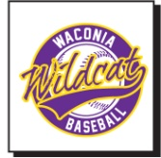 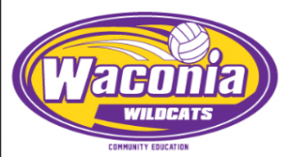 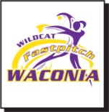

**Waconia Area Athletics Youth Recreation Advisory Board Criteria for Suspension and Probation:**

Use of foul or offensive language or verbal harassment of game officials:

1. Community Education staff may receive phone calls and then do a follow up conversation with the coach(es) involved. This individual(s) may be invited to the next scheduled or urgent impromptu Recreation Advisory Board meeting to discuss the situation depending on the severity of the act.
2. Improper language unbecoming of a volunteer coach will produce the following penalties in order of occurrence.
3. Recreation Advisory Board Warning
4. Recreation Advisory Board Suspension for the remainder of the activities season we are in.
5. Recreation Advisory Board Probation for one calendar year beyond the sport season from which he/she was just suspended, during which if a repeat incident occurs the individual will be suspended from one calendar year from the date of the occurrence.
6. Coaches, players, spectators and parents (both local and visiting) will demonstrate good sportsmanship attitudes toward our officials and our game management personnel. One warning will be given for such poor conduct as deemed unsportsmanlike by Waconia Community Education staff on duty. If after the first there is a second violation the coach, player, spectator or parent will be asked to leave the site of the event immediately.

(Continued)

**Physical contact by coach with game official, co-coach, player, parent or anyone else while the coach was representing Waconia Community Education as a coach.**

**First Offense:** Incidents reported will be investigated by the Recreation Advisory Board and the following actions will be taken if the violation can be substantiated.

1. An automatic suspension from all Waconia Community Education coaching for one year period from the date of infraction. No practice attendance or bench presence during the game would be allowed.
2. Two hours of anger management counseling, paid for by the individual, must be taken within 3 months of the incident. Proof of counseling needs to be presented to Waconia Community Education.
3. An apology letter must be sent to the following within one week of the incident:

- The individual that the contact occurred with

- Waconia Community Education

- The Recreation Advisory Board

**Second Offense:** If after a return to coaching (after the one year suspension where the individual coach has successfully met the criteria above numbers 1, 2, and 3) the individual were to have further proven physical contact with any game official, co-coach, player, parent, or anyone else while the coach was representing Waconia Community Education as a coach – then this coach would be permanently banned from coaching any District #110 School or Waconia Community Education activities immediately.

Updated March 2017



***Youth Activities Manual***

Waconia Area Athletics

[www.waconiaareaathletics.com](http://www.waconiaareaathletics.com)

[www.waconiacommunityed.org](http://www.waconiacommunityed.org)

952.442.0610

516 Industrial Blvd

Waconia, MN 55387



Welcome to Waconia Area Athletics a division of District #110 Waconia Community Education & Recreation. We are happy to have you participating with us and we hope your experience is a positive one! This Youth Activities Manual is intended to outline the standards for your recreational activities for all concerned.

**How to access the system if you have a question/concern:**

**First**, talk directly to the person you have a concern with. **Second**, communicate your concern to the Community Education Office. **Third**, communicate your concern to the Recreation Advisory Board through the Community Education Office. **Fourth**, request a meeting with the Recreation Advisory Board.

**Youth Recreation Advisory Board**

The purpose of the Recreation Advisory Board in ISD #110 Waconia Community Education and Recreation is to insure the development of a working relationship between the participants, the parents and the volunteer coaches.

**Objectives:**

1. To define, set and monitor standards pertaining to coaching youth sports.
2. To act as the governing board for coaching youth sports and to enforce standards set by the Community Education Advisory Council pertaining to youth sports.
3. To act as a liaison between the coaches, players, parents and the Community Education Staff.

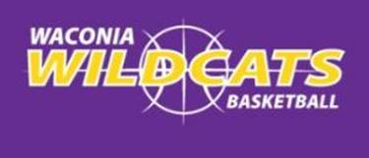

**Parents’ Standards**

By registering, I agree to uphold the following standards.

1. I will place my child’s emotional and physical well-being as my top priority.
2. I will be responsible for dropping off and picking up my child on time.
3. I will come to the event/contest drug and alcohol free.
4. I will treat coaches, umpires and league officials with courtesy and respect.
5. I will refrain from foul language and behavior unbecoming of a spectator.
6. I will place the realistic skill development of my child above my own personal expectations.
7. I will be supportive of my child’s chosen activity by make every effort to have them attend games and practices.
8. I will continue to grow in my knowledge of the activity my child is participating in.
9. I agree to uphold these parental standards for the benefit of my child.

**Players’ Standards**

By registering, I agree to uphold the following standards:

1. I will place my teams’ well-being ahead of my own.
2. I will adhere to my obligation as a player. I will attend games/practices ready and eager to participate and to follow my coaches’ instructions.
3. I will participate drug and alcohol-free.
4. I will treat each teammate and opponent fairly and league officials with courtesy and respect.
5. I will treat me fellow players, coaches, umpires and league officials with courtesy and respect.
6. I will be a positive participant for my team, refraining from foul language and unsportsmanlike behavior.
7. I agree to uphold these participant standards for the benefit of my team.

**___________________________________________________**

**Alcohol-Drug-Smoking-Chewing Violation**

**First Offense**: No participation in the event for 2 weeks or 3 games, whichever is greater.

**Second Offense**: Player is ineligible for the remainder of that activities season.

**___________________________________________________**

**Players’ Consequences**

Players not upholding the Players’ Standards will be warned and addressed in the following manner. Three officially filed warnings will result in the dismissal of a player in the activity concerned.

**First** occurrence will result in the communication from the Community Education Department to the player and his/her parent/guardian and if necessary, an official warning will be issued or filed.

**Second** occurrence will result in communication from the Community Education Department and if necessary and official warning will be issued and filed. Subsequently, a conference will be scheduled with the Coaches Corner and the player and his/her parent/guardian.

In the event of a **third** officially filed warning, the player will be notified of their dismissal and at the player’s or parents/guardians request and additional meeting with the Coaches Corner can be arranged.

 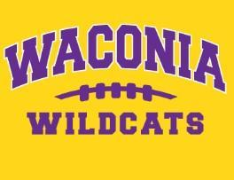

**Coaches’ Standards**

Becoming a volunteer coach requires not only a commitment to improve your knowledge of coaching but to uphold a special level of behavior in all of your coaching activities. It simply states that you agree to place your athlete’s safety and well-being first in all of your actions and decisions.

1. I will place my athlete’s emotional and physical well-being as my top priority.
2. I will provide a safe practicing and playing environment for my players and communicate all practice and game times to all involved.
3. I will provide a drug and alcohol-free environment for my players.
4. I will treat each athlete fairly and honestly.
5. I will treat my fellow coaches, umpires and league officials with courtesy and respect.
6. I will be a positive role model to all players and coaches within my program, refraining from foul language and unsportsmanlike behavior.
7. I realize there are different ability levels among my players and I will always strive to treat each player as a unique individual and capable of improving.

**Coaches’ Honor Concept**

Coaching is about Honor, Character and Tradition

You are judged by your peers and your players

Coaches are persons of integrity

You stand for which is right

Coaches do not swear, lie, cheat or steal

Coaches are communicators, not yellers

Coaches are mentors

Today’s athletes are tomorrow’s Coaches

The Three R’s: Respect for Self, Respect for Others & Respect for Your Actions

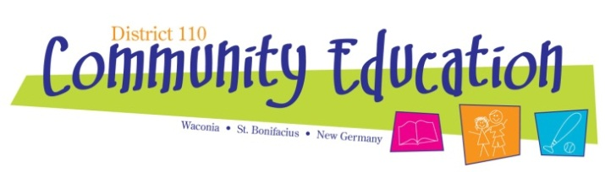

**Coaches’ Consequences**

Volunteer coaches not upholding the Coaches Standards will be warned and addressed in the following manner. Three officially filed warnings will result in the dismissal of the volunteer coach.

**First** occurrence will result in communication from the Community Education Department and if necessary and official warning will be issued and filed. (Con’t)