BROGDEN MIDDLE SCHOOL
MEDICAL ELIGIBILITY
************************************************************************
Athlete Name:________________________________________
Sport: (1)___________________ (2)____________________

Your student-athlete must be “medically eligible” to participate in athletics at Brogden Middle School. Compliance is a simple process of completing and updating the six forms listed below on an annual basis. 1. Medical History Form - The Medical History Form should be completed by the parent/guardian of the student-athlete and be available for review by the physician when the physical exam is performed. 2. Physical Examination Form - The Physical Examination Form must be completed by a Licensed Physician, Nurse Practitioner, or Physician’s Assistant.
3. Assumption of Risk/Medical Treatment Release Form- This form simply states that participation in athletics may result in injury and should injury occur you have given your permission for treatment to be provided. 4. HIPAA - The HIPAA Form allows us to share information, should an injury or condition occur, with people like doctors and coaches.
5. Student-Athlete Critical Contact Information Form - The Critical Contact Information Form contains important information necessary for emergency or urgent care to be provided for your student-athlete in the parent/guardians absence. 6. Concussion: Student-Athlete Form Concussion: Parent Form are both in compliance with the Gfeller-Waller Concussion Awareness Law.
_____ 1. North Carolina High School Athletic Association Sport Participation
Examination Form which is also referred to as the Medical History Form
_____ 2. Physical Examination Form (This form must be completed, and the
student- athlete cleared, by a Licensed Physician, Nurse Practitioner, or
Physician’s Assistant)
_____ 3. Durham Public Schools Assumption of Risk/
Medical Treatment Release Form
_____ 4. Authorization for Release of Protected Health Information which is also
referred to as HIPAA
_____ 5. Student –Athlete Critical Contact Information Form
_____ 6. Concussion: Student-Athlete Form/Parent Legal Custodian Form
Safety of our student-athletes by avoiding preventable injury or condition while they participate in athletics is a goal of the utmost importance. A student-athlete being “medically eligible”, by having completed and updated the five forms listed above, is critical in helping us achieve this goal while enabling us to provide a high standard of care in the event that an injury or condition were to occur.

Athletic Director: Sean Nickson
Email: Sean.nickson2@dpsnc.net Phone Number: (919) 560-3906

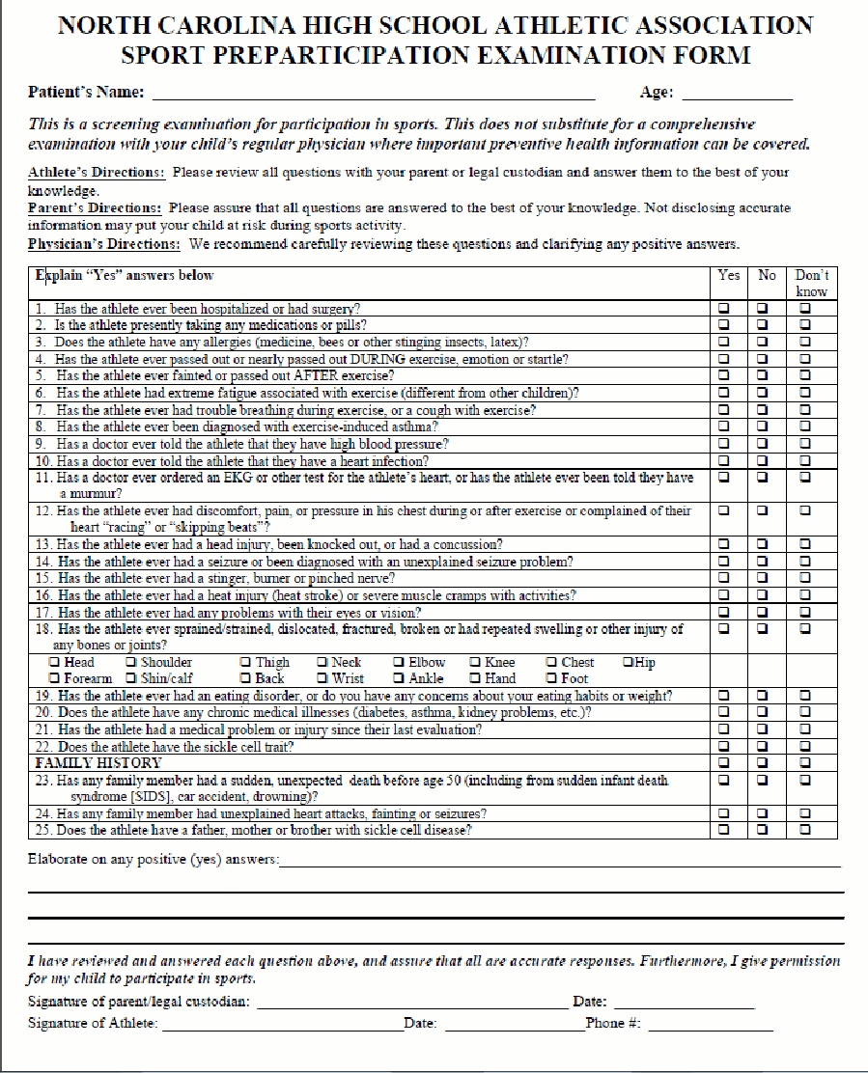

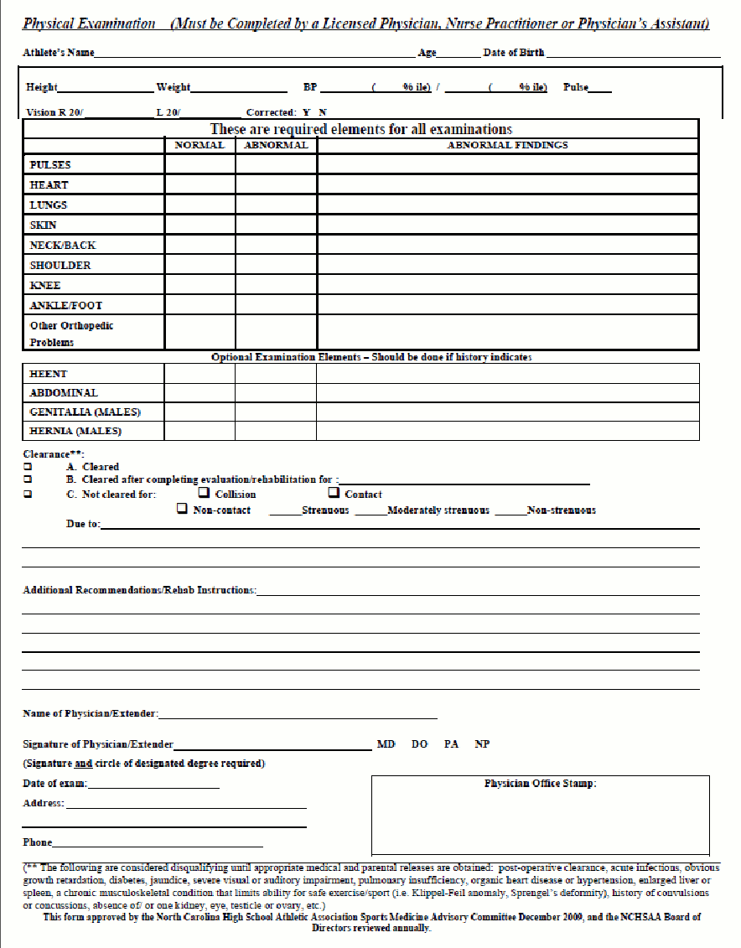

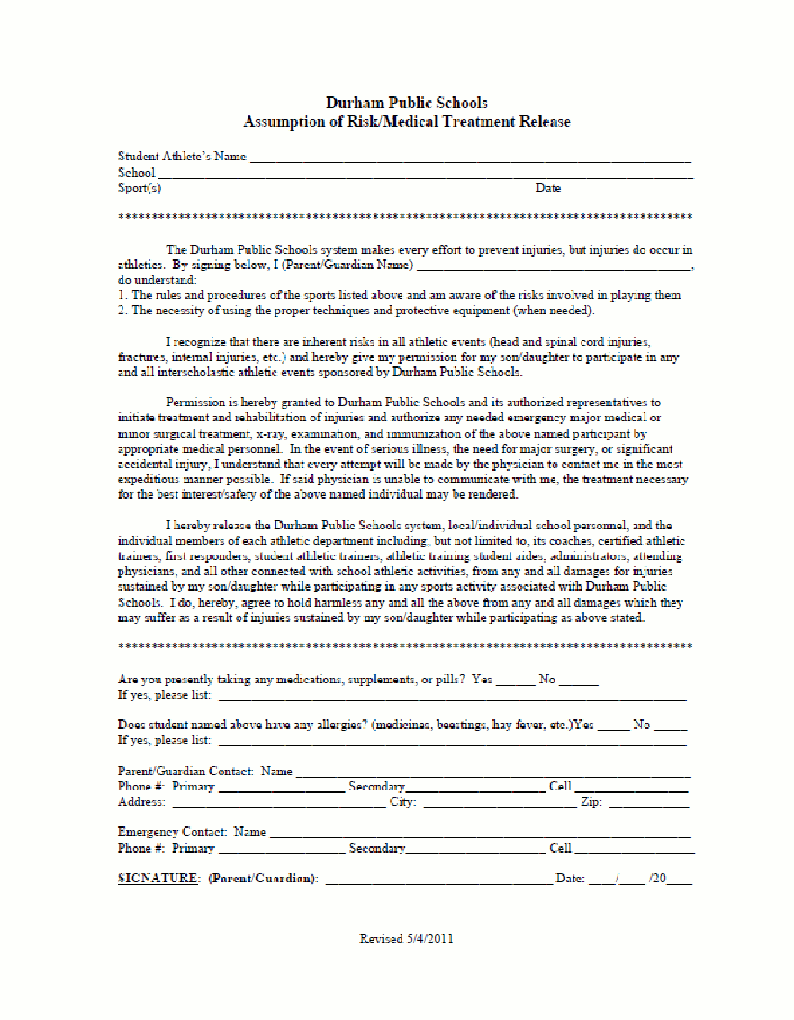

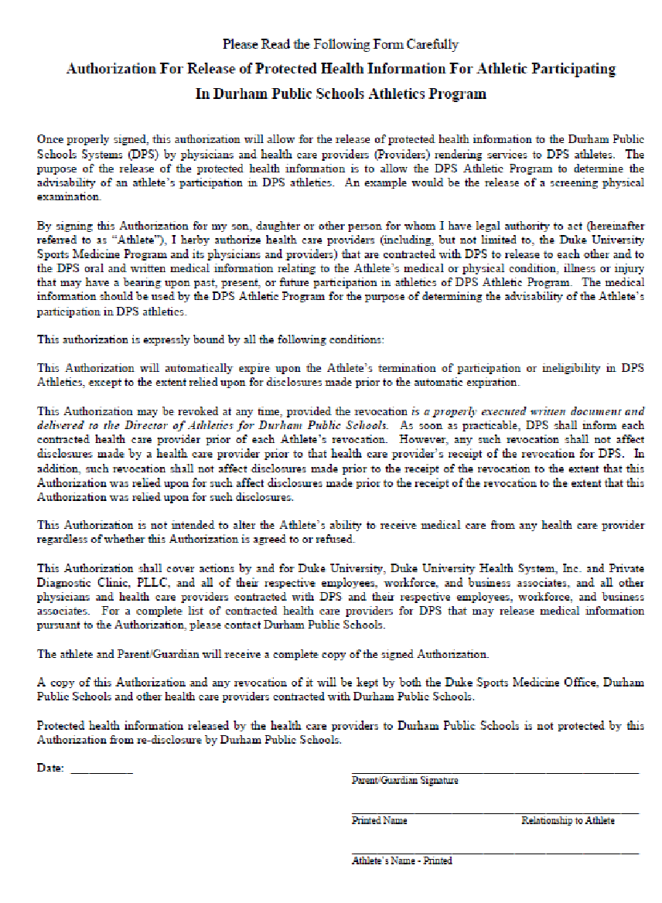
**This Authorization (and any revocation) must be signed by a parent, guardian, or other person acting in loco parents who has the authority to act on the Athlete’s behalf. By signing this form, you as the parent/guardian or party acting in loco parents warrant that you have the legal authority to act on the Athlete’s behalf.
**The signature may be only the Athlete if the Athlete is over 18 years of age or legally emancipated person.

.
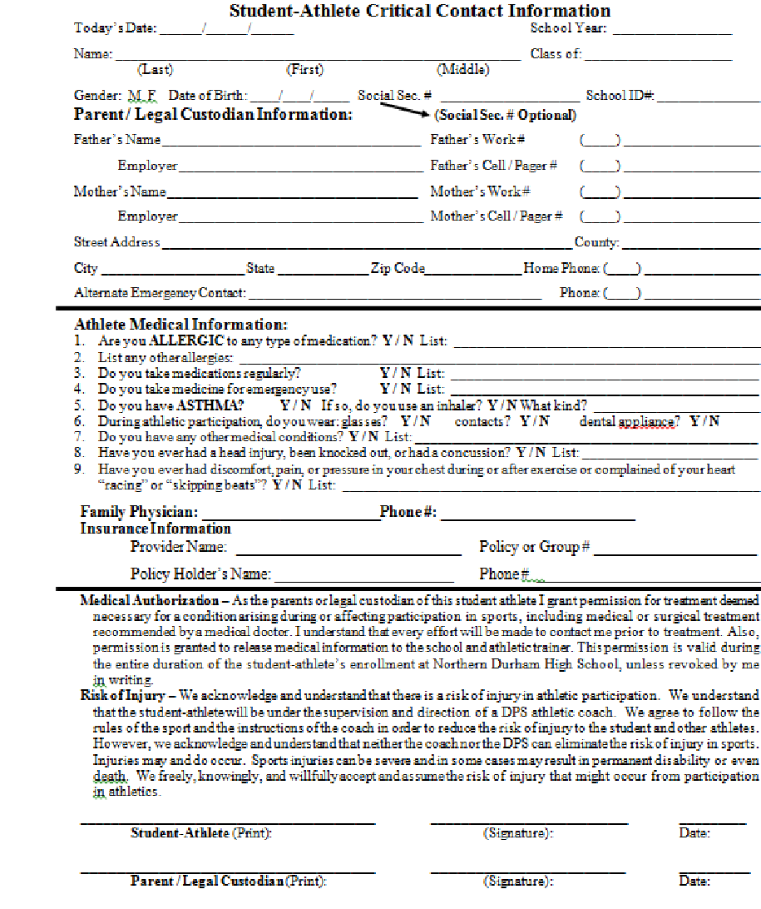

I 