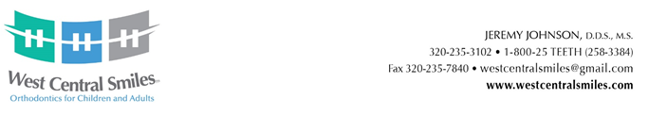

WEST CENTRAL SMILES SCHOLARSHIP

Two $500.00 Scholarships Awarded

Return this application to: West Central Smiles, 1100 19th Ave SW, Suite 1, Willmar, MN 56201
Due by: March 19th of the current school year
Criteria for applicants:
1) Must be a high school senior graduating in the spring of current year from Minnewaska, BBE, NLS, Paynesville or KMS (North Region).
2) Strong leadership roles, not necessarily high GPA.
3) Cannot be an immediate family member of an employee of West Central Smiles.

NAME _______________________________________________________________________________

ADDRESS _____________________________________________________________________________

EMAIL______________________________________PHONE ___________________________________

PARENTS_____________________________________________________________________________

CLASS RANK __________ out of ______________ GPA ____________

HIGH SCHOOL CURRENTLY ATTENDING_____________________________________________________

Please use a separate piece of paper to answer the following questions:

1) What are your future career plans and where do you plan to continue your education?

2) Please list all the extracurricular activities (including any work experience) you have been involved
with throughout high school.

3) How have those extracurricular activities prepared you for your future career plans?

