Why do we make measurements? (Make sure you can give an example of each)

1.

2.

3.

What are some different characteristics we can measure?

1.

2.

3.

4.

5.

6.

7.

8.

9.

In order to make measurements we have to use different tools or calculations. Next to each measurement put the tool or calculation we use to make that measurement.

What is the Metric System (also called the International System of Measurement or SI system) and why do we use it?

Why do we use the Metric System?

1.

2.

The Metric system has “base units” for each measurement we can make. What are the base units for the following measurements:

Distance-

Area-

Volume-

Temperature-

Sound-

Mass-

Light-

Density-

Time-

Using the Metric system, converting units using the Step Method-

First we need to know our prefixes!

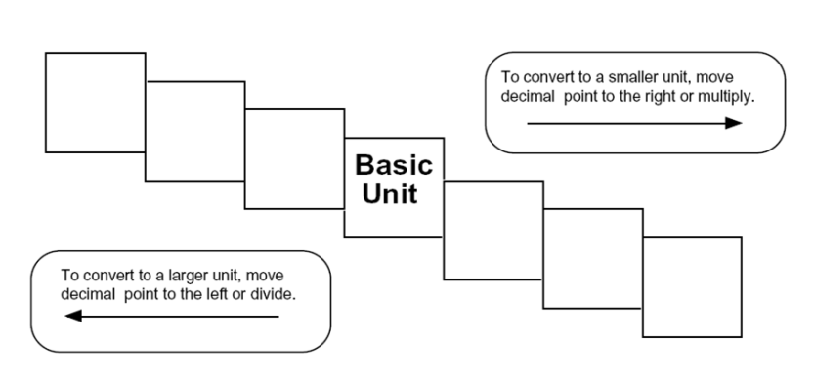

Using the Step Method

1. Determine the base unit, what step you are starting on and what step you are moving too.
2. Count the number of steps between your starting step and ending step.
3. Move the decimal the same number of places as steps moved and in the same direction.

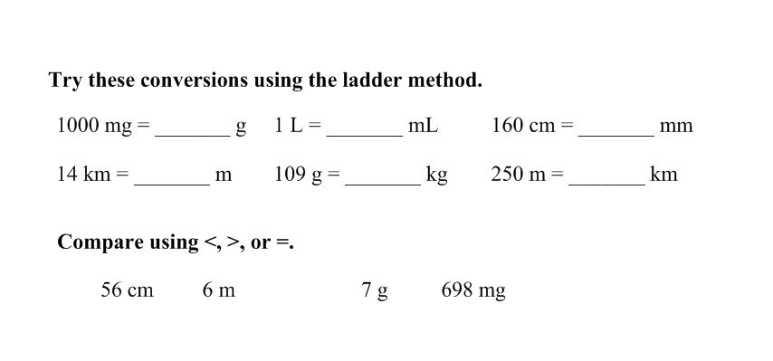

Do some practice measurements by finding the volume of your text book! (make sure we are writing our answers with the correct units)

Length-

Width-

Height-

Area-

Volume-

Find the volume of the classroom!

Length-

Width-

Height-

Area-

Volume-

Explain the difference (differentiate) between Accuracy and Precision.

1. Accuracy is how close a measurement is to the real thing.
2. Precision is how well YOU use the measurement tool.