What is a graph?

Listed below are different types of graphs. Describe what each one is used for:

1. Bar graph
2. Pie chart or Circle graph
3. Line graph

How to read a graph!

1. Title
2. Axis’
3. Key
4. What is the Slope of the line?
   1. Positive, negative, curved, straight, flat
   2. Calculate the slope of the line
      1. First step is to pick two points on the line that ARE NOT data points!
      2. Determine the x,y values for each point.
      3. Plug your x,y values into the formula for slope and calculate.
      4. Write down the formula for slope:

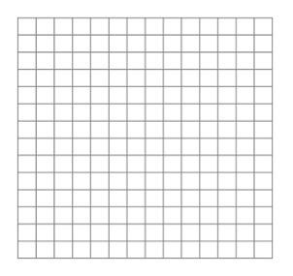

How to make a graph!

1. Axis – Determine what goes on each axis and how big to make each division.
   1. X axis -
   2. Y axis –
   3. How big to make each division?
2. Labels
   1. Axis-
   2. Title-
3. Key
4. Plotted Information
   1. Data points-
   2. The line-
   3. Slope of the line-
5. Line of Best fit
   1. Straight or curved?

