*“Dune”*

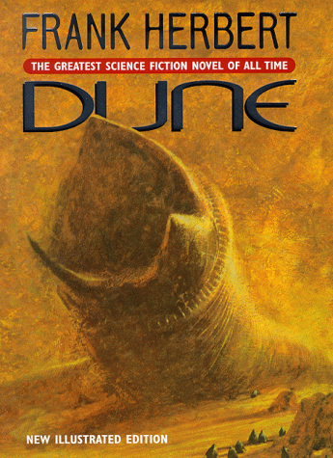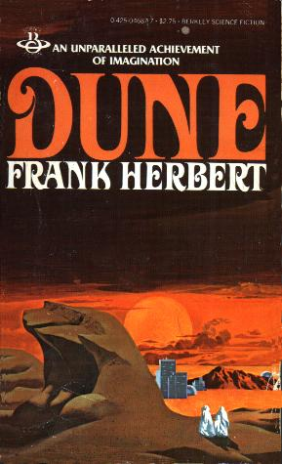

This quarter in science you will be reading the science fiction book “Dune”. It is one of the most acclaimed, award winning and bestselling science fiction books of all time. You will have the whole quarter to read the book with bi-weekly reading checks to make sure that everyone is making progress toward our goal. Our main purpose to reading this book is to try and gain a better understanding to the intricate role science plays in how we live. Drawing parallels between what is considered fiction and what we have today. Science fiction authors have proven to be very good prophets for what we will have in the future.

Goals:

* Read the entire book
* Create a list of science/science fiction concepts used in the book
* Understand the link between science fiction and science fact
* Understand how science and science fiction affect our everyday life

Graded on:

* Bi-weekly reading checks/activities (character and plot questions)
* Science concept list
* Full book test at end of quarter
* Science concept project at end of quarter

Schedule:

* _________________– Page 204
* _________________– Page 420
* _________________– Page 550
* _________________– Page 794