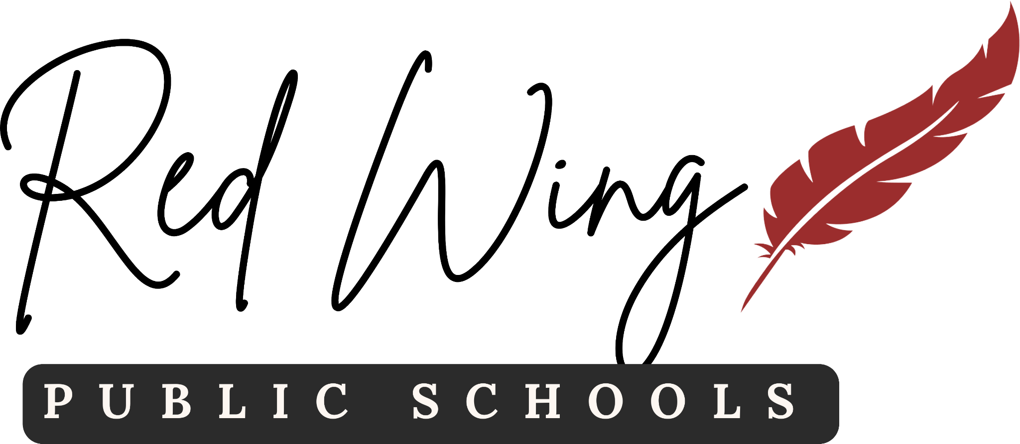

2451 Eagle Ridge Drive

Red Wing, MN 55066

Phone 651-385-4500 www.rwps.org Fax 651-385-4510

ISD 256 Policy 515 outlines what student data is considered public while also acknowledging that parents, legal guardians and eligible students (age 18 and up) have a right to opt out of student directory data. Keeping such data private shall only be applicable for that school year. The deadline is 30 days from the first day of the school year or from the student’s date of enrollment.
You cannot opt out of internal mandatory classroom identification. Your student is still legally required to disclose their name, school email, or display a physical student ID card within the classes they are actively enrolled.
To opt out, the parent/guardian’s or eligible student's written notice shall be directed to the responsible authority – the building principal – and shall include:
Student Name: _____________________________________________________
Parent/guardian: ____________________________________________________
Home address _____________________________________________________
_____________________________________________________
Student’s school ____________________________________________________
Categories of directory information to be made not public without prior written consent:
- All
- other _______________________________________________________________________________________________________________________________

Signature ______________________________________ Date _________________

