TO: KHS Parents & Ohana, Guardians, Friends (07/29/16)

KALANI High School
WEEKLY E-BULLETIN
UPDATES FROM A.M. BULLETINS, FLYERS, ETC.
IMPORTANT DATES…
1) Monday, August 1 First Day for Freshmen only
2) Tuesday, August 2 First Day for all other students
3) Thursday, August 4 Picture taking for those that missed registration (and re-takes)
4) Friday, August 5 Welcome Assembly
5) Friday, August 5 Freshmen Ice Cream Social
6) Thursday, August 18 Senior Parent Night 6:30pm @ Cafeteria
7) Friday, August 19 No School : Admissions Day
8) Monday, September 5 No School : Labor Day
9) Tuesday, September 6 Homecoming Week : Night Pep Rally
10) Thursday, September 8 Pep Rally during Advisory
11) Thursday, September 8 Financial Aid Night
12) Saturday, September 10 Homecoming : Kalani vs. Roosevelt
13) Friday, October 7 End of First Quarter
14) Friday, December 21 End of First Semester

Fall Break : October 10 – 14
Winter Break : December 22 – January 6
Spring Break : March 20 - 24

DEADLINE…Friday 9:00am is the deadline for your group’s input in next Parent Bulletin.
Email address ------ mitchell_otani@notes.k12.hi.us
* * * * * * * * * * * * * * * * * * * * * * * * * * * * * * * * * * * * * * * * * * * * * * * * * * * * * *
Welcome Falcons
On behalf of the faculty and staff, I would like to welcome you to Kalani High School – Home of the Falcons.
2016 was a banner year. We begin this year with renewed optimism that this school year will be even better. Together with your help, let us craft a learning environment second to none. With your help, let us plan activities that will foster friendships and create memories for our students that will last a lifetime.
With your help, we know that we will have a great year as we seek to promote Success for All.
Mitchell Otani – Principal

Congratulations
Miss Hawaii Allison Chu - Kalani 2011

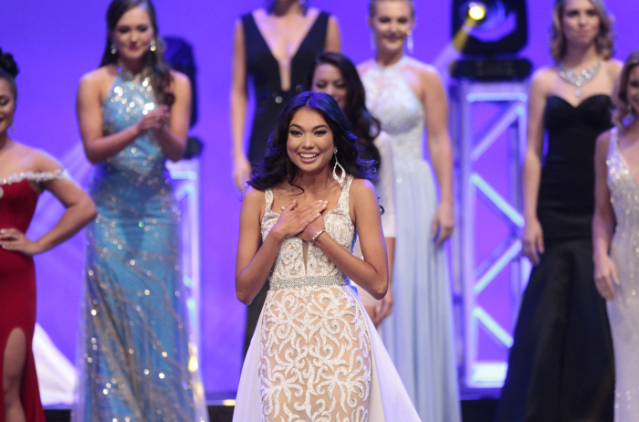

Congratulations
Class of 2017
Kacie Kajihara Emily Yang
ACT : Perfect Score 36 ACT : 35
SAT : 2310 740/770/800 SAT : 2260 800/800/660

Pacific Asian Affairs Council
Global Natural History Day Competition
The following Kalani students were in the top five teams (teams of two) and won scholarships to go to the international round in Shanghai this July.
Ryan Bracamontes and Rovi Porter Daniel Huang (partner – a student from HPA)

Society of American Military Engineers
James Fitzgerald has been selected to participate in SAME (Society of American Military Engineers) summer program through the U.S. Marine Corps at Camp Lejeune-Jacksonville, NC
For over 30 years, before STEM was being promoted, the Society of American Military Engineers has been advancing events and activities and offering scholarships designed to excite students to become engineers. SAME, in collaboration with the military services, offers a series of week long, STEM Engineering & Camps designed for High School students who excel in math, science and technology courses and are interested in pursuing engineering, architecture, or related fields in college. Each of our camps has their unique curriculum, with the common threads being: challenging environment, all activities are hand-on, young engineer mentors assigned to the teams and providing long term resources for alumni.

STUDENT SECTION
STUDENT GOVERNMENT
Here is the schedule for the Freshmen Day.
Time
7:45-8:20 | Sign-In
8:20-8:25 | Welcome
8:25-8:45 | Session 1
8:50-9:10 | Session 2
9:15-9:35 | Session 3
9:40-10:00 | Session 4
10:05-10:25 | Session 5
10:30-10:50 | Session 6
10:55-11:15 | Session 7
11:20-11:40 | Session 8
11:40-12:10 | Lunch
12:15-12:25 | Period 1
12:30-12:40 | Period 2
12:45-12:55 | Period 3
1:00-1:10 | Period 4
1:15-1:25 | Period 5
1:30-1:40 | Period 6
1:45-1:55 | Period 7
1:55 | Dismissal

Class Activities
Forthcoming

CLUB News :
List of clubs
Chinese Club CORE Creative Dance Club Future Farmers of America
Glee Club GSA HOSA Interact Club
Key Club KHOT Korean Club LEO Club
Math Team Mock Trial Polynesian Club NHS
Robotics – Team 3008 Science Olympiad Speech and Debate Team

Club events
Marching Band
Moanalua Menehune Classic October 22
TBD October 29
TBD November 5
UH Rainbow Invitational November 10
TBD November 12

COLLEGE AND CAREER GUIDANCE CENTER
College Information
- Please visit the College & Career Center link on Kalani's edline page <kalanihs.k12.hi.us>.
- Susan Arashiro / Yvette Achong College & Career Counselors (808)305-0556
- susan_arashiro@notes.k12.hi.us, yvette_achong@notes.k12.hi.us

ATHLETICS – Go Falcons

Football
August 13 Kalani @ Pearl City
August 20 Kalani vs. Kaimuki September 30 Kalani @ Kalaheo
August 27 Kalani @ Waialua October 7 Kalani @ Waipahu
September 3 Kalani vs. McKinley

Crosscountry
September 3 Kalani Invitational Crosscountry Meet

COMMUNITY CONNECTIONS
Stay tuned for future activities

Alumni information

US News Best High Schools - 2016
There are 5 silver medal schools from Hawaii included in the 2016 rankings of U.S. News Best High Schools.
Kalani is ranked 2nd amongst all of the public schools in Hawaii

U.S. News & World Report, a nationally recognized publisher of education news and information, recently announced the 2016 Best High Schools. The U.S. News Best High Schools rankings and data offer the most comprehensive information available on public high schools in the U.S. The 2016 edition includes profiles on more than 21,000 high schools and rankings of the nation's 4,707 highest-scoring schools across all 50 states and the District of Columbia.
Kalani High School is ranked 2nd within the State of Hawaii. Students have the opportunity to take
Advanced Placement® course work and exams. The AP® participation rate at Kalani High School is 54 percent.
The student body makeup is 52 percent male and 48 percent female, and the total minority enrollment is 90 percent.
Kalani High School is 2nd of 49 high schools in the Hawaii Public Schools.

Washington Post List of Challenging Schools
Congratulations to Kalani High School for getting on the Washington Post's list of Challenging High Schools – one of 8 Hawaii High Schools (list includes private schools) so recognized based on index score.
Index score : Total number of Advanced Placement, International Baccalaureate and Advanced International Certificate of Education tests given at a school each year divided by the number of seniors who graduated in May or June. With a few exceptions, public schools that achieved a ratio of at least 1.000 were put on the national list.

