TO: KHS Parents & Ohana, Guardians, Friends (08/05/16)

KALANI High School
WEEKLY E-BULLETIN
UPDATES FROM A.M. BULLETINS, FLYERS, ETC.
IMPORTANT DATES…
1) Thursday, August 11 Computer & Flashdrive Deployment in café @ 5:00
2) Thursday, August 18 Senior Parent Night 6:30pm @ Cafeteria
3) Friday, August 19 No School : Admissions Day
4) Tuesday, August 23 Open House 6:00 – 8:00
5) Monday, September 5 No School : Labor Day
6) Tuesday, September 6 Homecoming Week : Night Pep Rally
7) Thursday, September 8 Pep Rally during Advisory
8) Thursday, September 8 Financial Aid Night
9) Saturday, September 10 Homecoming : Kalani vs. Roosevelt
10) Friday, October 7 End of First Quarter
11) Friday, December 21 End of First Semester
Fall Break : October 10 – 14
Winter Break : December 22 – January 6
Spring Break : March 20 - 24

DEADLINE…Friday 9:00am is the deadline for your group’s input in next Parent Bulletin.
Email address ------ mitchell_otani@notes.k12.hi.us
* * * * * * * * * * * * * * * * * * * * * * * * * * * * * * * * * * * * * * * * * * * * * * * * * * * * * *
Welcome Falcons
On behalf of the faculty and staff, I would like to welcome you to Kalani High School – Home of the Falcons.
2016 was a banner year. We begin this year with renewed optimism that this school year will be even better. Together with your help, let us craft a learning environment second to none. With your help, let us plan activities that will foster friendships and create memories for our students that will last a lifetime.
With your help, we know that we will have a great year as we seek to promote Success for All.
Mitchell Otani – Principal

Mahalo to all of our morning drivers for your kokua. Student drop offs were great all week.

Congratulations
Miss Hawaii Allison Chu - Kalani 2011

August 5, 2016

“Celebrate what you’ve accomplished, but raise the bar a little higher each time you succeed.”
– Mia Hamm
Dear Parents and Guardians,
As a parent/guardian of a Hawaii Department of Education student, you have the right to know the professional qualifications of the classroom teacher(s) who instruct your child. Federal Law allows you to ask for certain information about your child’s classroom teacher(s) and requires us to give you this information in a timely manner upon request. You have the right to ask for the following information about each of your child’s classroom teacher(s).

1. Whether the teacher has met licensing criteria and has earned the designation of Highly Qualified for the grade levels and subject areas in which he/she teaches. Core academic subjects include :
a. English-Language Arts
b. Mathematics
c. Science
d. Foreign Languages
e. Civics and Government
f. Economics
g. History
h. Geography
i. Art
2. Whether the teacher is under emergency of other provisional status through which State qualifications or licensing criteria have been waived.
3. The teacher’s college major, whether the teacher has any advanced degrees and if so, the subject of the degrees and
4. Whether any teacher’s aides or similar paraprofessionals provide services to your child and, if they do, their qualifications.
If you would like to receive any of this information, please contact our school office.
Sincerely,
Mitchell Otani
Principal

LAPTOP / FLASHDRIVE DISTRIBUTION
We will begin distributing flash drives and laptops on THURSDAY, AUGUST 11 FROM 5:00 PM TO 7:00 PM out of room A13.
Parents need to sign forms. We will also be assisting parents in activating their access to the grade check portal.

Congratulations
Class of 2017
Kacie Kajihara Emily Yang
ACT : Perfect Score 36 ACT : 35
SAT : 2310 740/770/800 SAT : 2260 800/800/660

STUDENT SECTION
STUDENT GOVERNMENT
Awesome Welcome Assembly. A big mahalo to the KAS officers for organizing our welcome assembly. They did a great job.
Stay tuned for more activities.

Class Activities
Forthcoming

CLUB News :
List of clubs
Chinese Club CORE Creative Dance Club Future Farmers of America
Glee Club GSA HOSA Interact Club
Key Club KHOT Korean Club LEO Club
Math Team Mock Trial Polynesian Club NHS
Robotics – Team 3008 Science Olympiad Speech and Debate Team DECA

Interact Club
The Interact Club is community service club that is sponsored by the East Honolulu Rotary Club. The Interact Club of Kalani has been doing a variety of service projects for over two decades including working with the Dept. of Transportation for highway clean ups four times a year, beach clean-ups a couple of times a year, singing Christmas carols at Leahi Hospital, painting projects at Palolo Elementary, volunteering at aid stations at the Honolulu Marathon, helping the Aina Haina library set up for its annual book fair, as well as providing volunteer labor at many community fairs and other community activities. So if you see a bunch of students in orange T-shirt or vests on a Saturday morning between Kalani and Aina Haina with orange bags on both side of the highway, that will be our Kalani Interact Club students working to make our community a better place. See Mr. Shanahan if interested.
LEO Club
Interested in community service? Meeting new people? Come join the Kalani High School LEO Club. Our first meeting will be August 14 during lunch. Please stay tuned to the morning bulleting for more information! Please see Mrs. Hayashi if interested.

Math League
One of the most active and competitive academic teams on campus, the Kalani Math League Team is a member of the Oahu Mathematics League--a group of around 30 public and private schools from across the island which engages in monthly competitions that draw over 300 students apiece. Students can share their love of mathematics, form friendships with students from other schools, and engage in an impressive and enriching activity--all while strengthening their problem solving and computational abilities. See Doctor Ida if interested
NHS
The Kalani High School chapter of the National Honor Society--a nationally-recognized organization that recognizes academic excellence and promotes service and leadership--is among the largest student organizations on campus. NHS members help to improve the school and wider community through homegrown service projects and by partnering with organizations as diverse as the University of Hawaii's Kennedy Theatre and Habilitat. See Dr. ida if interested.

C.O.R.E.
Christ Our Real Example Club is all about fun, support, acceptance, and friendships. As a club, we meet during lunch on Wednesdays in room K-16. We talk about the daily struggles as well as times of celebration as teenagers and discuss ways to get through it all TOGETHER! Come join us for lively games, yummy snacks, and a brief time of sharing. Hope to see you there!

Club events
Marching Band
Moanalua Menehune Classic October 22
TBD October 29
TBD November 5
UH Rainbow Invitational November 10
TBD November 12

COLLEGE AND CAREER GUIDANCE CENTER
College Information
- Please visit the College & Career Center link on Kalani's edline page <kalanihs.k12.hi.us>.
- Susan Arashiro / Yvette Achong College & Career Counselors (808)305-0556
- susan_arashiro@notes.k12.hi.us, yvette_achong@notes.k12.hi.us

CAREER & COLLEGE VISITATION SCHEDULE: Fall 2016
DATE | DAY | COLLEGE | TIME
AUGUST
22nd | Mon | University of Nevada Las Vegas | 10:00-Even
29th | Mon | University of Portland | 8:10-Odd
SEPTEMBER
2nd | Fri | Vanderbilt, TN | 11:00-Odd
8th | Thurs | Pacific Lutheran University, WA | 8:15-Even
13th | Tues | Northern Arizona University | 1:00-Odd
15th | Thurs | Hawaii Pacific University | 9:45-Odd
16th | Fri | University of San Francisco | 11:00-Even
22nd | Thurs | Linfield College, OR | 9:45-Even
22nd | Thurs | Pacific University, OR | 1:00-Even
28th | Wed | Emerson College, MA | 11:00-Even
OCTOBER
Wed | 5th | UH-Honolulu Community College Tour | TBA - Odd
Mon | 17th | American University, DC | 9:45-Even
Mon | 17th | Weber State University, UT | 10:45-Even
Tues | 18th | Honolulu College Fair & UH-Manoa Tour | 8:00-12:00 Odd
Mon | 24th | Concordia University-Irvine, CA | 9:45-Odd

ACTIVITY PASSES for college visits must be approved by your teacher and submitted to C12 no later than the day BEFORE the visit. TOURS require parent/teacher permission. ADVISORY begins at 10:52 Bold-faced – newest additions

ATHLETICS – Go Falcons

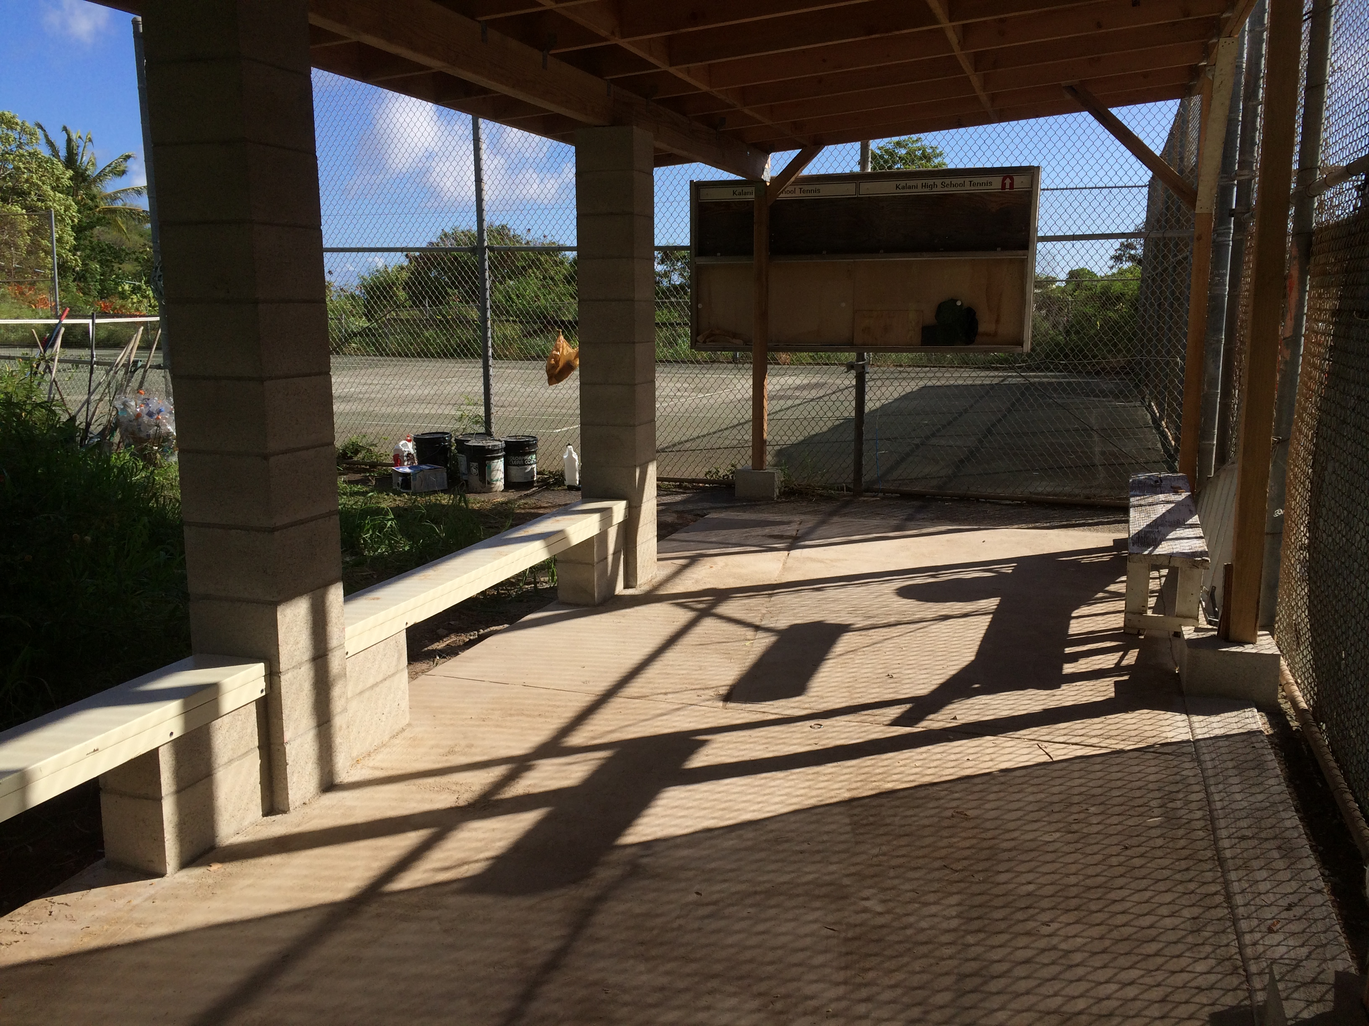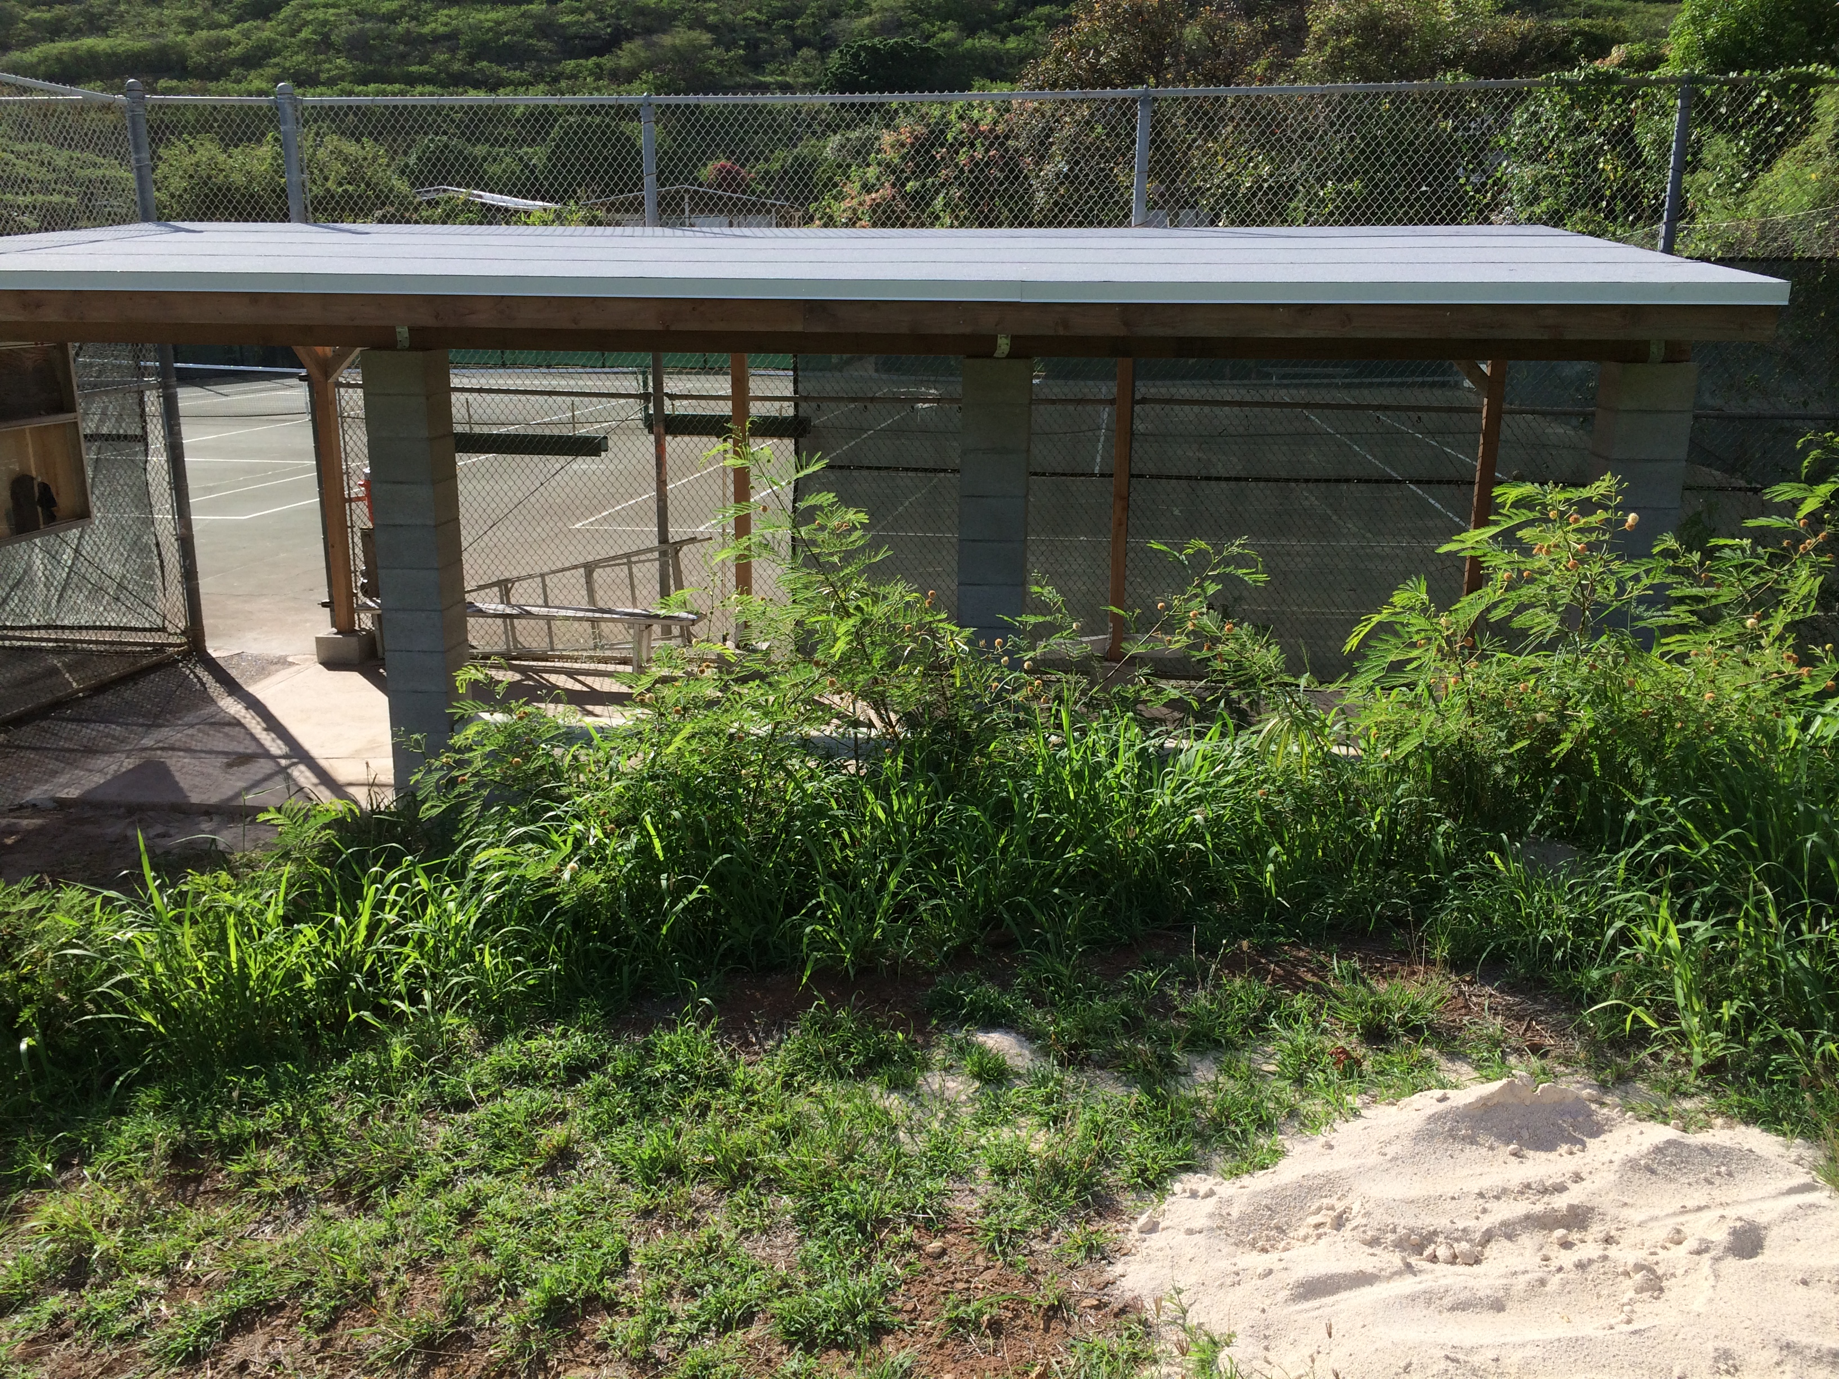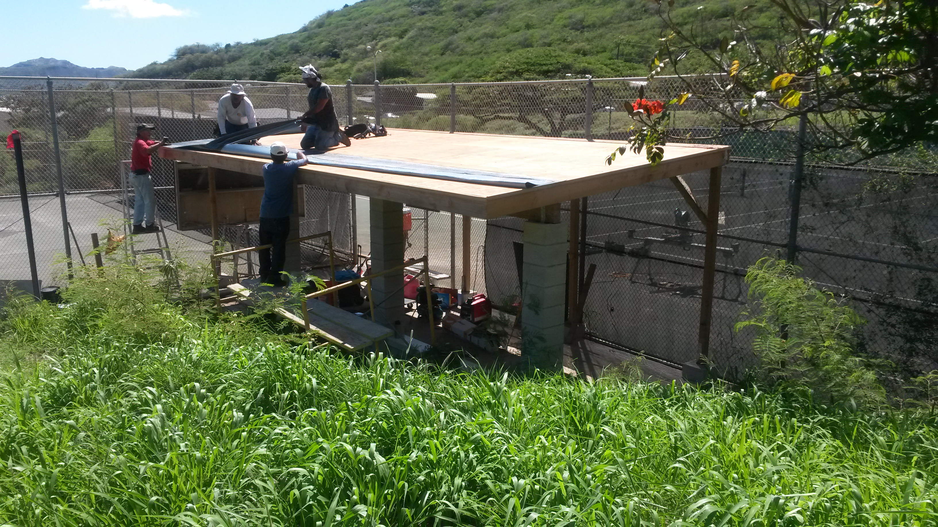
Mahalo Stan Wada and Byron Tanaka (Class of 1962)
A big mahalo to Stan Wada (Quality General Construction) and Byron Tanaka for providing the donations, materials and manpower to build a new structure for the Tennis Team. They were blessed with nice weather the past two Saturdays and Mr. Wada and his crew completed the beautiful, much-needed structure. The volunteers will be putting the final touches (paint, etc) this weekend. All are welcome to come and help.
Thanks to all the volunteers that came out to help with this project: Coach John, Doug and Lori Emoto, Donn and Jackie Terada, Jin Kim, Nick Ashikawa, Brandon Tanaka. Wayne Miyashiro (62, classmate) and of course Stan and his crew of masons, carpenters and roofers under his supervision.
Mahalo Alumni

Football
August 13 Kalani @ Pearl City
August 20 Kalani vs. Kaimuki September 30 Kalani @ Kalaheo
August 27 Kalani @ Waialua October 7 Kalani @ Waipahu
September 3 Kalani vs. McKinley

Crosscountry
September 3 Kalani Invitational Crosscountry Meet

CHANGE IN SPORTS MEETING PROCEDURES:
The DOE requires that parents/guardians who have a child participating in athletics must attend the Parent Sport Meeting, with their child, once their child has been selected to a team. This is required once each school year that the child is participating in a sport. The meetings have now been broken down and grouped by sport. Please attend the Parent Sport Meeting for your child’s sport.
The Parent/Guardian is required to go online (www.kalaniatheltics.org) to view the OIA/OC16 Risk Management video under the video tab and to view/read both the DOE Parent and Student-Athlete Handbook and Kalani's Guide to Athletic Participation. This must be complete PRIOR to coming to the Parent Sport Meeting. These items will no longer be distributed at the sport meeting. Those who do not have computer access may request an appointment with the Athletics Director to view the video and be provided a hard copy of the two handbooks. Since your child has already been selected to a team the $80.00 ASET fee is due at the Parent Sport Meeting. The Parent Sport Meetings shall be announced in the morning bulletin and will also appear on the athletic website, school calendar and Principal’s Newsletter. Contact your child’s coach if you should have any questions.

ATHLETIC PHYSICALS & CONSENT FORMS:
An Athletic Physical and the Parent Consent and Assumption of Risk (CAR) form is required before anyone may participate in any athletic training. Parents are encouraged to make every attempt to have these physicals completed during the summer months. If a student does not have a current physical on file with our Athletics Trainer prior to tryouts it may jeopardize their opportunity to make the team. Those participating in a winter sport should consider having their physicals completed no later than October. Spring sports should be no later than February. Physicals are good for one calendar year from the date of the physical. A separate CAR form is needed for each sport your child participates in. These forms are to be turned in directly to the Athletic Trainers. Please do not give them to the coach! For more information please contact our Athletic Trainers. The trainers start work at 1:00pm.
Ben Kuenzli – bkuenzli@ahct.k12.hi.us
Office: 305-0610

ACADEMIC REVIEW STATUS:
The parent/guardian whose child is on Academic Review Status (ARS) is encouraged to stay in close communication with their child’s teacher, counselor and coach. All parties should work in unison to ensure that the student-athlete has the greatest opportunity to be successful in their academics so that they may become eligible to participate in athletics.

ATHLETIC PRACTICE SAFETY:
For your safety and the safety of our student-athletes our practices are closed to the public. The gym doors will be closed during practice times and for the field/pool sports parents are asked to stay outside the fence line of the entire field/pool. Parents are asked to plan on arriving to pick up their child after a practice/game prior to end of the event. We want to be sure that there is adult supervision until all athletes have been picked up. Please communicate with your child’s coach if you should have any questions. Reminder that there is to be NO SMOKING/VAPORING, NO ALCOHOL AND NO PETS allowed on any DOE campus.

COMMUNITY CONNECTIONS
Stay tuned for future activities

Alumni information

US News Best High Schools - 2016
There are 5 silver medal schools from Hawaii included in the 2016 rankings of U.S. News Best High Schools.
Kalani is ranked 2nd amongst all of the public schools in Hawaii

U.S. News & World Report, a nationally recognized publisher of education news and information, recently announced the 2016 Best High Schools. The U.S. News Best High Schools rankings and data offer the most comprehensive information available on public high schools in the U.S. The 2016 edition includes profiles on more than 21,000 high schools and rankings of the nation's 4,707 highest-scoring schools across all 50 states and the District of Columbia.
Kalani High School is ranked 2nd within the State of Hawaii. Students have the opportunity to take
Advanced Placement® course work and exams. The AP® participation rate at Kalani High School is 54 percent.
The student body makeup is 52 percent male and 48 percent female, and the total minority enrollment is 90 percent.
Kalani High School is 2nd of 49 high schools in the Hawaii Public Schools.

Washington Post List of Challenging Schools
Congratulations to Kalani High School for getting on the Washington Post's list of Challenging High Schools – one of 8 Hawaii High Schools (list includes private schools) so recognized based on index score.
Index score : Total number of Advanced Placement, International Baccalaureate and Advanced International Certificate of Education tests given at a school each year divided by the number of seniors who graduated in May or June.

