TO: KHS Parents & Ohana, Guardians, Friends (08/12/16)

KALANI High School
WEEKLY E-BULLETIN
UPDATES FROM A.M. BULLETINS, FLYERS, ETC.
IMPORTANT DATES…
1) Friday, August 12 Football vs. Pearl City @ Aiea High School
2) Monday, August 15 Grade Check
3) Thursday, August 18 Senior Parent Night 6:30pm @ Cafeteria
4) Friday, August 19 No School : Admissions Day
5) Tuesday, August 23 Open House 6:00 – 8:00
6) Monday, September 5 No School : Labor Day
7) Tuesday, September 6 Homecoming Week : Night Pep Rally
8) Thursday, September 8 Pep Rally during Advisory
9) Thursday, September 8 Financial Aid Night
10) Saturday, September 10 Homecoming : Kalani vs. Roosevelt
11) Friday, October 7 End of First Quarter
12) Friday, December 21 End of First Semester

Fall Break : October 10 – 14
Winter Break : December 22 – January 6
Spring Break : March 20 - 24

DEADLINE…Friday 9:00am is the deadline for your group’s input in next Parent Bulletin.
Email address ------ mitchell_otani@notes.k12.hi.us
* * * * * * * * * * * * * * * * * * * * * * * * * * * * * * * * * * * * * * * * * * * * * * * * * * * * * *
“Celebrate what you’ve accomplished, but raise the bar a little higher each time you succeed.”
– Mia Hamm

New Student Welcome
Our counselors would like to welcome all new students to Kalani (10th-12th graders)
Please stop by C12 during lunch on Wednesday, August 17.

Mahalo – Parents / students
Thank you to all of the parents and students for the very smooth opening of school. Your kokua in the morning has helped to minimize traffic problems and has enabled students to be in school and in class on time.
Mitchell Otani Principal

PARKING GUIDELINES : To ensure safety, and security for our faculty, staff and students, all student vehicles are required to have a parking permit. Student vehicles parked on campus without a parking permit will result in the following actions: parent/student meeting, student's vehicle will not be allowed on campus.

Open House Schedule : August 23
6:00 – 6:12 p.m. Period 1 The Counselors will be available in their rooms from 6:00.
6:12 – 6:15 p.m. Passing time The vice-principals will be walking around to assist you as needed.
6:15 – 6:27 p.m. Period 2 Mr. Otani will be available from 7:30 – 8:00 in the office
6:27 – 6:30 p.m. Passing Time if you have any questions and / or concerns
6:30 – 6:42 p.m. Period 3
6:42 – 6:45 p.m. Passing Time
6:45 – 6:54 p.m. Period 4
6:54 – 7:00 p.m. Passing Time
7:00 – 7:12 p.m. Period 5
7:12 – 7:15 p.m. Passing Time
7:15 – 7:27 p.m. Period 6
7:27 – 7:30 p.m. Passing Time
7:30 – 7:42 p.m. Period 7

Project Gemini
Kalani High School is looking for students interested in astronomy to participate in Project Gemini. The intent of this project is to provide secondary students equity of access to STEM educators from Gemini Observatory and the Canada-France-Hawaii Telescope and enable them to experience real world applications of scientific inquiry and exploration. Through a series of distance and blended learning opportunities using observatory astronomical data, students will be able to learn from, and be assisted by participating observatory educators as they engage in collaborative inquiry projects across geographical locations. The goal of this collaboration is to increase student interest in astronomy-related science fair and senior projects, and provide mentoring and internship opportunities for the students.
Please see Mrs. Hamasaki in the library or Mr. Silver in J2 for more information

PARENT PORTAL ACCOUNT LETTERS
Parent portal account letters were distributed to students during Advisory on Thursday. Students were asked to deliver the letters home to parents. Information and activation code for parent accounts are shared in the letter. The Parent Portal Account allows parents to view child's schedule, grades, attendance and or assignments (if teacher posts assignments). If they have more than one child at Kalani, they should be able to see both with the same account. Some schools in the complex may not have opted in to use Infinite Campus to allow parents to view information and therefore parents may only see information of children that are at participating schools.

Welcome Koyo Senior High School – Hiroshima Prefecture
Kalani High School students welcomes students from Koyo Senior High School – Hiroshima Prefecture next week Tuesday. This sister school partnership presents opportunities for students from Hawaii and Japan to learn from each other while strengthening bonds of friendship, peace and tolerance between the United States and Japan. This program also helps to solidify the fellowship between schools as we continue to engage in correspondence and visits that promote a greater understanding of the cultures and social customs of both countries. We value the special relationships that we share with Koyo Senior High School and we are proud to be a part of a program that helps to develop lifelong friendships and global perspectives in our communities.
The Koyo students will depart for Japan on Tuesday, August 23

Dear Parents and Guardians,
As a parent/guardian of a Hawaii Department of Education student, you have the right to know the professional qualifications of the classroom teacher(s) who instruct your child. Federal Law allows you to ask for certain information about your child’s classroom teacher(s) and requires us to give you this information in a timely manner upon request. You have the right to ask for the following information about each of your child’s classroom teacher(s).

1. Whether the teacher has met licensing criteria and has earned the designation of Highly Qualified for the grade levels and subject areas in which he/she teaches. Core academic subjects include :
a. English-Language Arts
b. Mathematics
c. Science
d. Foreign Languages
e. Civics and Government
f. Economics
g. History
h. Geography
i. Art
2. Whether the teacher is under emergency of other provisional status through which State qualifications or licensing criteria have been waived.
3. The teacher’s college major, whether the teacher has any advanced degrees and if so, the subject of the degrees and
4. Whether any teacher’s aides or similar paraprofessionals provide services to your child and, if they do, their qualifications.
If you would like to receive any of this information, please contact our school office.
Sincerely,
Mitchell Otani
Principal

Kalani High School announces Partnership with the University of Hawaii Center for Cognitive Behavior Therapy
Kalani High School is excited to announce our new partnership with the University of Hawaii Center for Cognitive Behavior Therapy. We would like to welcome our newest partner to our Community of Learners. The letter below is an explanation of some of the services that they will be providing.

Dear Kalani High School parents,
Aloha! Our team at the Center for Cognitive Behavior Therapy (CCBT) at the University of Hawai‘i at Mānoa is honored and excited regarding our first year of collaboration with Kalani High School. CCBT has a long history of supporting children across the state that have difficulties with inattention, impulsivity, hyperactivity, anxiety, trauma, depression, and disruptive behavior. Our goal is to collaborate with the faculty and staff to develop a variety of supports for behavioral and emotional health on campus! The CCBT staff will include two licensed clinical psychologists and professors who are the directors of the center (Drs. Charles W. Mueller and Brad Nakamura,), one Postdoctoral Fellow (Dr. Andrea Hiura), and three psychology doctoral candidates (Ms. Priya McLennan, Mr. Daniel Wilkie, and Ms. Amanda Vincent).
To best assist us in supporting all Kalani students, we hope to consult with the faculty and staff regarding school climate, classroom management, and specific learning supports. This consultation process may include discussing supports for one or more
specific students in a classroom. In addition to consultation we will also offer some direct evaluation and support services to students and families at the school. If you do not want your child to be considered within the context of staff consultation support with CCBT
please contact your child’s grade-level counselor by September 1, 2016. Should you have any questions or concerns regarding this collaboration you may contact your child’s counselor at any time. Of course, if and when the school is considering any more formal
support services you will be individually informed. We will not provide any individualized direct psychological services or conduct any research with your child without first seeking and obtaining your informed consent. We look forward to our year together!

Brad J. Nakamura, Ph.D.
Associate Professor
Co-Director, Center for Cognitive Behavior Therapy
University of University of Hawai‘i at Mānoa
bradn@hawaii.edu
808/956-9559
Congratulations
Class of 2017
Kacie Kajihara Emily Yang
ACT : Perfect Score 36 ACT : 35
SAT : 2310 740/770/800 SAT : 2260 800/800/660

STUDENT SECTION
STUDENT GOVERNMENT
Awesome Welcome Assembly. A big mahalo to the KAS officers for organizing our welcome assembly. They did a great job.
Stay tuned for more activities.

Class Activities
Forthcoming

CLUB News :
List of clubs
Chinese Club CORE Creative Dance Club Future Farmers of America
Glee Club GSA HOSA Interact Club
Key Club KHOT Korean Club LEO Club
Math Team Mock Trial Polynesian Club NHS
Robotics – Team 3008 Science Olympiad Speech and Debate Team DECA

Interact Club
The Interact Club is community service club that is sponsored by the East Honolulu Rotary Club. The Interact Club of Kalani has been doing a variety of service projects for over two decades including working with the Dept. of Transportation for highway clean ups four times a year, beach clean-ups a couple of times a year, singing Christmas carols at Leahi Hospital, painting projects at Palolo Elementary, volunteering at aid stations at the Honolulu Marathon, helping the Aina Haina library set up for its annual book fair, as well as providing volunteer labor at many community fairs and other community activities. So if you see a bunch of students in orange T-shirt or vests on a Saturday morning between Kalani and Aina Haina with orange bags on both side of the highway, that will be our Kalani Interact Club students working to make our community a better place. See Mr. Shanahan if interested.
LEO Club
Join the LEO Club! exciting volunteer and scholarship opportunities. Pick up a form in B21 or attend our first meeting on Friday, August 12th during lunch in D22. Membership dues are $5.
Congratulations to last year's Kalani High School LEO club scholarship awardees
$750 Izumi Amemiya (Class of 2016)
$750 Keilani Kim (Class of 2018)
Thank you to the Kamehameha Lion's Club for the sponsorship.

Math League
One of the most active and competitive academic teams on campus, the Kalani Math League Team is a member of the Oahu Mathematics League--a group of around 30 public and private schools from across the island which engages in monthly competitions that draw over 300 students apiece. Students can share their love of mathematics, form friendships with students from other schools, and engage in an impressive and enriching activity--all while strengthening their problem solving and computational abilities. See Doctor Ida if interested
NHS
The Kalani High School chapter of the National Honor Society--a nationally-recognized organization that recognizes academic excellence and promotes service and leadership--is among the largest student organizations on campus. NHS members help to improve the school and wider community through homegrown service projects and by partnering with organizations as diverse as the University of Hawaii's Kennedy Theatre and Habilitat. See Dr. ida if interested.

C.O.R.E.
Christ Our Real Example Club is all about fun, support, acceptance, and friendships. As a club, we meet during lunch on Wednesdays in room K-16. We talk about the daily struggles as well as times of celebration as teenagers and discuss ways to get through it all TOGETHER! Come join us for lively games, yummy snacks, and a brief time of sharing. Hope to see you there!

Club events
Marching Band
Moanalua Menehune Classic October 22
TBD October 29
TBD November 5
UH Rainbow Invitational November 10
TBD November 12

Newswriting Awards from last May
Congratulations to this year's Kalani High School Newswriting class. Sophomore Rianne Pada was awarded as this year's Most Valuable Staffer for the Ka Leo O Kalani at the 2016 Hawaii High School Journalism Awards luncheon held at the Pagoda in April.
Honorable mention goes to:
Sophomore Kai Kuruhara - 4th place for her photo essay entry on the Big Island
Sophomore Rianne Pada - 4th place for her commentary article on Peace
Sophomore Noah Tamura - 4th place for his action shot photo entry on the boy's basketball team

COLLEGE AND CAREER GUIDANCE CENTER
College Information
- Please visit the College & Career Center link on Kalani's edline page <kalanihs.k12.hi.us>.
- Susan Arashiro / Yvette Achong College & Career Counselors (808)305-0556
- susan_arashiro@notes.k12.hi.us, yvette_achong@notes.k12.hi.us

CAREER & COLLEGE VISITATION SCHEDULE: Fall 2016
DATE | DAY | COLLEGE | TIME
AUGUST
17th | Wed | United States Naval Academy, MD | 1:00-Even
22nd | Mon | University of Nevada Las Vegas | 10:00-Even
29th | Mon | University of Portland | 8:10-Odd
SEPTEMBER
2nd | Fri | Vanderbilt, TN | 11:00-Odd
8th | Thurs | Pacific Lutheran University, WA | 8:15-Even
13th | Tues | Northern Arizona University | 1:00-Odd
14th | Wed | University of Laverne, CA | 11:00-Even
14th | Wed | Seattle Pacific University | 1:00-Even
15th | Thurs | Hawaii Pacific University | 9:45-Odd
15th | Thurs | Whittier College, CA | 1:00-Odd
16th | Fri | University of Washington | 9:45-Even
16th | Fri | University of San Francisco | 11:00-Even
20th | Tues | UH-Hilo | 9:45-Even
22nd | Thurs | Linfield College, OR | 9:45-Even
22nd | Thurs | Pacific University, OR | 1:00-Even
28th | Wed | Emerson College, MA | 11:00-Even
OCTOBER
5th | Wed | UH-Honolulu Community College Tour to be rescheduled | TBA - Odd
6th | Thur | Loyola Marymount University, CA  Parent-Student reception at Pacific Club | 7:00-9:00pm
17th | Mon | American University, DC | 9:45-Even
17th | Mon | Weber State University, UT | 10:45-Even
18th | Tues | Honolulu College Fair & UH-Manoa Tour | 8:00-12:00 Odd
24th | Mon | Concordia University-Irvine, CA | 9:45-Odd

ACTIVITY PASSES for college visits must be approved by your teacher and submitted to C12 no later than the day BEFORE the visit. TOURS require parent/teacher permission. ADVISORY begins at 10:52 Bold-faced – newest additions

ATHLETICS – Go Falcons

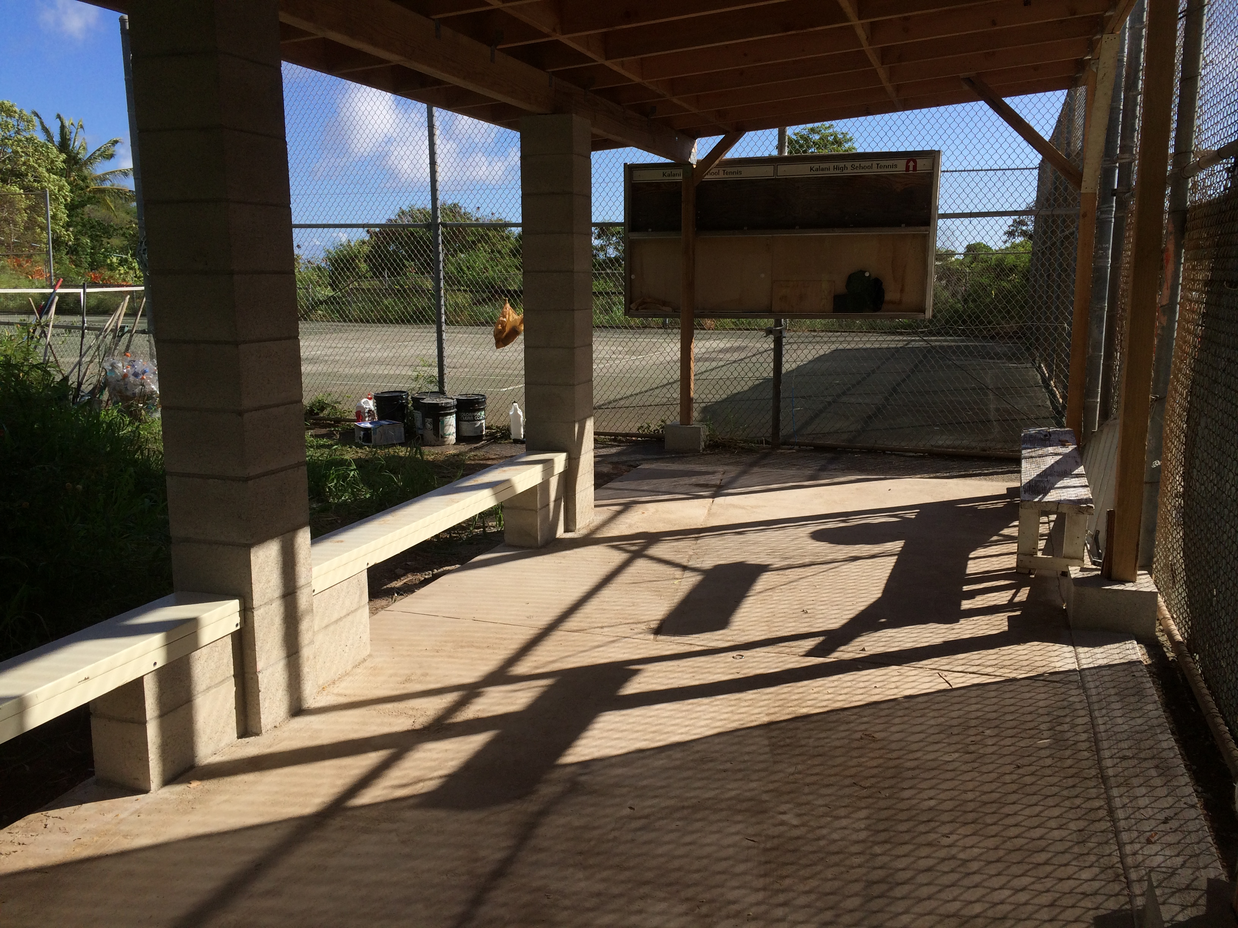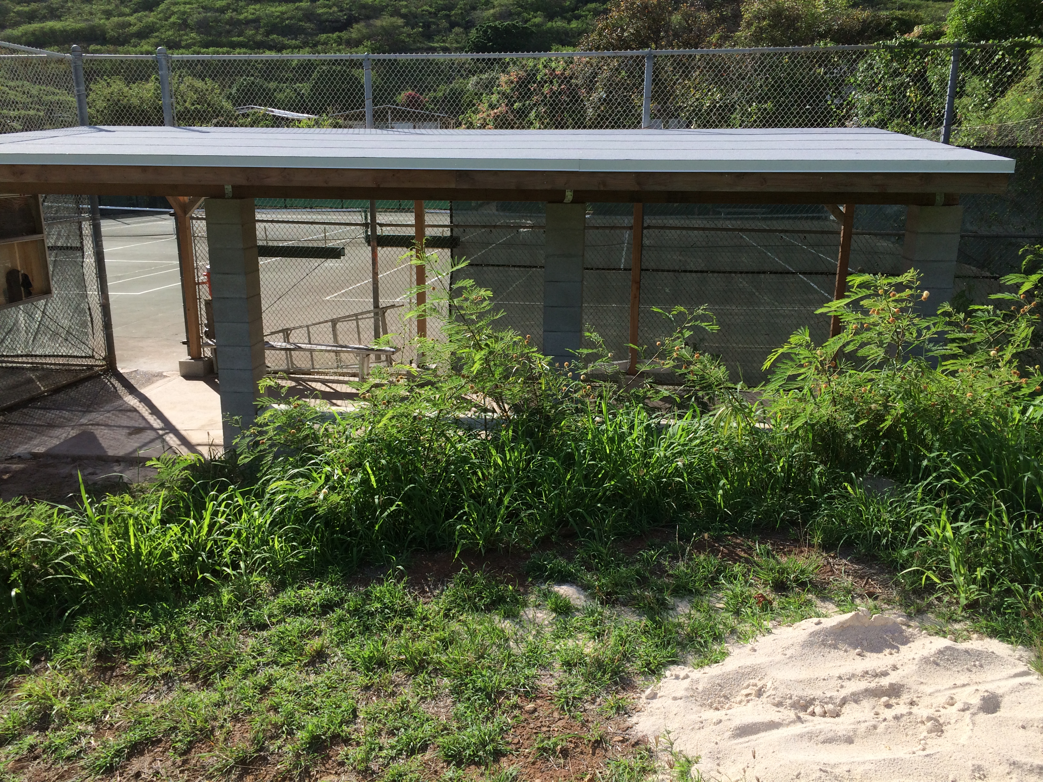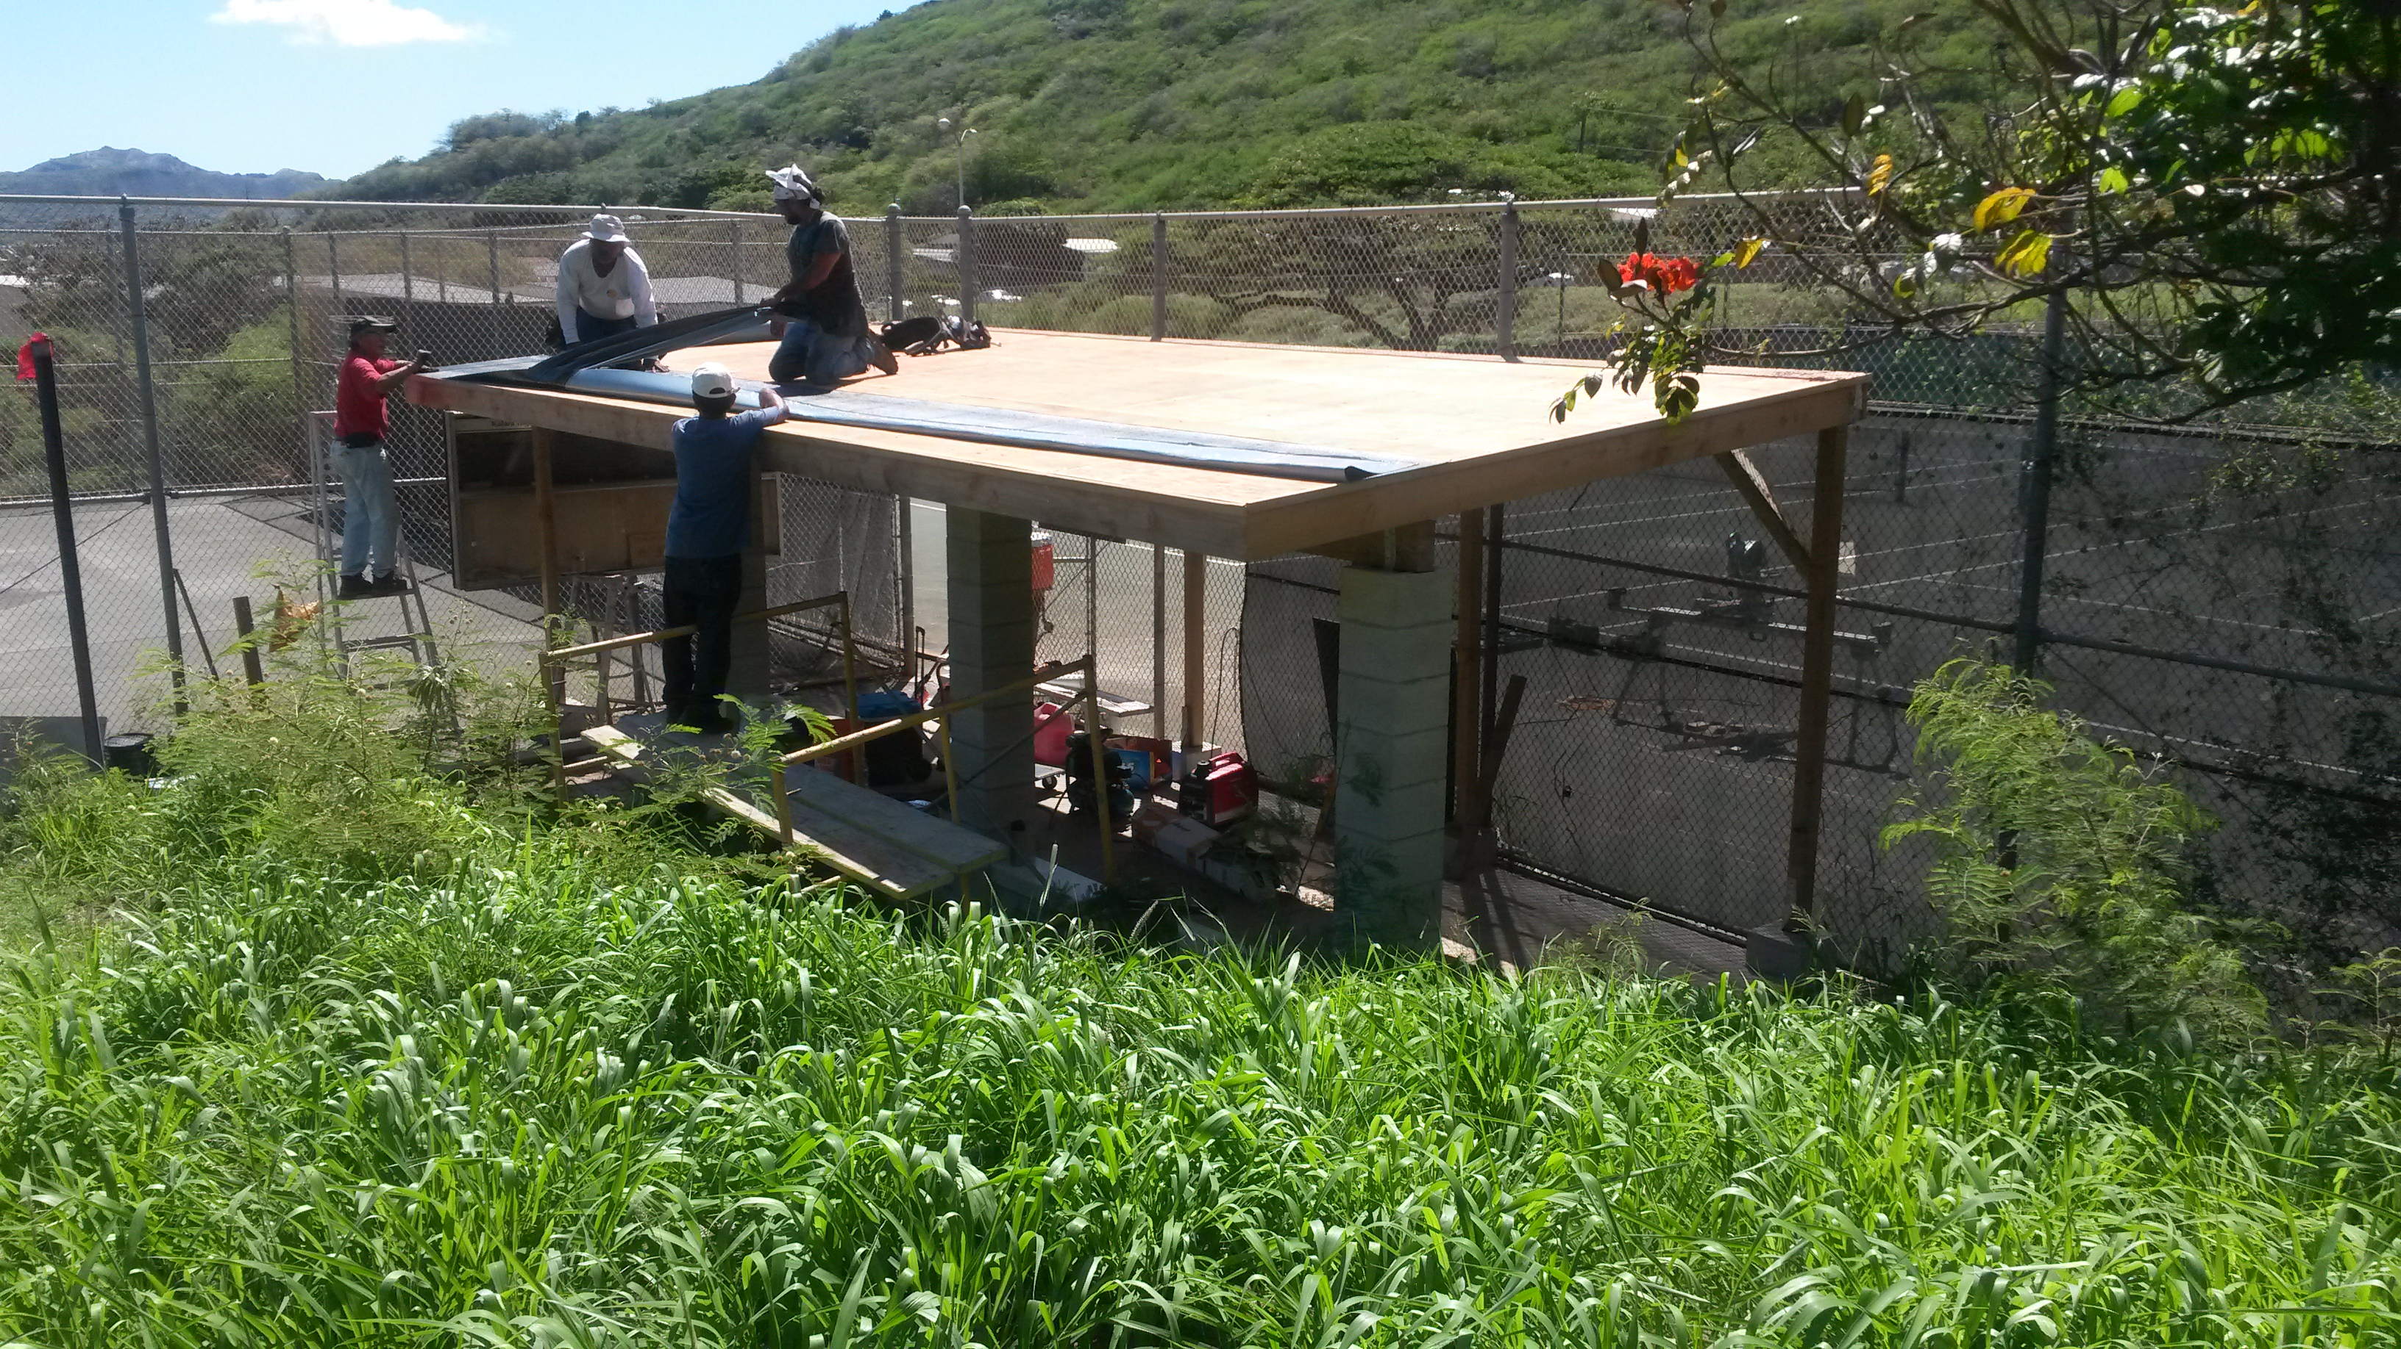
Mahalo Stan Wada and Byron Tanaka (Class of 1962)
A big mahalo to Stan Wada (Quality General Construction) and Byron Tanaka for providing the donations, materials and manpower to build a new structure for the Tennis Team. They were blessed with nice weather the past two Saturdays and Mr. Wada and his crew completed the beautiful, much-needed structure. The volunteers will be putting the final touches (paint, etc) this weekend. All are welcome to come and help.
Thanks to all the volunteers that came out to help with this project: Coach John, Doug and Lori Emoto, Donn and Jackie Terada, Jin Kim, Nick Ashikawa, Brandon Tanaka. Wayne Miyashiro (62, classmate) and of course Stan and his crew of masons, carpenters and roofers under his supervision.
Mahalo Alumni

Football
August 12 Kalani vs Pearl City @ Aiea
August 20 Kalani vs. Kaimuki September 30 Kalani @ Kalaheo
August 27 Kalani @ Waialua October 7 Kalani @ Waipahu
September 3 Kalani vs. McKinley

Crosscountry
September 3 Kalani Invitational Crosscountry Meet

CONGRATULATIONS TOBY MITCHELL
Toby Mitchell is one of the PCA-Hawaii Triple-Impact Competitor (TIC) Scholarship WINNERS! He has been awarded this scholarship because he has made an impact in athletics on three levels by improving himself, his teammates and the game.
Positive Impact Awards on Saturday, August 20th at The Pacific Club He will be awarded $1,000 in scholarship money at the Positive Impact Awards on Saturday, August 20^{th.}

CHANGE IN SPORTS MEETING PROCEDURES:
The DOE requires that parents/guardians who have a child participating in athletics must attend the Parent Sport Meeting, with their child, once their child has been selected to a team. This is required once each school year that the child is participating in a sport. The meetings have now been broken down and grouped by sport. Please attend the Parent Sport Meeting for your child’s sport.
The Parent/Guardian is required to go online (www.kalaniatheltics.org) to view the OIA/OC16 Risk Management video under the video tab and to view/read both the DOE Parent and Student-Athlete Handbook and Kalani's Guide to Athletic Participation. This must be complete PRIOR to coming to the Parent Sport Meeting. These items will no longer be distributed at the sport meeting. Those who do not have computer access may request an appointment with the Athletics Director to view the video and be provided a hard copy of the two handbooks. Since your child has already been selected to a team the $80.00 ASET fee is due at the Parent Sport Meeting. The Parent Sport Meetings shall be announced in the morning bulletin and will also appear on the athletic website, school calendar and Principal’s Newsletter. Contact your child’s coach if you should have any questions.

ATHLETIC PHYSICALS & CONSENT FORMS:
An Athletic Physical and the Parent Consent and Assumption of Risk (CAR) form is required before anyone may participate in any athletic training. Parents are encouraged to make every attempt to have these physicals completed during the summer months. If a student does not have a current physical on file with our Athletics Trainer prior to tryouts it may jeopardize their opportunity to make the team. Those participating in a winter sport should consider having their physicals completed no later than October. Spring sports should be no later than February. Physicals are good for one calendar year from the date of the physical. A separate CAR form is needed for each sport your child participates in. These forms are to be turned in directly to the Athletic Trainers. Please do not give them to the coach! For more information please contact our Athletic Trainers. The trainers start work at 1:00pm.
Ben Kuenzli – bkuenzli@ahct.k12.hi.us
Office: 305-0610

ACADEMIC REVIEW STATUS:
The parent/guardian whose child is on Academic Review Status (ARS) is encouraged to stay in close communication with their child’s teacher, counselor and coach. All parties should work in unison to ensure that the student-athlete has the greatest opportunity to be successful in their academics so that they may become eligible to participate in athletics.

ATHLETIC PRACTICE SAFETY:
For your safety and the safety of our student-athletes our practices are closed to the public. The gym doors will be closed during practice times and for the field/pool sports parents are asked to stay outside the fence line of the entire field/pool. Parents are asked to plan on arriving to pick up their child after a practice/game prior to end of the event. We want to be sure that there is adult supervision until all athletes have been picked up. Please communicate with your child’s coach if you should have any questions. Reminder that there is to be NO SMOKING/VAPORING, NO ALCOHOL AND NO PETS allowed on any DOE campus.

COMMUNITY CONNECTIONS
Stay tuned for future activities

Alumni information
US News Best High Schools - 2016
There are 5 silver medal schools from Hawaii included in the 2016 rankings of U.S. News Best High Schools.
Kalani is ranked 2nd amongst all of the public schools in Hawaii

U.S. News & World Report, a nationally recognized publisher of education news and information, recently announced the 2016 Best High Schools. The U.S. News Best High Schools rankings and data offer the most comprehensive information available on public high schools in the U.S. The 2016 edition includes profiles on more than 21,000 high schools and rankings of the nation's 4,707 highest-scoring schools across all 50 states and the District of Columbia.
Kalani High School is ranked 2nd within the State of Hawaii. Students have the opportunity to take
Advanced Placement® course work and exams. The AP® participation rate at Kalani High School is 54 percent.
The student body makeup is 52 percent male and 48 percent female, and the total minority enrollment is 90 percent.
Kalani High School is 2nd of 49 high schools in the Hawaii Public Schools.

Washington Post List of Challenging Schools
Congratulations to Kalani High School for getting on the Washington Post's list of Challenging High Schools – one of 8 Hawaii High Schools (list includes private schools) so recognized based on index score.
Index score : Total number of Advanced Placement, International Baccalaureate and Advanced International Certificate of Education tests given at a school each year divided by the number of seniors who graduated in May or June.

